Exceptional Student Services
Recruitment and Retention

Grow-Your-Own Program
Special Education Teacher Tuition Assistance
Grant Name: 2017 IDEA – SETTA Continuation
Funding Source: Individuals with Disabilities Education Improvement Act (IDEA)
Previously Approved Paraprofessional Required

FUNDING APPLICATION INSTRUCTIONS

Read this! Review the entire contents of this document and the SETTA-C Addendum 2017 before starting the application process. The local education agency (LEA) is responsible to follow the guidance provided and to submit complete and accurate information according to the grant requirements set forth in the instructions. This includes uploading all appropriate required and optional documents to the online funding application, Related Documents.

A funding application that is inaccurate or incomplete as instructed will be rejected for revision until compliance is met. If your funding application has been rejected, please make the necessary revisions and resubmit it ASAP.

Contact the IDEA capacity-building grant coordinator or the program and project specialist for assistance in the development of the online funding application and addendum (see Contacts for Assistance, Grant Issues). Contact Grants Management for assistance with technical issues related to the Grants Management Enterprise (GME) (see Contacts for Assistance, GME Technical Assistance). Contact information is located at the end of this document.

Introduction
The Arizona Department of Education, Exceptional Student Services, Recruitment and Retention (ADE/ESS/R&R) has designed this grant to address the critical shortfall in qualified special education teachers by providing college tuition assistance to eligible paraprofessionals who are serving students with disabilities. An eligible paraprofessional is one who was selected by the LEA and approved by ADE/ESS to participate in this grant program during FY 2016 and has successfully completed the required number of credits/hours between January 1, 2016, and June 30, 2016.

Purpose
This grant will pay the state college or university tuition and textbook allowance for eligible paraprofessionals who successfully complete coursework July 1, 2016–June 30, 2017.

Annual Program Cycle
July 1–June 30

The grant is funded on an annual state fiscal year basis July 1–June 30. A new funding application must be submitted for each fiscal year that continued funding is needed.

Grant Submission Deadline
November 7, 2016

notice! The grant year is July 1–June 30, so paraprofessionals may enroll in classes that start anytime during this program year. However, the online funding application may not be available in the GME until after October 7. You should plan for this late activation date when you develop the budget. If the LEA pays the tuition directly to the college or university, you may need to use another local, state, or federal funding source. You should reimburse this other funding source when the grant is web approved and funds are available to be drawn down.

Revision Submission Deadline
May 15, 2017

Uniform System of Financial Records (USFR)

The USFR provides guidance for the line item placement of funding in IDEA capacity-building training, tuition-assistance, and implementation grants. The USFR requires that the following function codes be used to show tuition:
- Teachers, instructional aides, and all other instructional staff who work with students in the classroom setting must be placed in the appropriate object codes under Function Code 2100, 2200, 2600, 2700–Support Services (Students, Instr., Operation, Transport).
- District or school administrators and other noninstructional related service providers and staff must be placed in the appropriate object codes under Function Code 2300, 2400, 2500, 2900–Support Services (General, School, Central Services, Other).

notice! Never place any funding for IDEA capacity-building training, tuition assistance, or implementation grants under 1000–Instruction.

You may contact the following for clarification or confirmation:
- Arizona Auditor General’s office at 602-553-0333; (or)
- Ingrid Rope, Finance Specialist, ESS Funding Unit, at 602-542-4064 or Ingrid.Rope@azed.gov.

ESS Funding Unit Standard Budget Format

ESS Funding Unit has developed standard budget formats to describe the materials and services in the budget’s narrative description for all IDEA capacity-building grants. These standard budget formats help the ESS grant evaluators to quickly and efficiently review a grant. The IDEA capacity-building grant applicants must use the standard budget formats.

The ESS Funding Unit has developed standard budget formats that must be used in all IDEA capacity-building discretionary grants to describe budget line items in the online funding application and addendum narrative descriptions. Be assured that all IDEA capacity-building training, tuition assistance, and implementation grants that are not written in the standard budget formats described in their instructional documents will be rejected until compliance is met. Examples of the standard budget formats for the purchase of each allowed item for this grant are shown below.

Funding Restrictions and Funding Allowances

Funding Restrictions
This grant does not allow or will not pay for the following:
- Carryover of funds from year to year. A new grant must be submitted for each year that the paraprofessional requires tuition assistance until the person completed the teacher preparation program.
- Teacher certification fees.
- Tuition for courses that do not receive a satisfactory grade, remedial courses, or courses that are not needed to complete degree requirements.
- 6700–Property (Capital Outlay) [for school districts only].
- 0190–Capital Outlay [for charter schools only].

Funding Allowances
Funding from this grant may be used to pay:
- Tuition and additional required fees such as technology and student activity fees at the college or university rate.
- Registration fees.
- Lab fees.
- $125 textbook allowance per class, including e-books.
- Indirect costs at the LEA’s approved indirect cost rate.

Consult with your finance director or tax attorney to determine federal and state taxes owed by the paraprofessional for tuition and other benefits received through this grant.

Standard Budget Format Examples

The following examples show the standard budget formats for the items that are allowed to be purchased with this grant.

Reimbursement of Tuition and Textbooks to the Paraprofessional
Hypothetical situation: Jane Doe is a paraprofessional who is registered at Northern Arizona University in the teacher preparation program. She is working toward a degree in Special and Elementary Education, Bachelor of Science in Education and attends classes that are offered online and at an extended campus in her community. She will be enrolling in 16 semester units during the fall and spring terms. Jane is maintaining ownership of the textbooks. The LEA will reimburse her for textbooks with proof of purchase and will reimburse her after the semester ends with proof of satisfactory grades received.

Jane’s FY 2017 course plan follows.

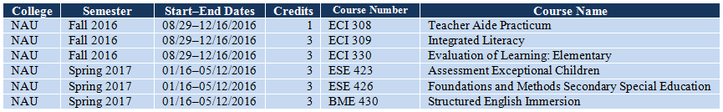

Budget Example 1 below shows the standard budget format for tuition and textbooks’ costs that are reimbursed to the paraprofessional. Use the most current tuition and fees information available when the budget is developed. In this scenario, the most current information is the Extended Campus, Resident Undergraduate Fall 2016 Tuition and Fees schedule, which was updated on May 22, 2015.

Note the following and follow the same format in your application:
- The college or university is identified by its acronym.
- The semester or term is identified.
- The number of credits/hours is listed for each semester.
- In this case, the tuition is not a per-credit/hour amount but is taken from the university’s tuition and fees schedule. NAU’s Extended Campus, Resident Undergraduate Fall 2016 Tuition and Fees schedule is shown below as an example.

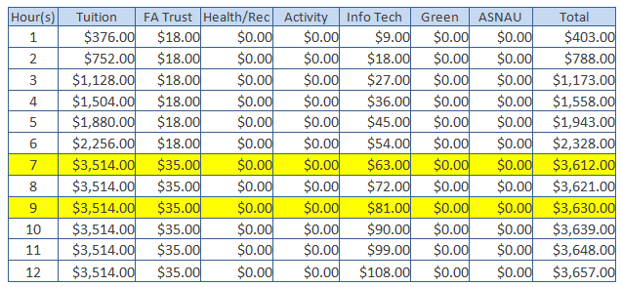

Funding that is reimbursed to the paraprofessional must be placed in:
Object Code: 6200–Employee Benefits
Function Code: 2100, 2200, 2600, 2700–Support Services (Students, Instr., Operation, Transport)

Budget Example 1
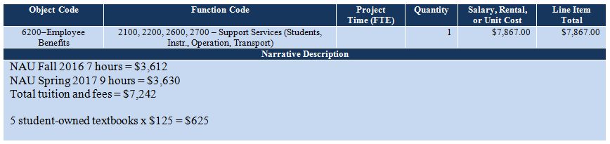

In the scenario in Budget Example 2 below, the university was contacted about a possible tuition increase that will take effect during the year. The university expects a 3% tuition increase but has not posted an updated tuition and fees schedule. Budget Example 2 shows the addition of the anticipated 3% tuition increase.

Budget Example 2
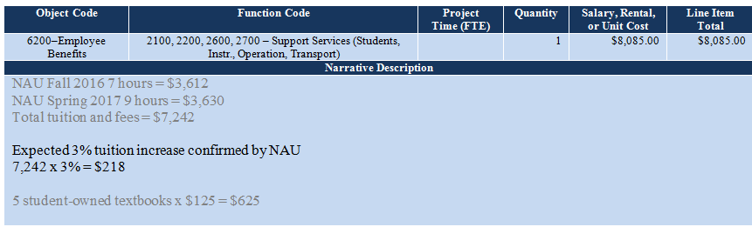

Payment Directly to the College/University by the LEA
Hypothetical situation: John Doe is a resident of Maricopa County and is attending Rio Salado College and pursuing a Bachelor’s Degree in Education, Special Education K–12 Mild to Moderate. The LEA will pay the tuition and fees directly to the college and collect grades at the end of each term to ensure that a satisfactory grade is received for each grant-paid class. If John does not meet the grade requirement for a class, he must pay for and retake that class or another that will fulfill program requirements. John will be reimbursed for textbooks with proof of purchase. John’s FY 2017 course plan is shown below.

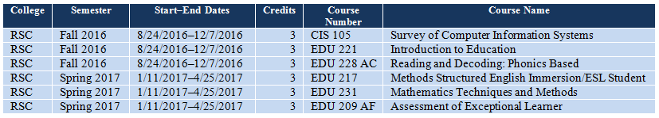

Budget Example 3 and Budget Example 4 show how payment is made to the college and textbooks are reimbursed to the student. Budget Example 3 shows the placement of textbooks that are reimbursed to the paraprofessional. Budget Example 4 shows tuition that is paid by the LEA directly to the college.

Note the following:
- Budget Example 4, tuition is a flat rate or $84 per credit hour.

Tuition will be paid to the college by the LEA; textbook costs will be reimbursed to the paraprofessional:
Object Code: 6200–Employee Benefits, textbook stipends
Object Code: 6300–Purchased Professional Services, tuition
Function Code: 2100, 2200, 2600, 2700–Support Services (Students, Instr., Operation, Transport)

Budget Example 3
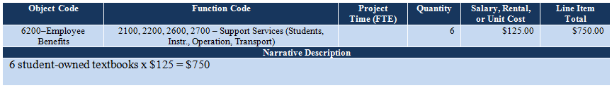

Budget Example 4
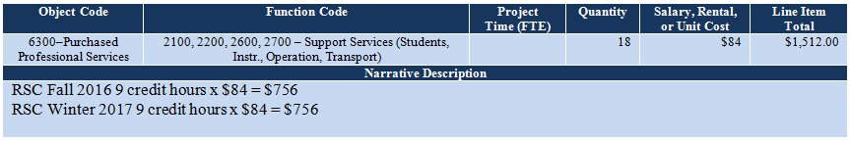

Textbooks Owned by the LEA
LEA-owned textbooks may be placed in either 6300–Purchased Professional Services or 6600–Supplies at the discretion of the designated fiscal agent (LEA).

Budget Example 5 and Budget Example 6 demonstrate the two ways to place funds in the budget for textbooks that remain the property of the LEA.

Textbook allowances when the LEA maintains ownership:
Object Code: 6300–Purchased Professional Services
Object Code: 6600–Supplies
Function Code: 2100, 2200, 2600, 2700–Support Services (Students, Instr., Operation, Transport)

Budget Example 5
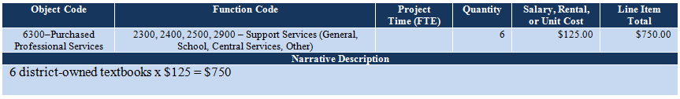

Budget Example 6
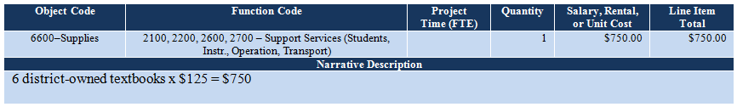

Indirect Cost Recovery
Indirect costs at the applicant’s approved indirect cost rate and county-approved indirect cost rate, if they are applicable, are allowed with this grant funding. The online funding application will automatically calculate the indirect cost amount; but you must manually type it in the appropriate cell in the budget to add the indirect cost amount to the grant’s total. If indirect cost rates are not available at the time of grant submission, the LEA may submit an amendment after grant approval to add this cost to the grant. No other administrative costs are allowed.

The following is an example of indirect cost that is shown in the online funding application in the Budget section. The GME system has calculated the indirect cost amount to be $292.76.

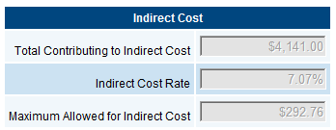

Type the GME-calculated maximum allowed indirect cost amount in the Salary, Rental, or Unit Cost and Line Item Total columns as shown in red type in the example below.

Budget Example 7
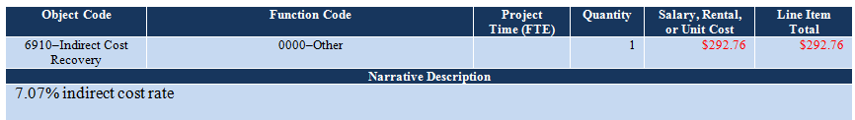

Contacts for Assistance

Program Support and Monitoring
Bill McQueary, Acting Director, 602-364-0642, William.McQueary@azed.gov

Grant Issues
Celia Kujawski, IDEA Capacity-Building Grant Coordinator, 602-542-4610 (office), 602-432-3213 (cell), Celia.Kujawski@azed.gov
Abby Sanchez, Program and Project Specialist I, 602-364-3026, Abby.Sanchez@azed.gov

USFR Questions
Arizona Auditor General’s Office, 602-553-0333

Ingrid Rope, Education Program Specialist, ESS Funding Unit, 602-542-4064, Ingrid.Rope@azed.gov

GME Technical Assistance
Grants Management, (844) 893-9789 or local (602) 542-3901, grants@azed.gov

Use the most current college or university tuition and fees when calculating tuition for each semester. The LEA or paraprofessional should contact the school to inquire about a possible increase in tuition during the year. If tuition is expected to increase, use the information provided by the school. Budget Example 2 shows a way in which an increase in tuition should be described when the school has not yet released new tuition rates. Note that the amount of a grant may not increase after the grant is approved unless the LEA’s approved indirect cost rate is not loaded into the GME system by the time the grant is submitted and approved. The grant amount will not increase due to an unexpected increase in tuition if the applicant has not investigated this.

