FY22 Guidance
Comprehensive Needs Assessment Updated 10/2020
Root Cause Analyses
Integrated Action Plan

Contents
FY 22 CNA Update 3
Continuous Improvement 4
What Is a Needs Assessment? 5
Arizona Comprehensive Needs Assessment (CNA) 5
Principles, Indicators and Elements 6
Completing the Comprehensive Needs Assessment 6
CNA Meetings 6
Overview of team tasks 6
CNA Data Collection, and Analysis 7
Guiding questions 7
GME Guidance Resources 9
Comprehensive Needs Assessment Completion 9
SSI Learning Modules 9
CNA Screenshots 9
Identify 3 or 4 Primary Needs 12
Root Cause Analyses 13
Fishbone Diagram Process Directions 14
The 5 Why Method 15
Integrated Action Plan 17
IAP Requirements: 17
Integrated Action Plan Diagram 18
School Integrated Action Plan (SIAP) 19
SMART GOALS 20
IAP Process: 21
Sample School Site IAP Worksheet 23
GME SIAP 24
LEA Integrated Action Plan (LIAP) 26
LEA Integrated Action Plan (Quick Reference Guide) 26
GME LIAP 27
Sample LEA Integrated Action Plan Worksheet 31
Appendices 34
Appendix A CNA Rubric (full details) 35
Appendix B CNA Planning Tool Format 109
Appendix C MONITORING AND EVALUATION 161
Appendix D Resources for Evidence-Based Strategies 166
Appendix E Types of Data and How They May Be Used 169
Appendix E CNA Glossary of Terms 179
Appendix F Comprehensive Needs Assessment Research Base 186

FY 22 CNA Update

The Planning Tool will be available in GME on November 15, 2020.

The CNA has been updated to reflect ADE’s Vision: Equity for all students to achieve their potential. There is now an intentional focus on equity throughout the indicators and elements. Other updates include a focus on the whole child, well rounded education and the essential nature of social-emotional learning and trauma sensitive practices and other Title lV requirements. The overall structure and process remain the same.

The guidance document has been updated with resources including the full updated CNA Rubric to be used for staff and other stakeholder small group discussions. The tool itself is also available to record consensus from different groups prior to putting all the data into GME.

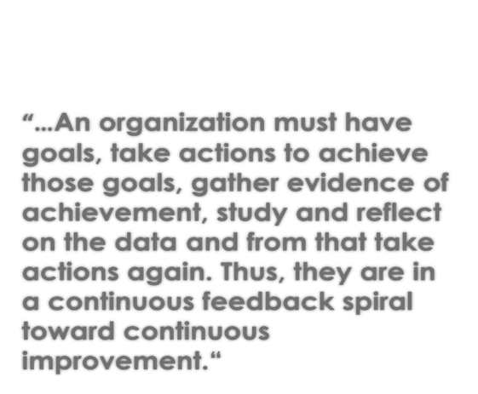

Continuous Improvement
Continuous improvement is an iterative process that unfolds progressively and is sustained over time. It encompasses the general belief that improvement doesn’t start and stop. It requires an organizational and professional commitment to an ongoing process of learning, self-reflection, adaptation, and growth. For example, when a school is continuously improving, a variety of changes occur in ways that cumulatively affect multiple dimensions of a school system.
The concept of continuous improvement also recognizes that improving school effectiveness is not only highly complex, but it entails unforeseen challenges and complications that require a sustained commitment to ongoing improvements.
Major components of continuous school improvement encompass creating, reviewing or revising the school vision; gathering and analyzing data related to that vision; planning the school’s work to align with the vision, selecting strategies, implementing the action steps; and gathering data to measure the impact.
Sustainable continuous improvement requires schools to have the knowledge, skills, and expertise needed to improve educational results and sustain improvement over time. Continuous improvement must build leader and staff capacity. The improvement cycle includes ongoing data collection that helps educators monitor progress and make adjustments in real time.
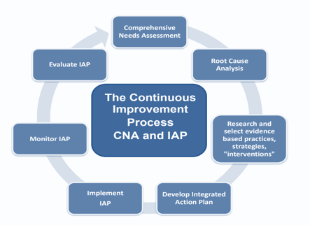

What Is a Needs Assessment?

A needs assessment is a systematic set of procedures that are used to gather data to determine needs, identify their root causes, and set priorities for future action. A needs assessment leads to action that will eliminate root causes and improve systems, services, processes and operations.
A needs assessment:
- Requires an inclusive team approach
- Requires gathering and analyzing data
- Informs identification of primary needs, root causes, need statements and desired outcomes
- Creates cohesion through the alignment of vision with greatest needs, root causes, and possible solutions.
- Identifies what’s working, what’s not and what’s needed
- Correlates qualitative and quantitative data

Arizona Comprehensive Needs Assessment (CNA)

The CNA is required by ADE. It is designed to inform need statements, identify root causes, desired outcomes, goals, strategies and action steps for the Title l, ll, lll, lV and School Improvement programs.

The CNA will guide the process of evidence-based decision making in schools and LEAs to drive continuous improvement and significantly impact student achievement.
The CNA reflects the school’s current state. Acknowledging that current state honestly and transparently, based on evidence, is essential. It is not about a comparison between and among schools. It is about identifying strengths, needs and desired outcomes specific to individual schools and their context. The CNA allows schools to identify the greatest needs, determine root causes, and identify solutions.
A limited number of well-defined desired outcomes and/or goals are a common feature of successful school and LEA improvement plans. These desired outcomes with goals, strategies and actions steps, help focus a school’s work by setting a target for improved student learning and achievement through systems, processes and programs that impact achievement. By choosing strategies and action steps that leverage strengths and focus on connections and coherence, student learning and achievement increase. Carefully chosen foundational small steps, lead to desired outcomes and systemic change over time.

Remember: The CNA is not a test; it is not an evaluation of good or bad. It is about knowing where you are as a school in relation to research-based exemplars of effective school systems, to improve and be the best school possible in your context.
.

Principles, Indicators and Elements
The Principles, with the Indicators and Elements describe an effective school system. Originally developed collaboratively by a team from multiple ADE program areas and representatives from schools and LEAs from across state, this self-reflection process required for continuous improvement is based on current educational research and evidence-based best practice.

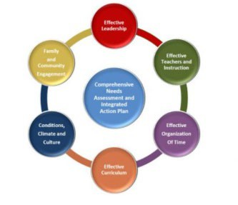
The Principles, Indicators and Elements describe criteria applicable to all schools, no matter their size, student population, philosophy or location. Schools use the Principles, Indicators and Elements to identify primary needs when addressed and resolved result in increased student achievement and strengthened school systems leading to sustainable improvement.

Principle 1: Effective Leadership
Principle 2: Effective Teachers and Instruction
Principle 3: Effective Organization of Time
Principle 4: Effective Curriculum
Principle 5: Conditions, Climate and Culture
Principle 6: Family and Community Engagement

Completing the Comprehensive Needs Assessment

Leadership Team: Establish/convene the Comprehensive Needs Assessment Team
A powerful, enthusiastic team from across the organization and community is essential to transform an organization. Deciding who should take part in the process is crucial. Diversity and inclusion is key. Building the momentum for change requires strong leadership and visible support from key people. Working as a team helps create momentum and build the sense of urgency in relation to the need for change.
The CNA Leadership Team facilitates the process with the larger CNA team
All staff members and stakeholders work together to complete the CNA process, gathering and analyzing data, discussing ratings, coming to consensus on individual elements. They plan and facilitate the process itself, ensuring inclusive involvement and representation that will lead to sustainable systemic change.
- Include stakeholders representing all parts of the system, principal, other administrative staff, teachers, paraprofessionals, school office staff, parents, families, community members, and students
    - Stakeholders are those individuals with valuable experiences and perspective who provide the team with important input, feedback, and guidance and represent all factions of the school community

CNA Meetings

Overview of team tasks:
- Establish a facilitator is to ensure that all CNA Completion Team members’ voices are heard and all possible thoughts and theories from the group are considered before coming to an agreement of a specific CNA Element descriptor that matches the current state.
- Establish group norms
- Develop completion timeline
- Establish roles and responsibilities
- Discuss the school vision and mission to ground the work

CNA Data Collection, and Analysis
- Use the rubrics with full explanation/tool with shortened explanations to discuss each indicator, elements and multiple data sources for evidence Data collection
- Analyze data to select the element descriptors that best match your school for all Principles’ Indicators.
- Discuss, discuss, discuss…the power is in the group discussion from different lenses.
- Reach consensus on each element’s rating.

Guiding questions
Gathering data:
- What data do we currently collect that is relevant to the CNA Indicator and Element?
- What additional data is needed or can contribute as evidence?
- Is data needed to show specific gains or losses or to better understand progression and/or effectiveness of a system or process?
- Which data points do you feel are the most meaningful and useful?
- What, if any, additional data is needed?

Leading indicator Data
Leading indicators are formative, prioritize key areas that are particularly helpful in assessing progress toward goals and make mid-course corrections
Demographic Data Guiding Questions
- How do student outcomes differ by demographics and programs?
- What is the longitudinal progress of a specific cohort of students?
- What are the characteristics of students who achieve proficiency and of those who do not?
- Where are we making the most progress in closing achievement gaps?

Dropout Rate Guiding Questions
  - Are there significant differences in dropout rates among subgroups?
  - Are there any trends? Who? When?
  - Student attendance rate
    - Have there been changes in the attendance rate overtime?
    - Are there trends among subgroups or grade levels?

Discipline Incidents Guiding Questions
    - Have there been changes in the discipline incidents rate overtime?
    - Have there been changes in the types of discipline incidents overtime?
    - Are there trends among subgroups, grade levels or teachers?

Truancy
    - Have there been changes in the truancy rate overtime?
    - Are there trends among subgroups or grade levels?

Teacher Attendance Rate
    - Are there any overall trends?
    - Do the trends correlate with achievement data?

Other Possible Leading Indicator Data
  - Formative Assessments
  - Early Reading Proficiency
  - Enrollment in Pre-Algebra and Algebra
  - Over-Age/Under-Credited Students
  - Student Attendance and Suspensions
  - Special Education Enrollment
  - Student Engagement
  - Principal Quality

Lagging/Achievement Indicator data
Lagging indicators are summative, longer term outcomes that enable us to reflect on the impact of a strategy.
End of year achievement Data Guiding Questions Possible Student Achievement
- Percentage of students at or above each proficiency level on State assessments in reading/language arts and mathematics, by grade and by student subgroup
- Are there trends among subgroups?
- Are there trends among grade levels?
- Are there teacher specific trends?
- Are there trends relative to ELA or Mathematics?

Percentage of Limited English Proficient Students Who Attain English Language Proficiency
  - Are there trends among grade levels?
  - Are there teacher specific trends?
  - Have there been changes in the proficiency rates overtime?

Graduation rate
- What processes are in place to support practices that positively affect graduation outcomes? What gaps exist in outcomes among student subgroups?
- Have there been changes in the graduation rates over time? 4-year cohort? 5-year cohort? 6-year cohort?

Remember, it is THE PROCESS to determine the current reality that has the POWER.
The DISCUSSION is what is important.
The scores you agree on and the summaries of the scores guide identification of the greatest needs.

GME Guidance Resources

Comprehensive Needs Assessment Completion

Planning Tool
LEA Integrated Action Plan (Quick Reference Guide)
Planning Tool Print (Quick Reference Guide)
School Integrated Action Plan (Mini-Handbook)
User Roles Assignment - Planning Tool (Short Snip)

SSI Learning Modules

CNA Screenshots

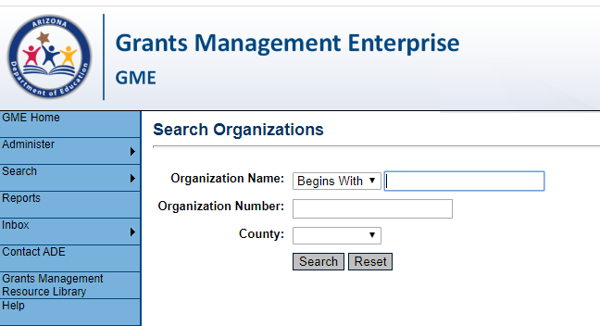

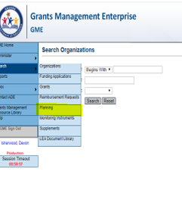

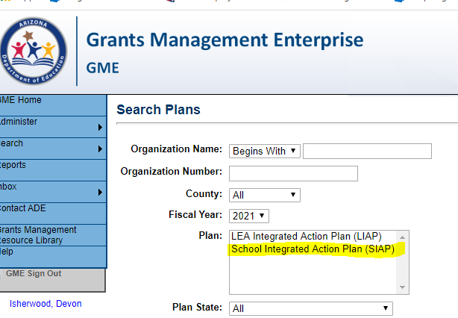

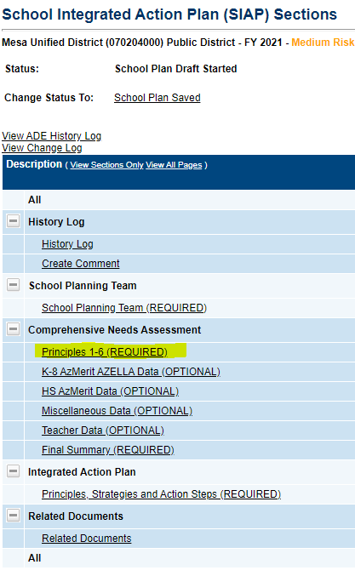

Complete for each Principle, 1 through 6

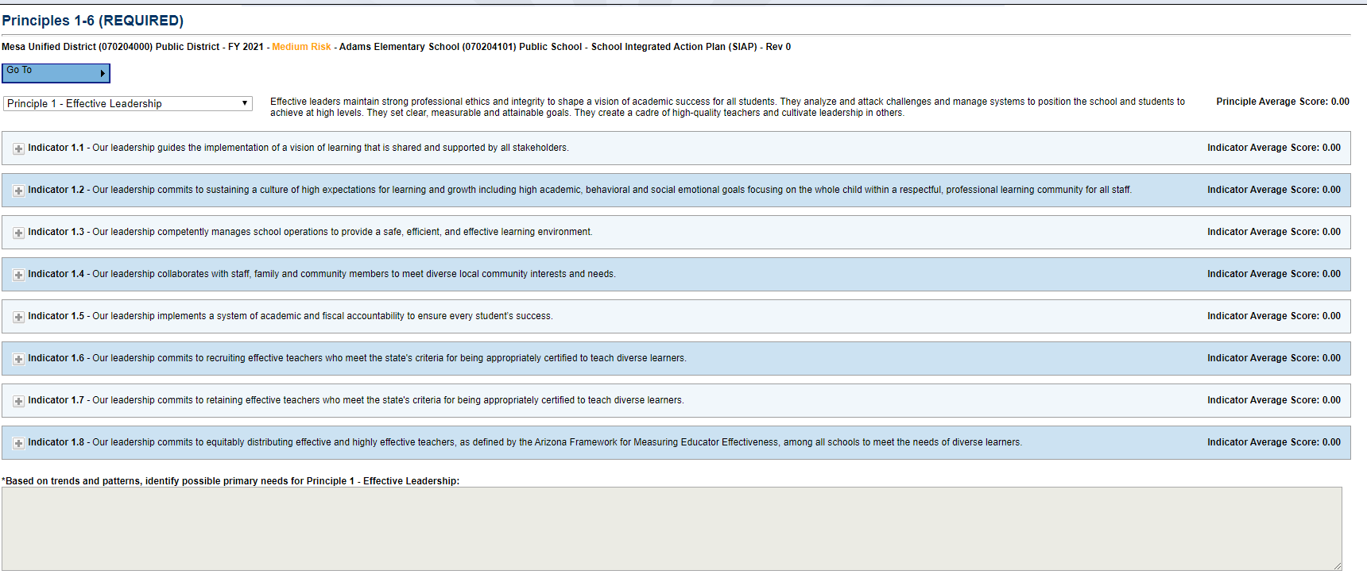

Analyze and consider quantitative data
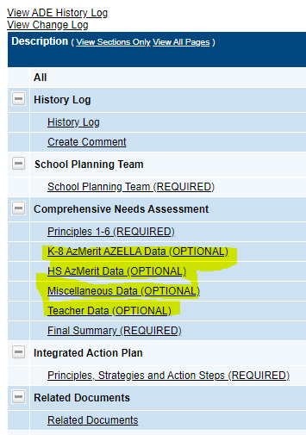

Final Summary
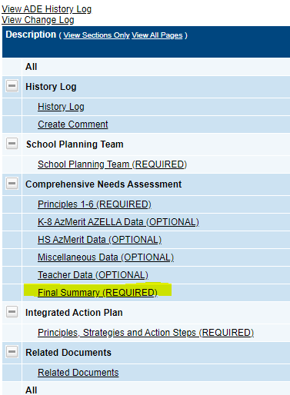
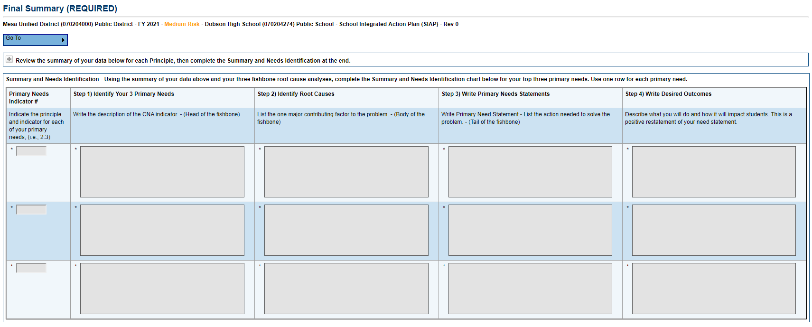

Required Related Documents-3 fishbone diagrams to identify root causes

Identify 3 or 4 Primary Needs
Primary need is CNA principle, indicator or element PLUS data source.
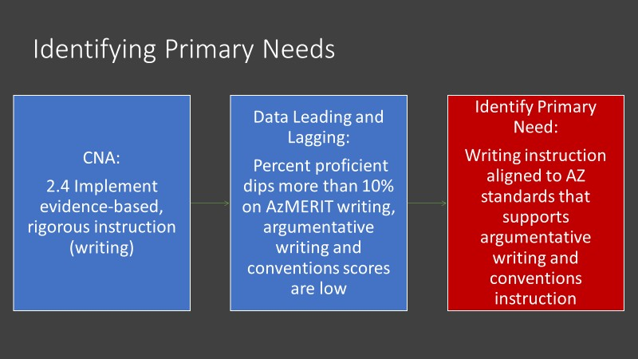
Reread the trends and patterns summaries and possible primary needs from all 6 Principles. Analyze the data you have from a variety of resources. Use the information in these summaries to Identify three or four primary needs.
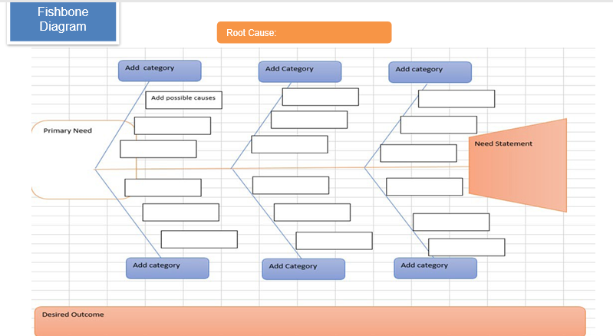
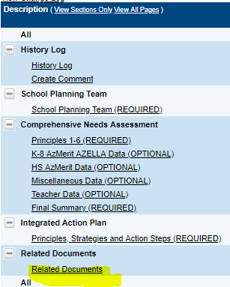

Root Cause Analyses
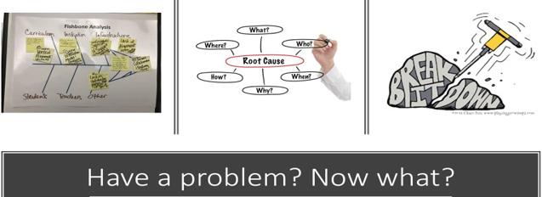

GME screenshot

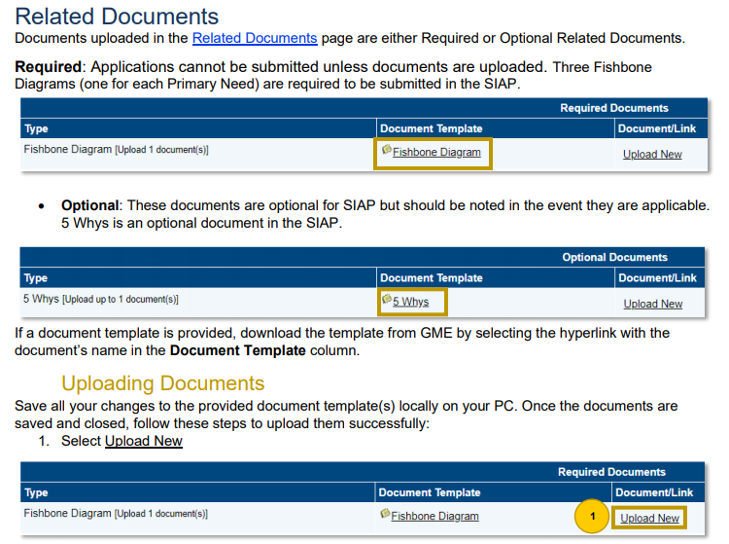

Conduct a Thorough Root Cause Analysis for your top 3 or 4 primary needs, resulting in Needs Statements and Desired Outcomes. Root cause analyses take time! It is necessary for impactful change.

Root cause analysis is a structured team process. It allows the use of a strategic method to dig down into the primary need and determine causes and contributing factors. Often during the discussion of causes, different perspectives of the same situation are uncovered for an enhanced picture of the problem. At the end of the root cause analysis, the major cause is discovered and what needs to happen to remove the problem is determined. This is time to discuss causes, not solutions.
The root cause is the ONE major contributing factor 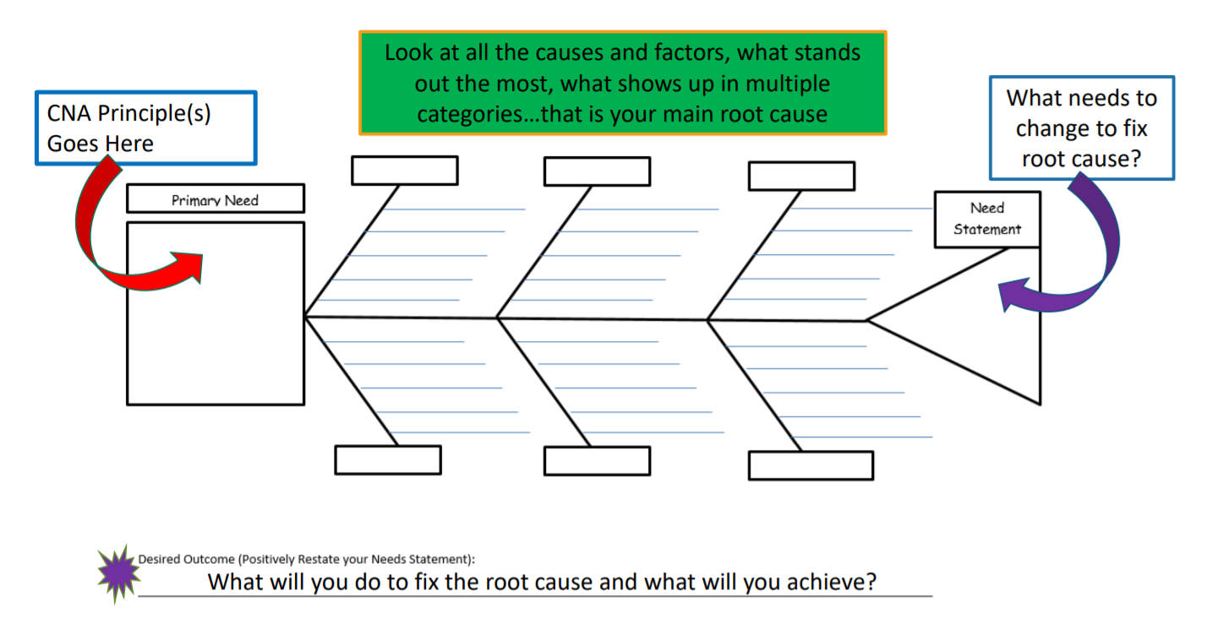

Fishbone Diagram Process Directions: The team identifies clear and specific primary needs based on patterns and trends in the CNA.
Choose ONE of the primary needs identified in the CNA to address first and write it in the head of the fishbone.
1. The team facilitator asks the team, “How do we know that problem exists? What are the teachers doing? What are the students doing? (see the root cause analysis questions for support with this) The team recorder documents comments on the fishbone grouping items in like categories, for example: teachers, students, curriculum, assessment, etc.

Possible fishbone categories: Instruction• Curriculum •Community• Teachers •students •infrastructure •Leadership • Assessment • Transportation • Attendance • Time • Professional development • Climate/culture • Technology • Subgroups

2. After, all ideas are documented on the fishbone. Reread the ideas on the fishbone.
3. Highlight similar items.
4. Look at the highlighted items, what pattern or trend surfaced? That is your root cause.
5. Once the team agrees on the root cause, determine what needs to change to eliminate the root cause---what needs to change is the need statement.
6. To verify you have gotten to the heart of the problem, ask the following:
If the need statement (tail) were corrected, would the problem continue?
If no, you found the root cause
If yes, you need to dig deeper
- Would the problem have occurred if the cause had not been present? If no, then it is a root cause. If yes, then it is a contributing cause.
- Will the problem reoccur as the result of the same cause if the cause is corrected or dissolved? If no, then it is a root cause. If yes, then it is a contributing cause.
- Will correction or dissolution of the cause lead to similar events? If no, then it is a root cause? If yes, then it is a contributing cause.

Root Cause guiding questions:
How do you know the problem exists? • What are your teachers or staff doing or not doing to contribute to the problem? • What are students doing or not doing to contribute to the problem? • What is the community or family doing or not doing to contribute? • What school systems support the problem? • What systems do not support the problem? • What barriers are in place? • How does the curriculum contribute? • How does time contribute? • Does the school schedule play a role in the problem? • What causes the teachers to contribute to the problem? • Why do students feel or act a certain way? • How does instruction contribute to the problem?

Important note: Focus on causes you can impact, not those out of the school’s control
Tips
- Use the fishbone diagram tool to keep the team focused on the causes of the problem, rather than the symptoms or solutions.
- Consider drawing your fish on a flip chart or large dry erase board.
- Make sure to leave enough space between the major categories on the diagram so that you can add minor detailed causes later.
- When brainstorming causes, consider having team members write each cause on sticky notes, going around the group asking each person for one cause. Continue going through the rounds, getting more causes, until all ideas are exhausted
- Encourage each person to participate in the brainstorming activity and to voice their own opinions.
- Note that the “5 whys” method, below, is often used in conjunction with the fishbone.

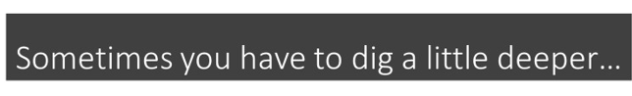

The 5 Why Method
The 5-Whys is a simple brainstorming tool that can help teams identify the root cause(s) of a problem. Once a general problem has been recognized, ask “why” questions to drill down to the root causes. Asking the “5- Whys” allows teams to move beyond obvious answers and reflect on less obvious explanations or causes.

Instructions:

- State the problem you have identified as a strategic problem to work on.
- Start asking “why” related to the problem. Like an inquisitive toddler, keep asking why in response to each suggested cause.
- Ask as many “whys” as you need in order to get insight at a level that can be addressed (asking five times is typical). You will know you have reached your final “why” because it does not make logical sense to ask why again.

The “5-Whys” is a strategy that is often used after an issue has been identified using another tool, such as a Fishbone Diagram. Using the “5-Why” questions on their own can lead to a narrow focus or bias.

This methodology is closely related to the Cause & Effect Fishbone diagram and can be used to complement the analysis necessary to complete a Cause & Effect diagram.

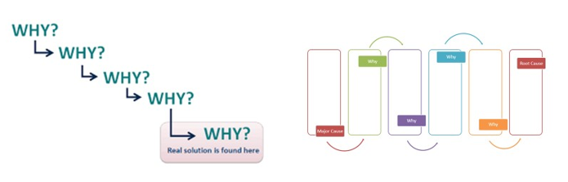
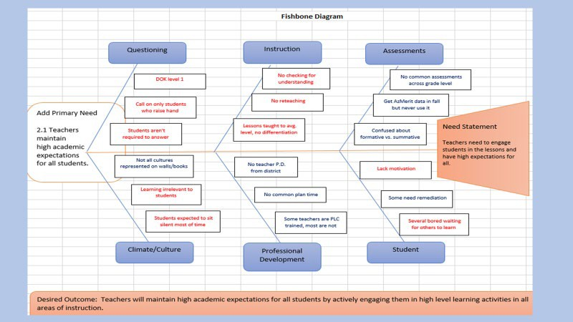
Root Cause: Teachers have low expectations
EXAMPLE

After conducting the root cause analysis, the need statement is still too general…so digging deeper is necessary.
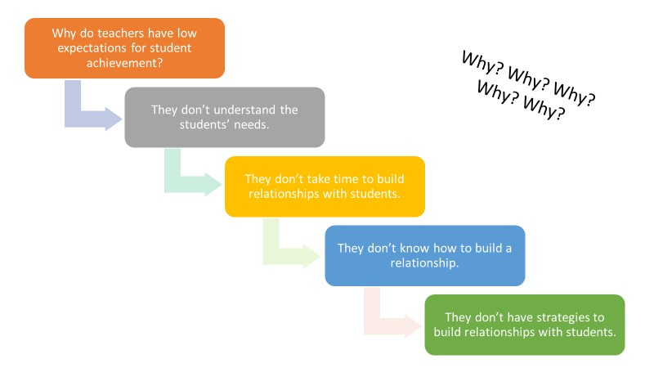
Root Cause

Tips
- Try to move on quickly from one question to the next, so that you have the full picture before you jump to any conclusions.
- The "5" in 5 Whys is just a "rule of thumb." In some instances, you may need to go on and ask "why?" a few more times before you get to the root of the problem. In others, you may reach this point before you ask your fifth "why?" If you do, be careful that you've not stopped too soon. The important point is to stop asking "why?" when the
  - useful responses stop coming.
- As you work through your chain of questioning, you'll often find that someone has failed to take a necessary action. The great thing about 5 Whys is that it prompts you to go further than just assigning blame, and to ask why that happened. This often points to organizational issues or areas where processes need to be improved.

Integrated Action Plan
GME Directions
School Integrated Action Plan (Mini-Handbook)

The Integrated Action Plan (IAP) is developed based on the School level Comprehensive Needs Assessment (CNA) and root cause analyses. It should be developed in concert with all applicable stakeholders, with opportunities for meaningful input and feedback from parents and community members, to ensure the plan is reflective of local context and needs.

The School-level IAP (SIAP) addresses three or four areas of need identified by the school’s CNA and Root Cause Analyses.

The LEA-level IAP (LIAP) supports the system’s areas of focus as identified and informed by an LEA’s analysis of school CNAs and school IAPs.

School integrated Action Plan (SIAP) and the LEA integrated Action Plan (LIAP) are written annually.

IAP Requirements:
Three or four Need Statements with correlated Desired Outcomes; SMART Goals, if required
- Evidence based Strategies
- Evidence based Action Steps (use appropriate tags are required, funding and program tags
  - Implementation Action Steps
  - Monitoring Action Steps
    - Measures
    - Success Criteria and Evidence
  - Evaluation Action Steps
    - Measures
    - Success Criteria and Evidence

Address only the applicable Principles on CNA, root cause analyses, identified three or four Need Statements and Desired Outcomes. All 6 Principles are not required based targeted, intentional, focused actions result in real change. A “laundry list” of needs and desired outcomes will dilute focus, scatter efforts and will not result in real change.

Integrated Action Plan Diagram
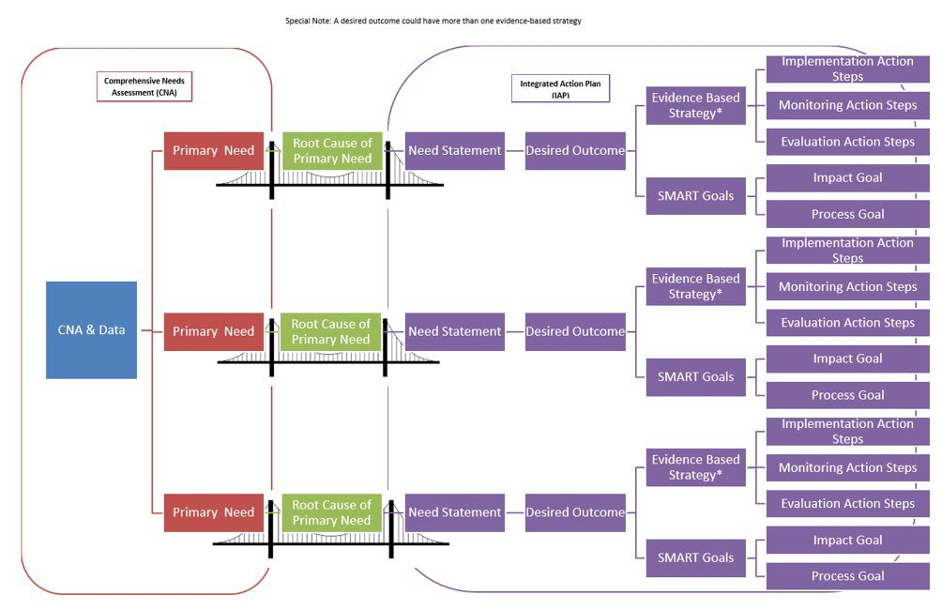

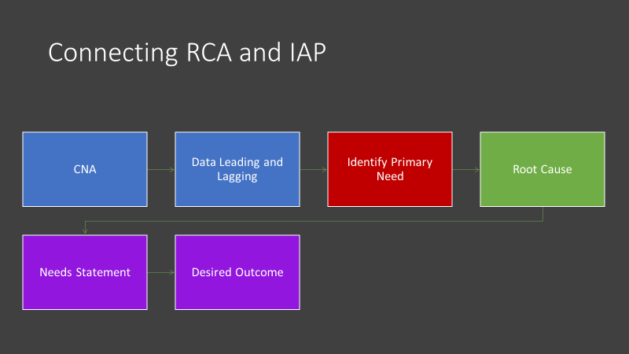
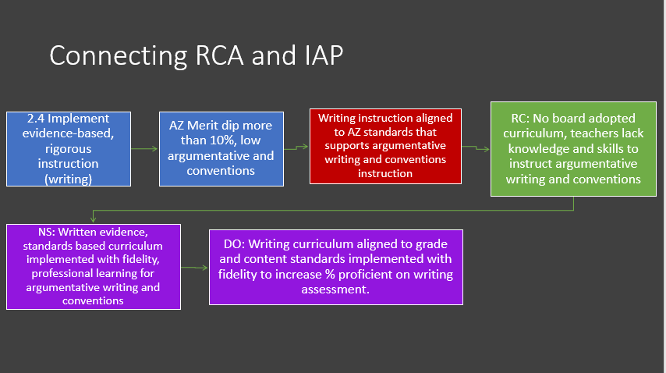
School Integrated Action Plan (SIAP)

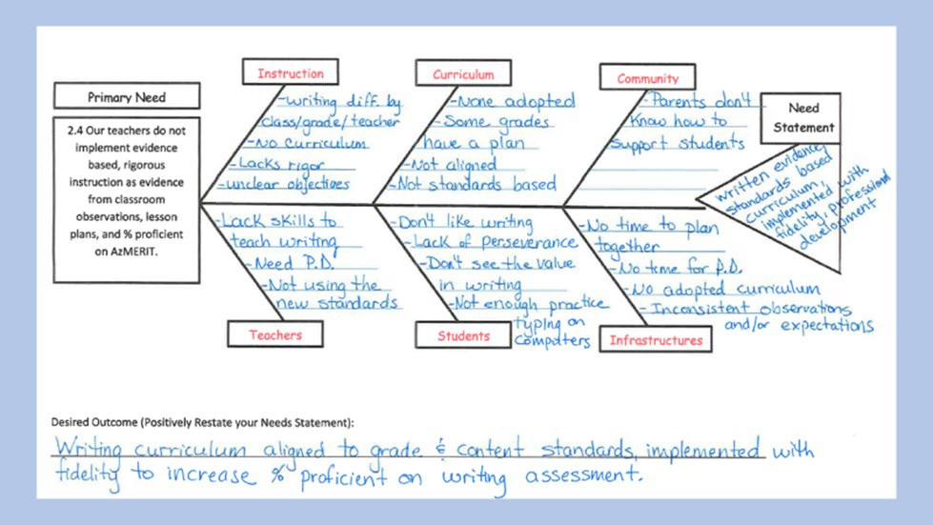
Root Cause: Lack of appropriate writing curriculum

SMART GOALS
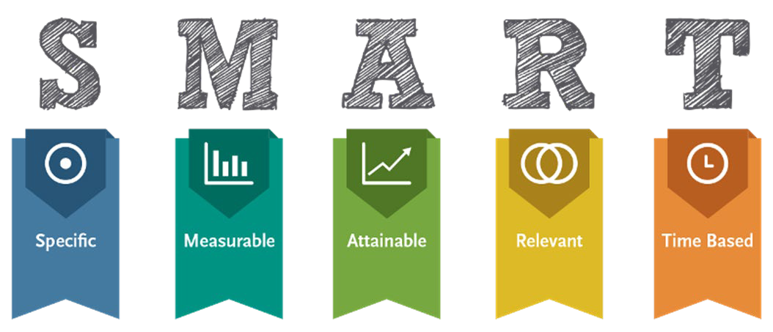

Specific + Strategic: A well-written goal addresses who will do what by when and how the results will be measured.
Measurable: The key concept here is: what gets measured, gets done. How you will measure its accomplishment?
Attainable, but Challenging: Goals that are unrealistic will only serve as a source of frustration for teachers, students, and administrators alike. Goals that are too easy generally won’t affect the kind of change needed to make significant and sustainable improvement. Goals must be attainable yet challenging.
Relevant: In the big picture, goals should link back to the stated educational aims, vision and mission of the school, derived from a careful analysis of data. Specifically, the goals address the primary and needs identified in the CNA.
Time Based: Setting a timeframe for the goal gives it urgency and helps move it to the top of the priority list of everyday activities.

There are two types of goals in the IAP.
- Process goals-implementation of a system or process
  - Committee will research evidence-based math curriculum and make a recommendation by November 1, 2021 as evidenced by written recommendation to Assistant Superintendent.
  - New walkthrough data collection form will be developed and implemented by Jan. 1, 2022 as evidenced by principal walkthrough summaries and feedback session notes.

- Impact goals-to show growth or increased proficiency, increased graduation rate.

- Increased attendance; show impact on student performance
  - Reading achievement for all students will increase by 12% from 10% to 22% proficient and highly proficient as measured by 2022 state assessment.
  - Attendance rate will increase by 15% from 80% to 95% for 2021 school year as evidenced by district demographic data summary report.

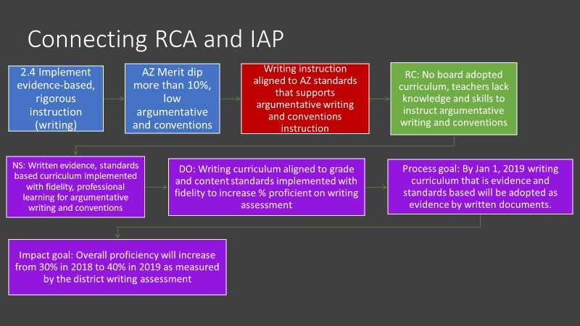

IAP Process:
  - Identify writing team to include all stakeholders
    - Establish group norms or agreements
  - Establish timeline for writing the plan
  - For each identified primary need, enter the need statement and desired outcome under the identified Principle
    - Add SMART goals as needed or required
  - Starting with the identified specific desired outcomes, backward design the evidence- based improvement strategies and action steps
  - Investigate evidence-based programs, strategies or interventions to address each desired outcome
    - Generate list of possibilities
    - Investigate possibilities
    - Select evidence-based strategies
  - Add selected strategy under appropriate principle
  - Develop action steps (using actionable verbs)
    - Implementation action steps
      - Develop clear and comprehensive actionable action steps including who is responsible and the timeline
      - Align resources, funding sources, people and time to action plan
    - Monitoring action steps
      - Determine measures to monitor implementation
        - Collect information to monitor the quality of supports being provided
      - Identify and track progress and performance
        - Consider what additional information is needed to determine if action steps are working
      - Assess the degree to which the implementation plan is being followed with fidelity
      - Is the intervention, strategy, system, or process accomplishing the intended goal/s?
      - Should it be continued, or adjustments made?

- Evaluation action steps
  - Determine measure/s to evaluate success
  - Determine criteria and evidence of success
  - Use the evidence to determine whether the intervention should continue as is, be modified, or be discontinued
  - Were desired outcomes reached?
  - Were SMART goals met?
Ensure coherence and obvious relationships between all need statements, desired outcomes, SMART goals, strategies and action steps.

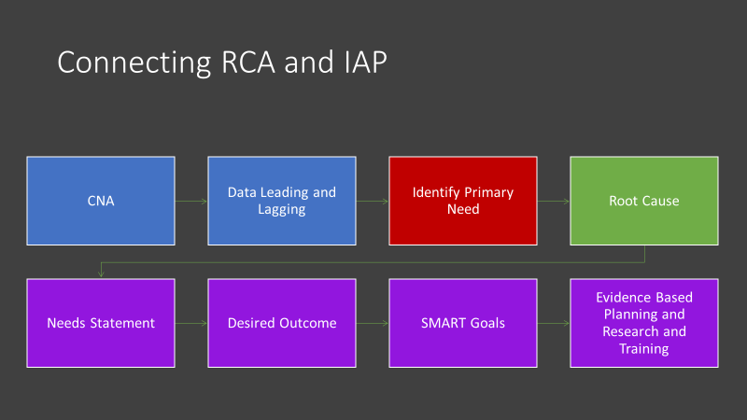

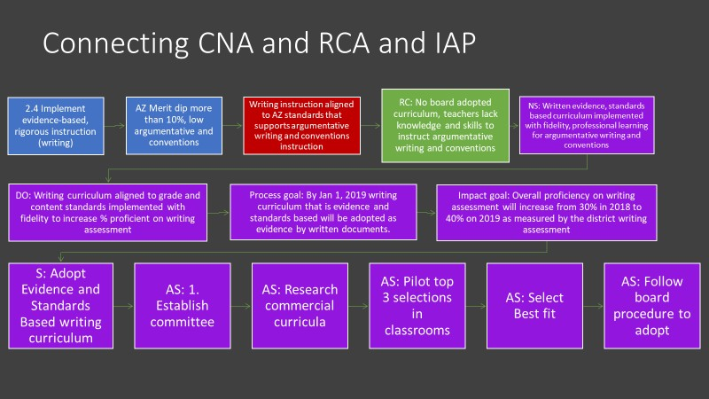

Sample School Site IAP Worksheet
SAMPLE  Primary Need #1 | Primary Need: (head of fishbone)  Strong Math Instruction Aligned to Standards
Root Cause:
No adopted math curriculum
Needs Statement: (tale of fishbone)
Need a written evidence and standards-based math curriculum implemented with fidelity and professionally learning for evidence-based math instruction (4.2, 4.3, 4.5, 2.2, 2.4,
2.6)
Desired Outcome: (Needs statement restated in a positive)
Evidence and standards-based Math curriculum aligned to grade level and content standards, implemented with fidelity to increase math proficiency on state assessment.
SMART Goal: (If the primary need is fixed how will your % proficient be affected?)
Math achievement for all students will increase by 15% moving from 0% proficient or highly proficient on 2019 AzMERIT to 15% proficient or highly proficient on 2021 state assessment.
 | Strategy:  Adopt an evidence and standards- based math curriculum. | Action Steps: (List all your Planning Strategies form your planning worksheet)  - Establish curriculum research committee  - Research available commercial curricula  - Visit schools with top 3 curriculum to view curriculum in action  - Select best fit curriculum  - Follow procedure to select and adopt a standards and evidence-based math curriculum
 | Strategy: Research and implement evidence-based math instruction. | Action Steps: (List all your Planning Strategies form your planning worksheet)  - Establish a committee  - Research different pedagogy and methodologies  - Select strategies to be implemented in all classrooms and/or grade level bands  - Plan PD to support implementation and training of methodologies
 | Strategy: Consistent high-quality professional development and support for all teachers. | Action Steps:  - Provide bi-weekly PD for 60 mins  - Provide bi-weekly planning PD to implement strategies  - Plan and ensure PLC sharing and discussions of resources used, student work and what works instructional strategies  - Plan and implement Peer observations  - Schedule and conduct administrative walk through observations with targeted feedback and teacher action plans
 | Strategy: Monitor Implementation | Action Steps:  - Ensure teacher lesson plans reflect standards-based objectives and evidence-based instructional strategies  - Monitor teacher assessments  - Administrative walk through observation forms  Determine successful completion of action steps on student achievement
 | Strategy: Evaluate Implementation | Action Steps:  Analyze summative assessment data

GME SIAP

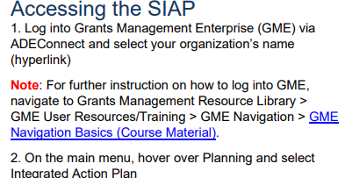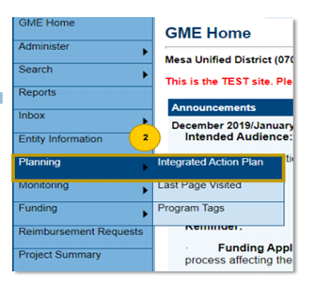

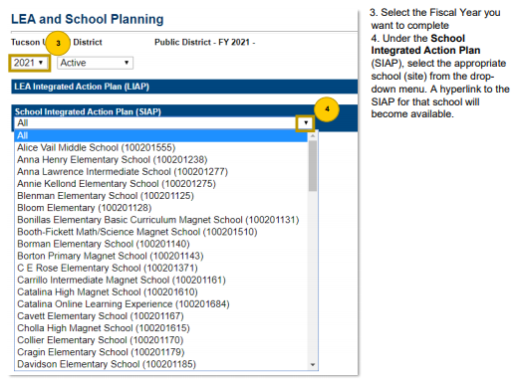
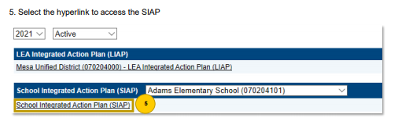

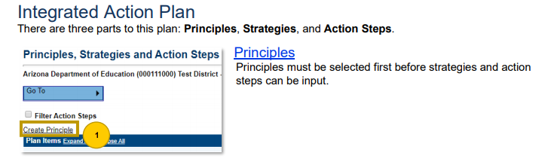
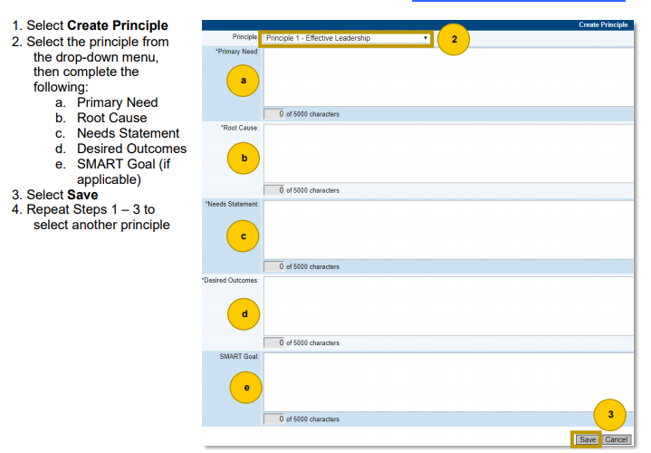
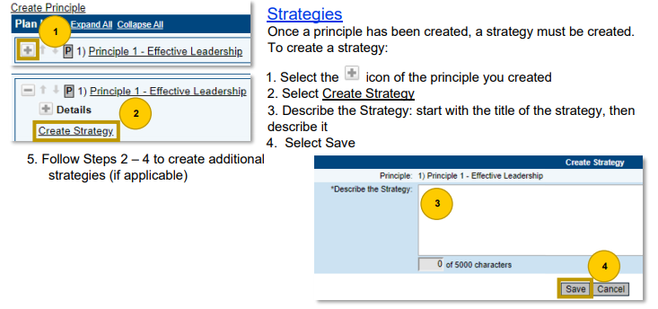

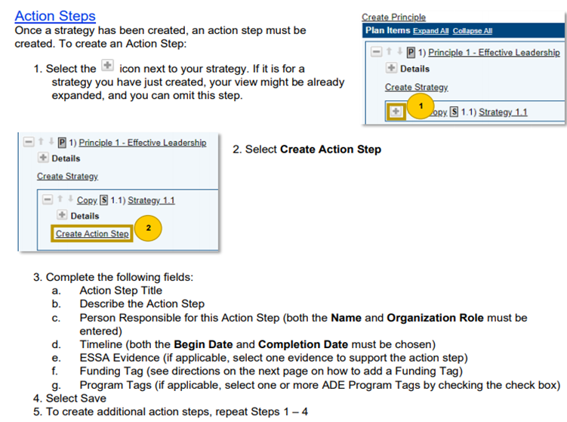

LEA Integrated Action Plan (LIAP)

LEA Integrated Action Plan (Quick Reference Guide)

LEA IAP supports the implementation of the SIAP. The LEA IAP is based on:
- A review of all School CNA results
- Reflective questioning process and discussion
- Identification of evidence-based strategies and action steps to support all school/s successful SIAP implementation.
- Analyze Schools’ Comprehensive Needs Assessment (CNA) data for trends and patterns across schools.

LEA Guiding Questions
- What patterns or trends are evident in student achievement data among the schools?
- What patterns or trends are evident in student and teacher demographic data?
- What patterns or trends are evident in the Leading Indicator data?
- What patterns or trends are evident in the data regarding the 6 Principles?
- What patterns or trends are evident in the primary needs selected by schools to be addressed in school IAPs?
- What specific evidence-based strategies, actions and interventions can the LEA implement to support schools to successfully address identified primary needs and desired outcomes?
- What systems, processes, procedures, operational flexibility can be put in place to support schools in implementation of School Integrated Action Plans?
- How will these actions be monitored and evaluated? Are we doing what we said we would do? Are we doing it well? Is it impacting students learning and achievement? How do we know?

Create an LEA integrated action plan with strategies and action steps that align systems across the LEA to ensure successful school IAP implementation.
- Three or four Need Statements with correlated Desired Outcomes and SMART Goals, if required based on school IAPs trends and necessary support
- Evidence based Strategies
- Evidence based Action Steps (use appropriate tags for required, funded and non- funded activities)
  - Implementation Action Steps
  - Monitoring Action Steps
    - Measures to be used
    - Success Criteria and Evidence
  - Evaluation Action Steps
    - Measures to be used
    - Success Criteria and Evidence

GME LIAP

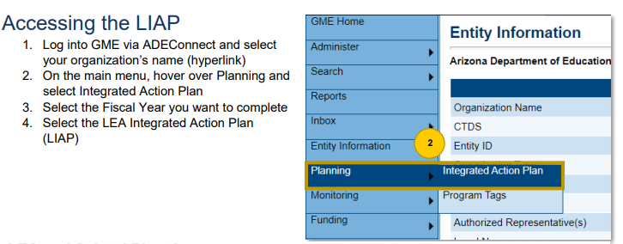

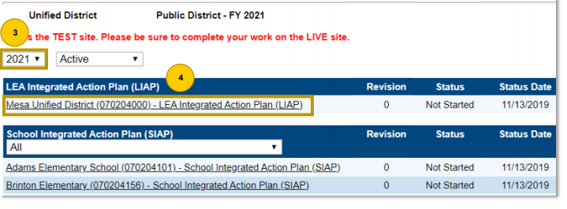

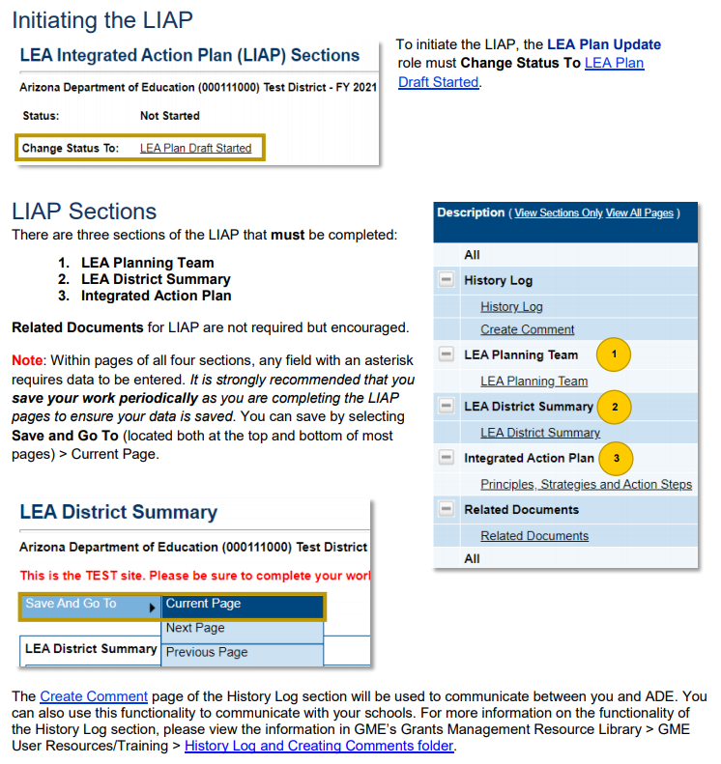
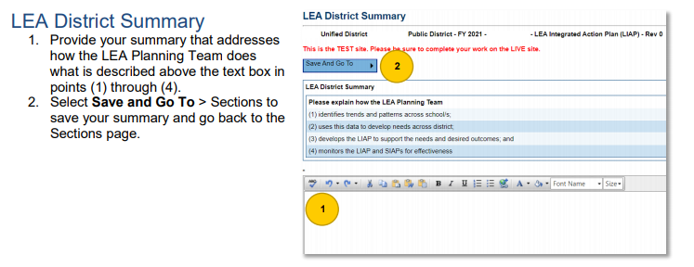

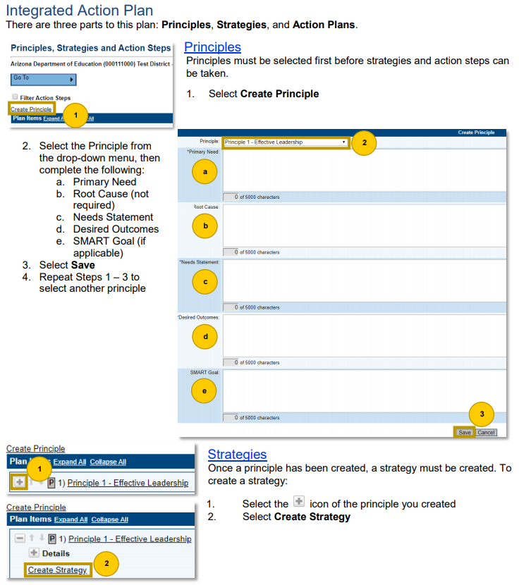
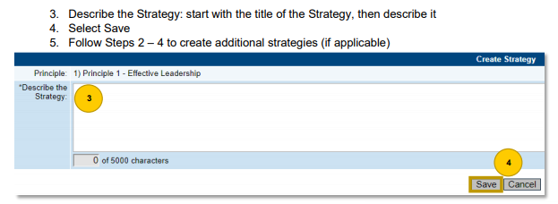

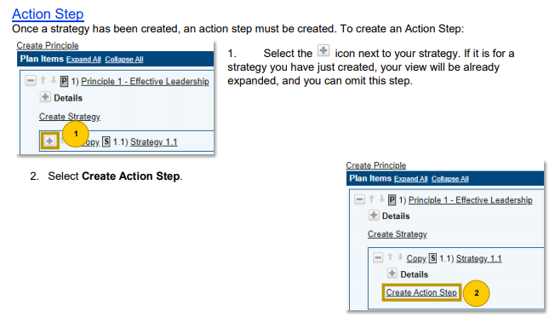

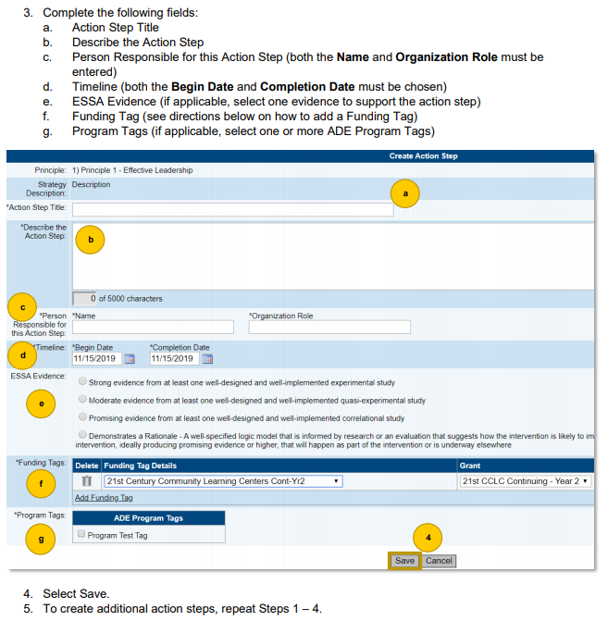

Sample LEA Integrated Action Plan Worksheet
SAMPLE  Primary Need #1 | Primary Need: (head of fishbone)  Strong Math Instruction Aligned to Standards
Schools that Display Primary Need:
Arizona Elementary School, Sunburst Elementary School
Root Cause(s):
No adopted math curriculum
Needs Statement(s): (tale of fishbone)
Need a written evidence and standards-based math curriculum implemented with fidelity and professionally learning for evidence-based math instruction (4.2, 4.3, 4.5, 2.2, 2.4,
2.6)
Desired Outcome: (Needs statement restated in a positive)
Evidence and standards-based Math curriculum aligned to grade level and content standards, implemented with fidelity to increase math proficiency on state assessment.
SMART Goal: (If the primary need is fixed how will your % proficient be affected?)
Math achievement for all students will increase by 10% moving from 0% proficient or highly proficient on 2017 AzMERIT to 10% proficient or highly proficient on 2018 AzMERIT.
 | Strategy:  Support Adoption of an evidence and standards-based math curriculum. | Action Steps: (List all your Planning Strategies form your planning worksheet)  - Help Research Evidence Based Programs for Elementary school  - Help facilitate the ordering of sample materials  - Meet with Curriculum Adoption Committee  - Help complete Curriculum Rubrics
 | Strategy:  Support Research and implement evidence-based math instruction. | Action Steps: (List all your Planning Strategies form your planning worksheet)  - Help Research Evidence Based PD strategies to support math PD  - Work with Site Principals to create a calendar to roll out implementation

 | Strategy:  Support Consistent high-quality professional development and support for all teachers. | Action Steps: (List all your Planning Strategies form your planning worksheet)  - Support sites with funds to conduct peer observations  - Schedule and conduct meetings with site principals to review walkthrough observations and action plans  - Attend site PDs to show support for the initiatives
 | Strategy: Monitor Implementation | Action Steps:  - Monitor site data (benchmarks/interims)  - Schedule and conduct walkthroughs to see curriculum in action
SAMPLE  Primary Need #2 | Primary Need: (head of fishbone)  Parent and Community Involvement
Schools that Display Primary Need:
Dream Big Middle School, Hope Middle School
Root Cause(s):
Not enough opportunities for parent and community involvement
Needs Statement(s): (tale of fishbone)
Need to provide opportunities for the parents and community to get involved in the school (1.4, 2.7, 5.2, 5.5, 6.1, 6.2, 6.3, )
Desired Outcome: (Needs statement restated in a positive)
Provide multiple opportunities for the parents and community to get involved to promote collaboration and increase student achievement
SMART Goal: (If the primary need is fixed how will your % proficient be affected?)
Increase parent and community involvement by 20% moving from 48% on the 2018 parent satisfaction survey to 68% on the 2019 parent satisfaction survey.
 | Strategy:  Create a volunteer program for parents and community. | Action Steps: (List all your Planning Strategies form your planning worksheet)  - Hold fingerprinting at each site to facilitate volunteers  - Provide substitutes for sites so admin/teachers can train volunteers once a quarter  - Create a district volunteer guide to support volunteer training
 | Strategy: Increase communication with community | Action Steps: (List all your Planning Strategies form your planning worksheet)  - Help Research local community partnerships with site principals

 | Strategy: Support site with parent and community involvement. | Action Steps: (List all your Planning Strategies form your planning worksheet)  - Attend community events to support schools’ sites with initiative  - Have Public Relations Person go to sites to photograph events and volunteers.  - Add photos and highlight on volunteer programs on district website
 | Strategy: Monitor Implementation | Action Steps:  - Monitor sign in sheets and training  - Review parent survey data and meet with site leadership

Appendices

Appendix A CNA Rubric (full details)

Principle 1 Effective Leadership
Effective leaders maintain strong professional ethics and integrity to shape a vision of academic success and schoolwide social emotional learning that leads to equitable access for all students. They analyze and attack challenges and manage systems to position the school and students to achieve at high levels. They set clear, measurable and attainable goals. They create a cadre of high-quality teachers and cultivate leadership in others.

Indicator 1.1 Our leadership guides the implementation of a vision of academic success and social emotional learning that leads to equitable access which is shared and supported by all stakeholders.
Output: Students believe that all staff and students share a vision of learning and is reflected in staff and student attitudes and behaviors.

Choose the statement within each element which best matches your school.
Rating | 0 | 1 | 2 | 3
Element A  How did leadership develop the vision of academic success and schoolwide social emotional learning? | There is no vision of academic success and schoolwide social emotional learning | Leadership developed the vision of academic success and schoolwide social emotional learning in isolation with little or no data | Leadership developed the vision of academic success and schoolwide social emotional learning with some of the stakeholders using some data | Leadership developed the vision of academic success and schoolwide social emotional learning collaboratively with the professional staff and the community using quantitative and qualitative data to inform the process
Element B  How often is the vision of learning used to guide the policies/procedures and decisions of the school? | The vision of academic success and schoolwide social emotional learning is not used to guide the policies/procedures and decisions of the school, or there is no vision of learning | The vision of academic success and schoolwide social emotional learning is infrequently used to guide the policies/procedures and decisions of the school | The vision of academic success and schoolwide social emotional learning is sometimes used to guide the policies/procedures and decisions of the school | The vision of academic success and schoolwide social emotional learning is consistently used to guide the policies/procedures and decisions of the school

Rating | 0 | 1 | 2 | 3
Element C  How often is the vision of learning reviewed and revised to reflect the current school community? | The vision of academic success and schoolwide social emotional learning is old and has never been reviewed and amended to reflect the school community, or it does not reflect the school community | The vision of academic success and schoolwide social emotional learning has not been recently reviewed and revised to reflect the school community | The vision of academic success and schoolwide social emotional learning is reviewed and revised every two or three years to reflect the school community | The vision of academic success and schoolwide social emotional learning is reviewed and revised annually to reflect the current school community
Element D  Are diversity, inclusion and equity included in the school’s mission? | Diversity, inclusion and equity are not included in larger efforts that focus on the core mission | While diversity, inclusion and equity complement many aspects of the mission, they remain on the periphery of the school. Diversity, inclusion and equity are rarely included in larger efforts that focus on the core mission | Diversity, inclusion and equity are often discussed as a priority, but are not included in the school’s official mission or strategic plan | Diversity, inclusion and equity are a top priority and are included in the school’s official mission and/or strategic plan

Indicator 1.2 Our leadership commits to sustaining a culture of high expectations for academic learning and social emotional growth of all students within a respectful, professional learning community for all staff.

Output: High student academic achievement and growth demonstrate a commitment of all staff and students to high expectations.

Choose the statement within each element which best matches your school.
Rating | 0 | 1 | 2 | 3
Element A  Are high expectations for learning and growth of all students reflected in clear, measurable goals, policies/procedures and all decisions, based on all available data? | High expectations for academic learning and social emotional growth of all students are not reflected in clear, measurable goals, policies/procedures and decisions | High expectations for academic learning and social emotional growth of students are reflected in some policies/procedures and some decisions. Goals are not always clear, measurable or based on data | High expectations for academic learning and social emotional growth of all students are reflected in some clear, measurable goals, some policies/procedures and some decisions, based on some available data | High expectations for academic learning and social emotional growth of all students are reflected in clear, measurable goals, policies/procedures and all decisions, based on all available data

Rating | 0 | 1 | 2 | 3
Element B  Does leadership create opportunities for professional growth for all staff members based on walk-through data, formal evaluations and/or self-reflection, that allow all staff to improve their teaching craft and encourage the development of leadership skills? | Leadership has not yet provided opportunities for professional growth for all staff members | Leadership provides opportunities for professional growth for all staff members, but it is one size fits all | The leadership creates some opportunities for professional growth for all staff members, based on walk through data, formal evaluations and/or self-reflection, that allow all staff to improve their teaching craft and encourage the development of leadership skills | The leadership creates many opportunities for professional growth for all staff members, based on walk-through data, formal evaluations and/or self-reflection, that allow all staff to improve their teaching craft and encourage the development of leadership skills
Element C  Does leadership provide opportunities for staff to reflect on and develop their own social, emotional and cultural competencies including activities to support staff in practicing self-care and examining their mindsets and biases, and does the leadership team regularly review data related to adult SEL and cultural competence to plan ongoing support? | Leadership has not yet provided opportunities for staff to reflect on and develop their own social, emotional, and cultural competencies | Leadership provides meaningful opportunities for staff to reflect on and develop their own social, emotional, and cultural competencies at least once per year | Leadership provides meaningful opportunities for staff to reflect on and develop their own social, emotional, and cultural competencies multiple times throughout the year. These opportunities include structured activities that support staff in practicing self-care and examining their mindsets and biases. | Leadership provides meaningful opportunities for staff to reflect on and develop their own social, emotional, and cultural competencies which are built into regular staff meetings and part of the school’s overall professional learning strategy. These opportunities include structured activities to support staff in practicing self-care and examining their mindsets and biases. The leadership team regularly reviews data related to adult SEL and cultural competence to plan ongoing support.
Rating | 0 | 1 | 2 | 3
Element D  Does leadership and staff regularly model social, emotional, and cultural competencies in their language and interactions with other staff, students, families, and community partners, and has the leadership team built supportive relationships with staff and regularly acknowledge staff efforts and contributions? | Leadership and/or staff have not yet prioritized modeling social, emotional, and cultural competencies in their interactions | The leadership team is developing an approach to support leadership and staff in modeling social, emotional, and cultural competencies in their language and interactions with other staff, students, families, and community partners | Leadership and staff regularly model social, emotional, and cultural competencies in their language and interactions with most staff, students, families, and community partners. Staff efforts and contributions are sometimes acknowledged. | Leadership and staff regularly model social, emotional, and cultural competencies in their language and interactions with other staff, students, families, and community partners. The leadership team has built supportive relationships with staff and regularly acknowledge staff efforts and contributions.
Element E  Are policies/procedures written to allow teachers both individual and collaborative time to use data and plan to meet student learning goals, cultivating mutual respect and collegiality among staff? | Policies/procedures are not written to allow teachers both individual and collaborative time to use data and plan to meet student learning goals, cultivating mutual respect and collegiality among staff | Policies/procedures are written to allow teachers individual or collaborative time to use data and plan to meet student learning goals, cultivating mutual respect and collegiality among staff | Policies/procedures are written to allow teachers individual or collaborative time, bi- weekly, to use data and plan to meet student learning goals, cultivating mutual respect and collegiality among staff | Policies/procedures are written to allow teachers both individual and collaborative time weekly, to use data and plan to meet student learning goals, cultivating mutual respect and collegiality among staff
Element F  Does leadership know federal and state requirements and the necessary support for teaching special populations? | Leadership does not know federal and state requirements and the support necessary for subgroup populations | Leadership knows some federal and state requirements and the necessary support for teaching subgroup populations | Leadership knows most federal and state requirements and the necessary support for teaching subgroup populations | Leadership knows federal and state requirements and the necessary support for teaching subgroup populations

Indicator 1.3 Our leadership competently manages school operations to provide a safe, inclusive and effective learning environment.
Output: Students believe that the school environment is psychologically, physically, and academically safe.

Choose the statement within each element which best matches your school.
Rating | 0 | 1 | 2 | 3
Element A  Does the leadership identify resources to meet the academic, social and emotional needs of students and adults in the school to prevent or respond when events threaten to disrupt the learning environment? | The leadership does not identify minimal resources to meet the academic, social and emotional needs of students and adults in the school to prevent or respond when events threaten to disrupt the learning environment | The leadership identifies minimal resources to meet the academic, social and emotional needs of students and adults in the school to prevent or respond when events threaten to disrupt the learning environment | The leadership identifies sufficient resources to meet the academic, social and emotional needs of students and adults in the school to prevent or respond when events threaten to disrupt the learning environment | The leadership identifies multiple resources to meet the academic, social and emotional needs of students and adults in the school to prevent or respond when events threaten to disrupt the learning environment
Element B  Are school buildings, equipment, and furnishings designed and maintained for the optimal safety of every-one who uses them? | Maintenance is severely lacking and there are safety concerns | Maintenance of school buildings, equipment, and furnishings are lacking | Some school building, equipment, and furnishings are designed and maintained for the optimal safety of everyone who uses them | All school buildings, equipment, and furnishings are designed and maintained for the optimal safety of everyone who uses them
Element C  Are the school safety and emergency preparedness plans current, disseminated to all, subject to regular review and amendment, and practiced regularly? | There are no safety plans | The school safety and emergency preparedness plans are not current, disseminated, or subject to regular review and amendment, or practiced | The school safety and emergency preparedness plans are current and disseminated, but are not reviewed regularly and/or practiced | The school safety and emergency preparedness plans are current, disseminated to all, subject to regular review and amendment, and practiced regularly

Indicator 1.4 Our leadership collaborates with staff, family and community members to meet diverse local community interests and needs.
Output: Students, family, and community are actively involved as partners with the school.

Choose the statement within each element which best matches your school.
Rating | 0 | 1 | 2 | 3
Element A  Are the leadership and staff deeply knowledgeable about students’ experiences, cultural backgrounds, and the local community context, and do school leadership, staff, students, families, and community members work in partnership to develop practices and make decisions that create a more inclusive and equitable school community? | Leadership and staff are not yet familiar with their students’ cultural backgrounds, life circumstances, or the local community context. | Leadership and staff are familiar with most of their students’ cultural backgrounds, life circumstances, and the local community context. | Leadership and staff are using their knowledge of students’ cultural backgrounds, life circumstances, and the local community context to inform their actions and create a more inclusive and equitable school community. | Leadership and staff are deeply knowledgeable about students’ experiences, cultural backgrounds, and the local community context. School leadership, staff, students, families, and community members work in partnership to develop practices and make decisions that create a more inclusive and equitable school community.
Element B  How does the leadership collect and review data about community interests and needs as well as the environment in which the local school resides? | The leadership does not collect or review data about community interests and needs as well as the environment in which the local school resides | The leadership collects but does not review data about community interests and needs as well as the environment in which the local school resides | The leadership collects and reviews some data about community interests and needs as well as the environment in which the local school resides | The leadership systematically collects and reviews data about community interests and needs as well as the environment in which the local school resides
Rating | 0 | 1 | 2 | 3
Element C  Does the leadership provide meaningful, formal and informal opportunities for families and community members to interact with the school? | The leadership does not provide formal or informal opportunities for families and community members to interact with the school | The leadership provides minimal meaningful, formal or informal opportunities for families and community members to interact with the school | The leadership provides meaningful, formal and informal opportunities for families and community members to interact with the school | The leadership provides numerous meaningful, formal and informal opportunities for families and community members to interact with the school
Element D  How often does the leadership regularly share data through various family-friendly venues? | The leadership does not share data through various family-friendly venues | The leadership rarely shares data through various family-friendly venues | The leadership sometimes shares data through various family- friendly venues | The leadership regularly shares data through various family-friendly venues
Element E  Does the leadership develop and use a wide variety of communication strategies to encourage collaboration among the diverse members of the community? | The leadership does not use a variety of communication strategies to encourage collaboration among the diverse members of the community | The leadership develops and uses minimal communication strategies to encourage collaboration among the diverse members of the community | The leadership develops and uses some communication strategies to encourage collaboration among the diverse members of the community | The leadership develops and uses a wide variety of communication strategies to encourage collaboration among the diverse members of the community

Indicator 1.5 Our leadership implements a system of academic and fiscal accountability to ensure every student’s success.
Output: High student academic achievement and growth indicate a strong integrated infrastructure supporting every student’s success.

Choose the statement within each element which best matches your school.
Rating | 0 | 1 | 2 | 3
Element A  Does the leadership effectively balance administrative tasks and instructional leadership responsibilities? | The leadership does not balance administrative tasks and instructional leadership responsibilities | The leadership attempts to balances administrative tasks and instructional leadership responsibilities | The leadership sometimes balances administrative tasks and instructional leadership responsibilities | The leadership effectively balances administrative tasks and instructional leadership responsibilities
Element B  Does the principal maintain oversight of fiscal resources? | There is inadequate oversight of fiscal resources | The principal maintains oversight of fiscal resources, with no input | The principal maintains oversight of fiscal resources, with some input | The principal, with the leadership team, maintains oversight of fiscal resources
Element C  Does the leadership team use a robust data-based decision-making process to evaluate school needs including sufficient time for staff input into the whole process? | The leadership team does not use a data- based decision-making process to evaluate needs of the school | Using a data-based decision-making process, the leadership team evaluates needs of the school without staff input | Using a data-based decision-making process, the leadership team evaluates needs of the school with some time for staff input into the whole process | Using a robust data-based decision-making process, the leadership team evaluates school needs and include sufficient time for staff input into the whole process

Rating | 0 | 1 | 2 | 3
Element D  Does our LEA and/or school provide access to a student information system containing sufficient data to make informed decisions, such as behavioral, SEL, attendance, EL, IEP, dropout, graduation rate, formative assessments, district interim/ benchmark, classroom summative assessments, health and academic screenings, diagnostic tests, end of course assessments, state assessments, course enrollment, program participation and schedules as well as teacher observations, and student reflection? | Our LEA and/or school does not have or provide access to a student information system | Our LEA and/or school provides a student information system containing limited data and/or it is not provided in a timely way | Our LEA and/or school provides access to a student information system containing some of the data sources, but not in real time | Our LEA and/or school provides real time access to a student information system containing sufficient data to make informed decisions such as behavioral, SEL, attendance, EL, IEP, dropout, graduation rate, formative assessments, district interim/benchmark, classroom summative assessments, health and academic screenings, diagnostic tests, end of course assessments, state assessments, course enrollment, program participation and schedules as well as teacher observations, and student reflection

Rating | 0 | 1 | 2 | 3
Element E  Does leadership demonstrate the value and use of data; leading a data-driven, collaborative culture; supporting teachers in overcoming the barriers to effective data use; ensuring that instructional staff has the understanding, training and ability to access the school’s data systems and tools to develop learning goals or targets and track progress for each student throughout the year? | Data is not a priority at our school yet | Leadership makes an attempt to demonstrate the value and use of data; but does not ensure that the instructional staff has the understanding, training and ability to access the school’s data systems and tools to goals or targets and track progress for each student throughout the year | Leadership demonstrates the value and use of data; and is starting to develop a data-driven, collaborative culture; supporting teachers in overcoming the barriers to effective data use; makes an attempt to ensure that instructional staff has the understanding, training and ability to access the school’s data systems and tools to develop learning goals or targets and track progress for each student throughout the year | Leadership demonstrates the value and use of data; leading a data-driven, collaborative culture; supporting teachers in overcoming the barriers to effective data use; ensuring that instructional staff has the understanding, training and ability to access the school’s data systems and tools to develop learning goals or targets and track progress for each student throughout the year

Rating | 0 | 1 | 2 | 3
Element F  Is the school calendar established and acknowledged by the LEA, before the school year begins, with a detailed data plan that includes: professional development, assessment administration dates, and scheduled data meetings to analyze, interpret, and discuss proper utilization of the data results to plan instruction? | School data calendar is not developed before school begins | An attempt is made to establish a school data calendar, but changes are often required by the LEA | Before the school year begins, a school calendar is established and acknowledged by the LEA including some but not all of the following: professional development, assessment administration dates, and scheduled data meetings to analyze, interpret, and discuss proper utilization of the data results to plan instruction | Before the school year begins, a school calendar is established and acknowledged by the LEA with a detailed data plan that includes professional development, assessment administration dates, and scheduled data meetings to analyze, interpret, and discuss proper utilization of the data results to plan instruction
Element G  Does the leadership ensure that there is a continuum of supports that meet the academic, social, emotional, and behavioral needs of all students and has accountability practices to monitor the supports? | There is not a continuum of supports that meet the academic, social, emotional, and behavioral needs of all students | The leadership is in the process of developing a continuum of supports that meet the academic, social, emotional, and behavioral needs of all students | The leadership expects that there is a continuum of supports that meet the academic, social, emotional, and behavioral needs of all students, but does not ensure it | The leadership ensures that there is a continuum of supports that meet the academic, social, emotional, and behavioral needs of all students and has accountability practices to monitor the supports
Element H  Are practices in place, to facilitate frequent, ongoing data-driven conversations related to student learning with all stakeholders? | Practices are not in place to facilitate ongoing data-driven conversations related to student learning | Inconsistent practices are used to facilitate data-driven conversations related to student learning with all stakeholders | Practices are in place to facilitate data-driven conversations related to student learning with all stakeholders | Evidence-based practices are in place to facilitate frequent, ongoing data- driven conversations related to student learning with all stakeholders

Indicator 1.6 Our leadership commits to recruiting effective teachers who meet the state’s criteria for being appropriately certified to teach diverse learners.
Output: Students’ diverse needs are being met by appropriately certified and effective teachers in every classroom.

Choose the statement within each element which best matches your school.
Rating | 0 | 1 | 2 | 3
Element A  Does the LEA and/or school leadership have a recruitment plan in place and follow it to actively recruit a diverse workforce of appropriately certified teachers? | The LEA and/or school leadership does not have a recruitment plan in place | The LEA and/or school leadership has a recruitment plan in place but doesn't follow it | The LEA and/or school leadership has a recruitment plan in place but doesn't always follow it to actively recruit a diverse workforce of teachers for vacant positions | The LEA and/or school leadership has a recruitment plan in place and follows it to actively recruit a diverse workforce of appropriately certified teachers
Element B  Does the LEA and/or school leadership have a recruitment plan in place and follow it to actively recruit teachers to meet the needs of diverse learners? | The LEA and/or school leadership does not have a recruitment plan in place | The LEA and/or school leadership has a recruitment plan in place but doesn't follow it | The LEA and/or school leadership has a recruitment plan in place but doesn't always follow it to recruit teachers to meet the needs of diverse learners | The LEA and/or school leadership has a recruitment plan in place and follows it to actively recruit teachers to meet the needs of diverse learners
Element C  Does the LEA and/or school leadership have a recruitment plan in place to actively recruit effective teachers as defined by the Arizona Framework for Measuring Educator Effectiveness? | The LEA and/or school leadership does not have a recruitment plan in place | The LEA and/or school leadership has a recruitment plan in place but doesn't follow it | The LEA and/or school leadership has a recruitment plan in place but doesn't always follow it to actively recruit effective teachers as defined by the Arizona Framework for Measuring Educator Effectiveness | The LEA and/or school leadership has a recruitment plan in place and follows it to actively recruit effective teachers as defined by the Arizona Framework for Measuring Educator Effectiveness

Indicator 1.7 Our leadership commits to retaining effective teachers who meet the state’s criteria for being appropriately certified to teach diverse learners.
Output: Students’ diverse needs are being met by appropriately certified and effective “continuing” teachers in every classroom.

Choose the statement within each element which best matches your school.
Rating | 0 | 1 | 2 | 3
Element A  Does the LEA and/or school leadership have a retention plan in place and follow it to actively retain a diverse workforce of appropriately certified teachers? | The LEA and/or school leadership does not have a retention plan in place | The LEA and/or school leadership has a retention plan in place but doesn't follow it | The LEA and/or school leadership has a retention plan in place but doesn't always follow it to actively retain a diverse workforce of appropriately certified teachers | The LEA and/or school leadership has a retention plan in place and follows it to actively retain a diverse workforce of appropriately certified teachers
Element B  Does the LEA and/or school leadership have a plan in place to actively retain teachers to meet the needs of diverse learners? | The LEA and/or school leadership does not have a retention plan in place | The LEA and/or school leadership has a retention plan in place but doesn't follow it | The LEA and/or school leadership has a retention plan in place but doesn't always follow it to actively retain teachers to meet the needs of diverse learners. | The LEA and/or school leadership has a retention plan in place and follows it to actively retain teachers to meet the needs of diverse learners.
Element C  Does the LEA and/or school leadership have a plan in place to actively retain effective teachers as defined by the Arizona Framework for Measuring Educator Effectiveness? | The LEA and/or school leadership does not have a retention plan in place | The LEA and/or school leadership has a retention plan in place but doesn't follow it | The LEA and/or school leadership has a retention plan in place but doesn't always follow it to retain effective teachers as defined by the Arizona Framework for Measuring Educator Effectiveness | The LEA and/or school leadership has a retention plan in place and follows it to retain effective teachers as defined by the Arizona Framework for Measuring Educator Effectiveness

Indicator 1.8 Our leadership commits to equitably distributing effective and highly effective teachers, as defined by the Arizona Framework for Measuring Educator Effectiveness, among all schools to meet the needs of diverse learners.
Output: Students of color, students economically disadvantaged and students with special needs are not taught by inexperienced, unqualified, or ineffective educators at higher rates than students outside those demographics.

Choose the statement within each element which best matches your school.
Rating | 0 | 1 | 2 | 3
Element A  Does the LEA and/or school leadership have a plan in place and follow it to equitably distribute effective and highly effective teachers to meet the needs of diverse learners? | The LEA and/or school leadership does not have a plan in place | The LEA and/or school leadership has a plan in place but doesn't follow it | The LEA and/or school leadership has a plan in place but doesn't always follow it to equitably distribute effective and highly effective teachers to meet the needs of diverse learners | The LEA and/or school leadership has a plan in place and follows it to equitably distribute effective and highly effective teachers to meet the needs of diverse learners

Indicator 1.9 Our leadership commits to drive continuous improvement.
Output: All students benefit from data driven decision making through improved programs impacting classrooms, schools and communities.

Choose the statement within each element which best matches your school.
Rating | 0 | 1 | 2 | 3
Element A  Does the leadership team use a structured, ongoing process to collect, reflect on, and use implementation and outcome data to inform school level decisions during each meeting, and is the team empowered to lead staff in this process by regularly (at least quarterly) communicating their findings and creating opportunities to use data to drive continuous improvement at the school, classroom, family, and community level? | The leadership team has not yet developed a structured and ongoing process to collect, reflect on, and use data to inform school-level decisions. | The leadership team is in the early stages of developing a structured and ongoing process to collect, reflect on, and use data to inform school-level decisions. | The leadership team has a structured, ongoing process to collect, reflect on, and use data to inform school level decisions. This process is used at strategic times (e.g., the beginning and end of each year), but does not yet happen consistently at each team meeting. The team communicates with and includes staff in this process on an annual basis. | The leadership team uses a structured, ongoing process to collect, reflect on, and use implementation and outcome data to inform school level decisions during each meeting. The team is empowered to lead staff in this process by regularly (at least quarterly) communicating their findings and creating opportunities to use data to drive continuous improvement at the school, classroom, family, and community level.
Element B  Does the leadership team use a full range of implementation data and disaggregated outcome data to track progress toward school goals and monitor outcome, and is staff highly skilled at data reflection and planning and has dedicated time and resources to engage meaningfully in regular cycles of continuous improvement? | The leadership team does not yet use implementation data and disaggregated outcome data to track progress toward school goals and monitor outcomes. Staff do not yet have the time and skills necessary to engage in cycles of continuous improvement. | The leadership team has begun to use some implementation and disaggregated outcome data to track progress toward school goals and monitor outcomes. Staff are developing the skills necessary to engage in cycles of continuous improvement. | The leadership team uses a full range of implementation and disaggregated outcome data to track progress toward school goals and monitor outcomes. Staff have the time and skills necessary to engage in cycles of continuous improvement. | The leadership team uses a full range of implementation data and disaggregated outcome data to track progress toward school goals and monitor outcomes. Staff are highly skilled at data reflection and planning and have dedicated time and resources to engage meaningfully in regular cycles of continuous improvement.

Principle 1 Effective Leadership Data/Evidence
1.1
Written vision, mission and core belief statements
Meeting notes/minutes from stakeholder meetings
Meeting notes/minutes from staff meetings
Evidence of vision, mission and core beliefs posted in office areas and classrooms

1.2
Meeting notes/minutes from Leadership Team meetings
Evidence of vision, mission and core beliefs posted in office areas and classrooms
Meeting notes/minutes from Leadership Team meetings
Meeting notes/minutes from staff meetings
Integrated action plans
PLC notes
School calendar
Staff and stakeholder surveys
Classroom observations
Classroom environment audits for evidence of high expectations for academic and social emotional learning
Data dashboard or other evidence that data is shared in timely and useable format
Lesson plans (high expectations, data informed instruction, goals…)
School calendar
Student data books, notes, wall, other system for ongoing use of data
Professional Learning calendar
Schedules, daily, weekly
Compliance with state and Federal regulations
1.3
Procedures and plans relative to emergency preparedness,
Site audit of facilities, equipment, furniture and resources
School wide MTSS plan
Behavioral referral data
1.4
Family involvement activity calendar
Meeting notes/minutes from Stakeholder meetings
Meeting notes/minutes from Leadership Team meetings
Meeting notes/minutes from staff meetings
1.5
Assessment audit
Balanced assessment system
Assessment calendar
Intervention calendar
Intervention implementation plan
Data decision making model
Data dashboard or other evidence that data is shared in timely and useable format
Conversation notes
Schoolwide budget tracking sheet
1.6
Recruitment plans
Hiring protocols and procedures
Hiring records

1.7
Written retention plan
Teacher evaluations
Evidence of appropriate certification
1.8
Written equitable distribution plan
Teacher evaluations
1.9
Site leadership meeting notes and agendas
Policy or procedures for continuous improvement
Data cycle documents

Principle 2 Effective Teachers and Instruction
Effective instruction occurs with quality teaching in a student-centered, safe environment where there are high expectations for all students to succeed. Teachers have a solid knowledge of the content they teach and a common understanding of the content standards and curricula. Effective teachers intentionally plan, emphasize evidence-based practices in their lessons, and utilize a balanced assessment system to make instructional decisions for all students.
Indicator 2.1 Our teachers maintain high academic, behavioral and social emotional learning expectations for all students.
Output: Students are self-sufficient learners within a safe, supportive, and collaborative environment.

Choose the statement within each element which best matches your school.

Rating | 0 | 1 | 2 | 3
Element A  How many teachers' commitments and actions demonstrate high expectations for all learners? | Teachers' commitments and actions do not demonstrate high expectations for all learners | Few teachers' commitments and actions demonstrate high expectations for all learners | Some teachers' commitments and actions demonstrate high expectations for all learners | All teachers' commitments and actions demonstrate high expectations for all learners
Element B  How many teachers establish goals and high expectations for all student learning in all content areas, including goals for closing achievement gaps, when applicable? | Teachers do not establish goals and high expectations for  all student learning in all content areas, including goals for closing achievement gaps, when applicable | Few teachers establish goals and high expectations for  all student learning in all content areas, including goals for closing achievement gaps, when applicable | Some teachers establish goals and high expectations for  all student learning in all content areas, including goals for closing achievement gaps, when applicable | All teachers establish goals and high expectations for  all student learning in all content areas, including goals for closing achievement gaps, when applicable
Element C  Do teachers plan rigorous instruction? | Teachers do not plan rigorous instruction in all classrooms | Teachers plan rigorous instruction in just a few classrooms | Teachers plan rigorous instruction in some classrooms | Teachers plan rigorous instruction in all classrooms

Element D  Is there classroom evidence of data use informing instruction? | Evidence of data use that informs instruction is not present | Evidence of data use that informs instruction is present in just a few classrooms | Evidence of data use that informs instruction is present in some classrooms | Evidence of data use that informs instruction is present in all classrooms
Element E  Do teachers monitor evidence of student learning and well-being to determine if sufficient progress is being achieved and make any necessary adjustments? | Teachers do not monitor evidence of student learning and well-being to determine if sufficient progress is being achieved and make any necessary adjustments | Few teachers monitor evidence of student learning and well-being to determine if sufficient progress is being achieved and make any necessary adjustments | Some teachers monitor evidence of student learning and well-being to determine if sufficient progress is being achieved and make any necessary adjustments | All teachers monitor evidence of student learning and well-being to determine if sufficient progress is being achieved and make any necessary adjustments
Element F  Do teachers purposefully and intentionally use MTSS principles to create an environment that empowers all students to be successful in their learning and reach expected levels of achievement? | Teachers do not purposefully and intentionally create an environment that empowers all students to be successful in their learning and reach expected levels of achievement | Very few teachers purposefully and intentionally create an environment that empowers all students to be successful in their learning and reach expected levels of achievement | Some teachers purposefully and intentionally create an environment that empowers all students to be successful in their learning and reach expected levels of achievement | All teachers purposefully and intentionally create an environment that empowers all students to be successful in their learning and reach expected levels of achievement
Element G  Do teachers create a classroom environment where students hold themselves accountable for their individual learning? | Teachers do not create a classroom environment where students hold themselves accountable for their individual learning | Very few teachers create a classroom environment where students hold themselves accountable for their individual learning | Some teachers create a classroom environment where students hold themselves accountable for their individual learning | All teachers create a classroom environment where students hold themselves accountable for their individual learning

Indicator 2.2 Our teachers have shared knowledge of the content standards, curricula and social emotional learning practices.
Output: Every student receives the same guaranteed and viable curriculum, aligned to state standards.

Choose the statement within each element which best matches your school.
Rating | 0 | 1 | 2 | 3
Element A  Is depth of knowledge evident in lessons? | Depth of knowledge of content areas is not evident | Knowledge of some content areas is evident | Some depth of knowledge of most content areas is evident | Depth of knowledge of all content areas is evident
Element B  How much content aligns with the state standards? | Content does not align with the state standards | Very little content aligns with the state standards | Some content aligns with the state standards | Content aligns with the state standards
Element C  How many grade level teams/content areas have a common understanding of the content standards and social emotional learning practices? | Grade level teams/content areas do not have a common understanding of the content standards and social emotional learning practices | Few grade level teams/content areas have a common understanding of the content standards and social emotional learning practices | Some grade level teams/content areas have a common understanding of the content standards and social emotional learning practices | All grade level teams/content areas have a common understanding of the content standards and social emotional learning practices
Element D  Are curricula implemented with fidelity? | Curricula are not implemented with fidelity | Some curricula are implemented with loose fidelity | Some curricula are implemented with some fidelity | All curricula are implemented with complete fidelity

Indicator 2.3 Based on all available student data, teachers intentionally plan instruction that supports every student in meeting rigorous learning goals by differentiating instruction and implementing Universal Design for Learning.
Output: Students receive comprehensive lessons designed to meet the needs of all learners.

Choose the statement within each element which best matches your school.
Rating | 0 | 1 | 2 | 3
Element A  Is instruction aligned with standards? | Most instruction does not align with standards | Limited instruction aligns with standards | Some instruction aligns with standards | All instruction aligns with standards
Element B  Does lesson planning include learning goals, success criteria, and possible student misconceptions? | Lesson planning does not include learning goals, success criteria, or possible student misconceptions | Lesson planning includes learning goals only | Lesson planning includes learning goals, success criteria, but not possible student misconceptions | Lesson planning includes learning goals, success criteria, and possible student misconceptions
Element C  Is understanding of student prior knowledge evident in planning? | Understanding of each student’s cultural background and prior knowledge is not evident in planning | Little understanding of each student’s cultural background and prior knowledge is evident in planning | Some understanding of each student’s cultural background and prior knowledge is evident in planning | Understanding of each student’s cultural background and prior knowledge is evident in planning
Element D  Do teachers use Universal Design for Learning (UDL) in planning lessons (UDL is specifically stated in ESSA)? | Very few, if any, teachers use Universal Design for Learning (UDL) in planning lessons | Some teachers use Universal Design for Learning (UDL) in planning lessons | Most teachers use Universal Design for Learning (UDL) in planning lessons | All teachers use Universal Design for Learning (UDL) in planning lessons
Element E  Is pacing appropriate for the group and all individual students? | Pacing is not appropriate for the group or individual students | Pacing is appropriate for some of the group but not for individual students | Pacing is appropriate for the group and some individual students | Pacing is appropriate for the group and all individual students

Indicator 2.4 Our teachers implement evidenced-based, rigorous and relevant instruction.
Output: Students are engaged in classrooms where they are encouraged to take responsibility for their own learning through effective instruction.

Choose the statement within each element which best matches your school.
Rating | 0 | 1 | 2 | 3
Element A  Do students have access to grade level appropriate general education curriculum? | Few students have access to the general education curriculum (grade level appropriate) | Some students have access to the general education curriculum (grade level appropriate) | Most students have access to the general education curriculum (grade level appropriate) | All students have access to the general education curriculum (grade level appropriate)
Element B  Is teaching for understanding by all students the primary outcome for all lessons? | Teaching for understanding is not the primary outcome for lessons | Teaching for understanding by most students is the primary outcome for some lessons | Teaching for understanding by all students is an outcome for most lessons | Teaching for understanding by all students is the primary outcome for all lessons
Element C  Do teachers intentionally develop and utilize scaffolded questions at a variety of levels of depth of knowledge? | Teachers do not use questioning strategies | Teachers do not intentionally develop lesson questions, but ask some questions spontaneously | Teachers develop and utilize questions at a variety of levels of depth of knowledge | Teachers intentionally develop and utilize scaffolded questions at a variety of levels of depth of knowledge

Rating | 0 | 1 | 2 | 3
Element D  Do teachers employ a variety of student engagement strategies and best practices? | Teachers do not employ a variety of student engagement strategies and best practices | Few teachers employ a variety of student engagement strategies and best practices | Most teachers employ a variety of student engagement strategies and best practices | All teachers employ a variety of student engagement strategies and best practices
Element E  Do teachers use evidence-based interventions, strategies, and routines? | Teachers do not use evidence-based interventions, strategies, and routines | Few teachers use evidence-based interventions, strategies, and routines | Most teachers use evidence-based interventions, strategies, and routines | All teachers use evidence-based interventions, strategies, and routines
Element F  Do teachers consistently guide classroom discourse through providing students with multiple modes and opportunities to contribute, question, and explore content? | Teachers do not guide classroom discourse through providing students with multiple modes and opportunities to contribute, question, and explore content | Teachers rarely guide classroom discourse through providing students with multiple modes and opportunities to contribute, question, and explore content | Teachers sometimes guide classroom discourse through providing students with multiple modes and opportunities to contribute, question, and explore content | Teachers consistently guide classroom discourse through providing students with multiple modes and opportunities to contribute, question, and explore content
Element G  How often do teachers provide opportunities for students to construct their knowledge including an allowance and support of productive struggle with new ideas? | Teachers do not provide opportunities for students to construct their knowledge including an allowance and support of productive struggle with new ideas | Teachers provide minimal opportunities for students to construct their knowledge including an allowance and support of productive struggle with new ideas | Teachers provide a few opportunities for students to construct their knowledge including an allowance and support of productive struggle with new ideas | Teachers regularly provide opportunities for students to construct their knowledge including an allowance and support of productive struggle with new ideas
Rating | 0 | 1 | 2 | 3
Element H  Is collaboration valued and consistently evident between teacher to student and student to student? | Collaboration is not valued and not evident between teacher to student and student to student | Collaboration is rarely evident between teacher to student and student to student | Collaboration seems valued and sometimes evident between teacher to student and student to student | Collaboration is valued and consistently evident between teacher to student and student to student
Element I  Is a variety of grouping strategies used intentionally to meet the needs of all students? | Grouping strategies are not used intentionally to meet the needs of all students | Very limited grouping strategies are used intentionally to meet the needs of all students | Some grouping strategies are used intentionally to meet the needs of all students | A variety of grouping strategies are used intentionally to meet the needs of all students
Element J  Is feedback to students is specific and actionable? | Feedback to students is not specific or actionable | Feedback to students is specific but never actionable | Feedback to students is specific but not always actionable | Feedback to students is specific and actionable
Element K  Is there coherence across all content areas with value placed on real-world applications and experience? | There is no coherence across content areas and no value placed on real-world applications and experience | Limited coherence across content areas and little value is placed on real-world applications and experience | Some coherence across content areas with some value placed on real-world applications and experience | Coherence across all content areas and with value placed on real-world applications and experience

Indicator 2.5 Our teachers have a strong understanding of types of assessment.

Output: Students and teachers collaboratively utilize assessment data to plan, drive, and evaluate student learning outcomes
Choose the statement within each element which best matches your school.
Rating | 0 | 1 | 2 | 3
Element A  Do teachers understand and implement a balance of assessment types? | A balance of assessment types is not understood and implemented | Few teachers understand and implement a balance of assessment types | Some teachers understand and implement a balance of assessment types | All teachers understand and implement a balance of assessment types
Element B  Are formative assessments or assessments for learning an essential part of instruction? | Formative assessment or assessment for learning is not part of instruction | Formative assessment or assessment for learning is infrequently part of instruction | Formative assessment or assessment for learning is a limited part of instruction | Formative assessment or assessment for learning is an essential part of instruction
Element C  Are students a fundamental part of the assessment process and fully involved in data analysis, goal setting, and progress monitoring? | Students are not included in the assessment process and use of data. | Students are minimally included in the assessment process and are rarely involved in data analysis, goal setting, and progress monitoring. | Students are partially included in the assessment process and sometimes involved in data analysis, goal setting, and progress monitoring. | Students are a fundamental part of the assessment process and are fully involved in data analysis, goal setting, and progress monitoring.
Element D  How many teachers use differentiated, in-the moment, checks for understanding and in-class assessments to ensure individual student progress between benchmark assessments? | Differentiated, in-the- moment, checks for understanding and in- class assessments are not used to ensure individual student progress between benchmark assessments | Few teachers use differentiated, in-the- moment, checks for understanding and in-class assessments to ensure individual student progress between benchmark assessments | Some teachers use differentiated, in-the- moment, checks for understanding and in-class assessments to ensure individual student progress between benchmark assessments | All teachers use differentiated, in-the- moment, checks for understanding and in-class assessments to ensure individual student progress between benchmark assessments
Rating | 0 | 1 | 2 | 3
Element E  How many teachers use evidence of learning (both qualitative and quantitative data) to determine the next instructional steps and provide actionable feedback to student? | Teachers do not use evidence of learning (both qualitative and quantitative data) to determine the next instructional steps | Few teachers use evidence of learning (both qualitative and quantitative data) to determine the next instructional steps and provide actionable feedback to student | Some teachers use evidence of learning (both qualitative and quantitative data) to determine the next instructional steps and provide actionable feedback to student | All teachers use evidence of learning (both qualitative and quantitative data) to determine the next instructional steps and provide actionable feedback to student
Element F  Are classroom summative assessment, regularly scheduled interim/ benchmark assessment and state assessment data used appropriately? | Classroom summative assessment, interim/benchmark assessment and state assessment data are not used | Planned classroom summative assessment and state assessment data are used; no benchmarks or interims are given | Planned classroom summative assessment, regularly scheduled interim/benchmark assessment and state assessment data are not always used | Planned classroom summative assessment, regularly scheduled interim/benchmark assessment and state assessment data are used appropriately
Element G  What access to timely, user-friendly, data reports, which include item-level analysis, standards-level analysis and subgroup achievement do your educators have? | All educators do not have access to timely user- friendly data reports, which include item-level analysis, standards-level analysis, and subgroup achievement | All educators have access to data reports, but may not be timely or user-friendly and may not include item-level analysis, standards-level analysis, and subgroup achievement | All educators have access to user-friendly data reports, which include item-level analysis, standards-level analysis, and subgroup achievement but there is a lag time | All educators have access to timely, user-friendly data reports, which include item-level analysis, standards-level analysis, and subgroup achievement

Rating | 0 | 1 | 2 | 3
Element H  Are diagnostics and screeners available and used appropriately? | Diagnostics and screeners are not available and used appropriately | Diagnostics and screeners are available but not used at all | Diagnostics and screeners are available and but not used on a regular basis | Diagnostics and screeners are available and used appropriately
Element I  Is data used for federal and state accountability precisely defined and understood? | Data used for federal and state accountability is not precisely defined or understood | Data used for federal and state accountability is loosely defined and understood | Data used for federal and state accountability is generally defined and understood | Data used for federal and state accountability is precisely defined and understood

Indicator 2.6 Our teachers and appropriate other staff participate in ongoing, applicable professional learning opportunities.
Output: Student achievement and growth increase due to teachers/staff actively engaged in differentiated professional learning.
Choose the statement within each element which best matches your school.
Rating | 0 | 1 | 2 | 3
Element A  Are professional learning opportunities for staff on content knowledge, standards and lesson planning consistently embedded, varied, aligned to needs and differentiated? | The professional learning opportunities for staff on these topics does not exist | The professional learning opportunities for staff on these topics are limited and/or not based on need | The professional learning opportunities for staff on these topics are frequent and aligned to needs | The professional learning opportunities for staff on these topics are consistently embedded, varied, aligned to needs and differentiated
Element B  Are professional learning opportunities offered in evidence based instructional practice? (i.e., pedagogy, engagement strategies, UDL, classroom management) | The professional learning opportunities for staff on these topics does not exist | The professional learning opportunities for staff on these topics are limited and/or not based on need | The professional learning opportunities for staff on these topics are frequent and aligned to needs | The professional learning opportunities for staff on these topics are consistently embedded, varied, aligned to needs and differentiated
Element C  Are professional learning opportunities offered in assessment and data use? | The professional learning opportunities for staff on these topics does not exist | The professional learning opportunities for staff on these topics are limited and/or not based on need | The professional learning opportunities for staff on these topics are frequent and aligned to needs | The professional learning opportunities for staff on these topics are consistently embedded, varied, aligned to needs and differentiated
Rating | 0 | 1 | 2 | 3
Element D  Are professional learning opportunities offered in collaboration and professional learning communities? | The professional learning opportunities for staff on these topics does not exist | The professional learning opportunities for staff on these topics are limited and/or not based on need | The professional learning opportunities for staff on these topics are frequent and aligned to needs | The professional learning opportunities for staff on these topics are consistently embedded, varied, aligned to needs and differentiated
Element E  Are professional learning opportunities offered in social emotional learning, trauma sensitive, and culturally relevant practices? | The professional learning opportunities for staff on these topics does not exist | The professional learning opportunities for staff on these topics are limited and/or not based on need | The professional learning opportunities for staff on these topics are frequent and aligned to needs | The professional learning opportunities for staff on these topics are consistently embedded, varied, aligned to needs and differentiated

Indicator 2.7 Our teachers collaborate with other teachers, administrators, families, and education professionals to ensure the success of all students.
Output: Students excel within a collaborative educational community which focuses on the holistic student

Choose the statement within each element which best matches your school.
Rating | 0 | 1 | 2 | 3
Element A  Are professional learning communities regularly scheduled, and do they focus on increasing student learning? | Professional learning communities are not scheduled or do not focus on increasing student learning | Professional learning communities are scheduled but do not focus on increasing student learning | Professional learning communities are scheduled sporadically and focus on increasing student learning | Professional learning communities are regularly scheduled and focus on increasing student learning
Element B  How often is articulation, across content areas and grade levels, scheduled? | Articulation, across content areas and grade levels, is not scheduled | Articulation, across content areas and grade levels, occurs infrequently | Articulation, across content areas and grade levels, is scheduled but doesn’t always occur regularly | Articulation, across content areas and grade levels, is scheduled and occurs regularly
Element C  Do educators understand our framework for collecting, storing, accessing, and disseminating district, school, and student-level data? | Staff members do not understand our framework for collecting, storing, accessing, and disseminating district, school and student-level data | Few staff members understand our framework for collecting, storing, accessing, and disseminating district, school, and student-level data | Some staff members understand our framework for collecting, storing, accessing, and disseminating district, school, and student-level data | All staff members understand our framework for collecting, storing, accessing, and disseminating district, school, and student-level data

Rating | 0 | 1 | 2 | 3
Element D  Do educators continuously access, interpret, analyze, act upon, and communicate multiple types of data from the classroom, the school, the district or charter holder, the state and other sources (e.g., research, community data, etc.) to improve student outcomes? | Educators do not access, interpret, analyze, act upon, and communicate multiple types of data from the classroom, the school, the district or charter holder, the state and other sources (e.g., research, community data, etc.) to improve student outcomes | Educators infrequently access, interpret, analyze, act upon, and communicate multiple types of data from the classroom, the school, the district or charter holder, the state and other sources (e.g., research, community data, etc.) to improve student outcomes | Educators sporadically access, interpret, analyze, act upon, and communicate multiple types of data from the classroom, the school, the district or charter holder, the state and other sources (e.g., research, community data, etc.) to improve student outcomes | Educators continuously access, interpret, analyze, act upon, and communicate multiple types of data from the classroom, the school, the district or charter holder, the state and other sources (e.g., research, community data, etc.) to improve student outcomes
Element E  Do ongoing coaching and mentoring opportunities exist? | Ongoing coaching and mentoring opportunities do not exist | A few ongoing coaching and mentoring opportunities exist | Some ongoing coaching and mentoring opportunities exist | Many ongoing coaching and mentoring opportunities exist
Element F  Do ongoing collaborative efforts between the teacher and leadership team/administrator lead to explicit, data-based teacher action plans for whole-class instruction, small groups, interventions, and before/after-school activities to support improved instruction and student outcomes? | There are no teacher action plans based on data | A collaborative effort between the teacher and leadership team/administrator leads to general plans only | A collaborative effort between the teacher and leadership team/administrator leads to some teacher planning based on data for whole-class instruction, small groups, interventions, and before/after-school supports | An ongoing collaborative effort between the teacher and leadership team/administrator leads to explicit teacher action plans based on data for whole-class instruction, small groups, interventions, and before/after-school supports to improve instruction and student outcomes

Principle 2 Effective Teachers and Instruction Data/Evidence
2.1
Classroom policies and procedures
Student surveys/Student interviews
Teacher lesson plans
Student work samples and goal setting documents
2.2
PLC team minutes/agendas
Classroom observations
Teacher lesson plans
Informal student assessment information
Curriculum mapping and/or pacing guides
Classroom behavior data
2.3
Formal and informal student assessment information analyzed
Teacher lesson plans
UDL framework
Classroom observations
Evidence of differentiate instruction
Grade level or content meeting minutes
Evidence of classroom level RTI

2.4
Classroom observations
Evidence of differentiated instruction
Evidence of classroom level RTI
Teacher lesson plans
Flexible student groupings evident
Continuum of service options for special populations (SPED, EL, etc.)
Classroom policies and procedures
Student surveys/Student interviews
Student data portfolios/Student data evident in classroom
PLC team minutes/agendas
Curriculum mapping
Progress reports
Parent Meetings
2.5
Evidence of user-friendly data provided to teachers
Teacher lesson plans
Classroom observations
Evidence of RTI and/or referral process
PLC team minutes/agendas
Assessment plan implemented
Assessment system for instructional purposes
Student surveys/Student interviews
Student data evident in classroom/Student data portfolios
2.6
PLC team minutes/agendas
Job embedded professional learning
Teachers seek professional development
Teachers engaged in professional learning
Teachers plan professional learning opportunities
2.7
Evidence of user-friendly data provided to teachers
PLC team minutes/agendas
Classroom observations and lesson plans
Curriculum mapping
Coaching/mentoring for teachers evident
Teachers provided regular assessment data and training on analysis
Teachers provide regular feedback to admin/team regarding data use and needs
Data use framework embedded in teacher instruction and planning
Regular parent communication from teacher (communication log, newsletter, email blasts, etc.)
Professional development offerings include data use and communication results
Assessment plan implemented

Principle 3 Effective Organization of Time
Effective schools organize their time to support the vision of academic success for all students. Students have appropriate instructional and non- instructional time to support their learning and growth. Teachers have sufficient time to engage in professional learning, collaboration, and planning to support their students and their professional practice.
Indicator 3.1 Our school year/calendar is organized to maximize instruction.
Output: Student achievement and growth increase as students participate in a variety of intervention and enrichment programs.

Choose the statement within each element which best matches your school.
Rating | 0 | 1 | 2 | 3
Element A  Does the school offer well-rounded intervention and enrichment summer programs? | The school does not offer summer programs | The school offers summer programs for intervention or enrichment | The school offers summer programs for both intervention and enrichment | The school offers well-rounded intervention and enrichment summer programs that are well planned, targeted, evidence-based; with an evaluation component
Element B  Does the school offer well-rounded intersession programs for both intervention and enrichment? | School does not have intersessions | The school does not offer intersession programs | The school offers intersession programs for intervention or enrichment | The school offers well-rounded intersession programs for both intervention and enrichment

Indicator 3.2 Our school day is organized to maximize well-rounded instruction.
Output: Students are engaged in a comprehensive instructional program supported by effective and efficient use of time.

Choose the statement within each element which best matches your school.
Rating | 0 | 1 | 2 | 3
Element A  Does the master schedule reflect the mission, vision and core values of the school? | Master schedule does not reflect the mission, vision and core values of the school. | Master schedule somewhat reflects the mission, vision and core values of the school. | Master schedule mostly reflects the components of the mission, vision and core values of the school. | Master schedule reflects the mission, vision and core values of the school.
Element B  Do classroom daily schedules optimize instructional time in all content areas? | Classroom daily schedules vary throughout the school with no consistency or do not consistently optimize instructional time | Classroom daily schedules optimize instructional time for ELA and MATH only | Classroom daily schedules optimize instructional time in some content areas | Classroom daily schedules optimize instructional time in all content areas
Element C  Does the scheduling meet requirements for all subgroups? | Subgroup populations are not considered when schedules are developed | Scheduling does not meet requirements for a few subgroup populations | Scheduling meets requirements for some subgroup populations | Scheduling meets requirements for all subgroup populations
Element D  Do schedules permit for daily evidence-based tiered academic, behavioral and social emotional interventions and enrichment? | Schedules do not permit for evidence-based interventions and/or enrichment | Schedules permit for evidence-based interventions or enrichment, but not both | Schedules permit for evidence-based interventions and enrichment, but not daily | Schedules permit for daily evidence-based interventions and enrichment
Rating | 0 | 1 | 2 | 3
Element E  Does the school have dedicated time during the school day for all students to learn about, reflect on, and discuss SEL competencies through developmentally appropriate and culturally responsive instruction? | The school has not yet dedicated time for students to learn about, reflect on, and discuss SEL competencies through developmentally appropriate and culturally responsive instruction | The school has dedicated time during the school day for some students to learn about, reflect on, and discuss SEL competencies through developmentally appropriate and culturally responsive instruction | The school has dedicated time during the school day for all students to learn about, reflect on, and discuss SEL competencies through developmentally appropriate and culturally responsive instruction | The school has dedicated time during the school day for all students to learn about, reflect on, and discuss SEL competencies through developmentally appropriate and culturally responsive instruction, and SEL instruction is connected to other opportunities for practicing and reflecting on SEL competencies throughout the day

Indicator 3.3 Our school day is organized to ensure sufficient time for non-instructional activities for students and staff.
Output: Students are engaged in non-instructional programs that offer cognitive, social, emotional, and physical benefits.

Choose the statement within each element which best matches your school.
Rating | 0 | 1 | 2 | 3
Element A  Are there daily, regularly scheduled, safe and well supervised recesses offering cognitive, social, emotional, and physical benefits? | There are no daily recesses | Recesses are scheduled but are not always well- supervised | Safe and well-supervised recesses that offer cognitive, social, emotional, and physical benefits are scheduled daily, but schedule is not always followed | Daily, regularly scheduled, safe and  well-supervised recesses offer cognitive, social, emotional, and physical benefits
Element B  Is lunchtime scheduled so that students have plenty of time to leisurely eat adequate amounts of food to meet their nutritional needs? | Students have insufficient time to eat (less than 10 minutes) | Students have minimal time to eat | Students have time to eat adequate amounts of food to meet their nutritional needs | Students have plenty of time to leisurely eat adequate amounts of food to meet their nutritional needs
Element C  Are co-curricular activities available for all students? | Co-curricular activities are not available | Very limited co- curricular activities are available for some students | Limited co-curricular activities are available for all students | A large variety of co- curricular activities are available for all students

Indicator 3.4 Our professional (contract) day is structured to support professional learning for all teachers and staff.
Output: Student attitudes reflect an understanding of a shared culture of life-long learning.

Choose the statement within each element which best matches your school.
Rating | 0 | 1 | 2 | 3
Element A  Does professional learning include job-embedded opportunities? | Professional learning does not include job- embedded opportunities | Professional learning includes few job- embedded opportunities | Professional learning includes some job- embedded opportunities | Professional learning includes many job- embedded opportunities
Element B  Does scheduling provide time for professional learning? | Scheduling is not used to provide time for professional learning | Not applicable | Not applicable | Scheduling is used to provide time for professional learning
Element C  Are opportunities provided for staff to support their ongoing development and recertification requirements? | Opportunities are not provided for staff to support their ongoing development and recertification requirements | Not applicable | Not applicable | Opportunities are provided for staff to support their ongoing development and recertification requirements.
Element D  Are opportunities provided for peer to peer observation and feedback and other collaboration? | Opportunities are not provided for peer to peer observation and feedback and other collaboration | Few opportunities are provided for peer to peer observation and feedback and other collaboration | Some opportunities are provided for peer to peer observation and feedback and other collaboration | Many opportunities are provided for peer to peer observation and feedback and other collaboration

Indicator 3.5 Our professional (contract) day is organized to provide appropriate planning and preparation time as well as collaboration opportunities for all teachers, staff, and administrators to ensure continuous improvement.
Output: Students engage in cohesive, effectively planned and well-articulated instructional programs across content and grade levels.
Choose the statement within each element which best matches your school.

Rating | 0 | 1 | 2 | 3
Element A  Is there time reserved for Professional Learning Communities (PLCs) and data reflection through grade level/subject area common prep time? | Time is not reserved for Professional Learning Communities (PLCs) and data reflection through grade level/subject area common prep time | There is time reserved for monthly Professional Learning Communities (PLCs) and data reflection through grade level/subject area common prep time | There is time reserved for biweekly Professional Learning Communities (PLCs) and data reflection through grade level/subject area common prep time | There is time reserved for weekly Professional Learning Communities (PLCs) and data reflection through grade level/subject area common prep time
Element B  Do regularly scheduled opportunities exist for grade level/content articulation and across discipline teams to analyze data for consistent student growth? | Scheduled opportunities do not exist for grade level/content articulation and across discipline teams to analyze data for consistent student growth | Few scheduled opportunities exist for grade level/content articulation and across discipline teams to analyze data for consistent student growth | Some scheduled opportunities exist for grade level/content articulation and across discipline teams to analyze data for consistent student growth | Regularly scheduled opportunities exist for grade level/content articulation and across discipline teams to analyze data for consistent student growth
Element C  Does leadership support and ensure release time for teachers to participate in IEP meetings and needed planning to support diverse learners? | Leadership does not support appropriate, adequate release time for teachers to participate in IEP meetings and needed planning to support diverse learners | Leadership supports but does not ensure appropriate, adequate release time for teachers to participate in IEP meetings and needed planning to support diverse learners | Leadership supports and ensures some release time for teachers to participate in IEP meetings and needed planning to support diverse learners; but time is insufficient | Leadership supports and ensures appropriate, adequate release time for teachers to participate in IEP meetings and needed planning to support diverse learners

Principle 3-Effective Organization of Time Data/Evidence
3.1
Planning meeting minutes
School Calendar
Overview of Summer program enrichment and intervention offerings
Overview of Intercession enrichment and intervention offerings
3.2
Planning meeting minutes
PLC agendas and minutes
Bell schedule
Daily schedules
Lesson plans
Intervention schedules
Governing Board Policies/ Professional Days
21st Century Learning, after school activities, extra-curricular activities
RED, MET, IEP meeting schedules
3.3
Teacher duty lists (indicated supervised recess time for students)
Food and Nutrition policies and procedures
Co-curricular activity calendar and participation numbers
Bell Schedules for recesses and lunch
Governing Board Policies/ Professional Days
3.4
Schedule of professional learning opportunities for faculty and staff
Governing Board Policies/ Professional Days
Peer to peer observation schedules
Peer to peer observation notes
Peer to peer feedback forms
3.5
Professional day schedules
Student contact daily schedules
PLC schedules
PLC agendas and minutes
Articulations between grade levels
IEP meetings schedules

Principle 4 Effective Curriculum
Effective curricula are evidence-based resources used for teaching and learning aligned to Arizona standards in all content areas. Districts and schools adopt local curricula. An effective curriculum ensures a continuum of inclusive, equitable and challenging learning opportunities, high expectations for learning and access to a well-rounded education for all learners.
Indicator 4.1 Our written curricula provide access to a well-rounded education that fully maximizes the potential of the education for all students.
Output: Students are engaged in a variety of disciplines resulting in a well-rounded education.
Choose the statement within each element which best matches your school.
Rating | 0 |  | 1 |  | 2 |  | 3
Element A  Do all students have access to a well-rounded education including a wide variety of disciplines including physical education/health, music, the arts, world languages, social studies, environmental education, computer science and civics? | Students do not have access to a wide variety of disciplines |  | Most students have access to a variety of disciplines – including some of the following: physical education/health, music, the arts, world languages, social studies, environmental education, computer science and civics |  | All students have access to a variety of disciplines–including most but not all of the following: physical education/health, music, the arts, world languages, social studies, environmental education, computer science and civics |  | All students have access to a well-rounded education including a wide variety of disciplines – including physical education/health, music, the arts, world languages, social studies, environmental education, computer science and civics
Element B  Do students have  access to a school  media center? | Students do not have access to a school media center |  | Most students have access to a school media center staffed by a certified librarian |  | All students have access to a school media center, but not staffed by a certified librarian |  | All students have access to a school media center staffed by a certified librarian
Rating |  | 0 |  | 1 |  | 2 |  | 3
Element C  Do all students have access to appropriate technology resources either through a 1:1 program or through embedded classroom technology? | Students do not have access to appropriate technology resources |  | Some students have access to appropriate technology resources |  | All students have access to appropriate technology resources; however, those resources are shared via computer labs, computer carts or personal technology devices |  | All students have access to appropriate technology resources either through a 1:1 program or through embedded classroom technology
Element D  Do students have access to comprehensive digital citizenship instruction and supports with instruction based in an effective curriculum that results in digital safety and media literacy? | Students do not have access to instruction and support for digital citizenship |  | Some students have access to digital citizenship instruction and supports |  | All students have access to digital citizenship instruction and supports; however, the instruction is not based on ensuring digital safety and media literacy |  | All students have access to comprehensive digital citizenship instruction and supports with instruction based in an effective curriculum that results in digital safety and media literacy

Indicator 4.2 Our written curricula align with the AZ State Standards and English Language Proficiency Standards, when appropriate, for all content areas.
Output: Students have access to evidence-based curriculum and materials aligned to AZ State Standards.

Choose the statement within each element which best matches your school.
Rating | 0 | 1 | 2 | 3
Element A  Does curricula align with the appropriate grade level and content standards? | Curricula does not align with the appropriate grade level and content standards | Curricula align with the appropriate grade level or content standards, but not always both | Curricula mostly align with the appropriate grade level and content standards | Curricula align with the appropriate grade level and content standards
Element B  Is there a current curriculum adoption process and a revision cycle in place that are consistently followed for all content areas? | Curriculum adoption process is not current | Curriculum adoption process is current, and a revision cycle is in place only for Math and ELA | Curriculum adoption process is current, but revision cycle is not always followed for all content areas | Curriculum adoption process is current, and a revision cycle is both in place and consistently followed for all content areas

Indicator 4.3 Our written curricula are evidence-based, address diverse learner needs and promote a proper balance of depth of knowledge levels.
Output: Students are engaged in evidence-based curricula, addressing diverse learner needs (student, teacher, and parent) that promotes a proper balance of cognitive knowledge levels.

Choose the statement within each element which best matches your school.
Rating | 0 |  | 1 |  | 2 | 3
Element A  Do pacing guides provide flexibility based on diverse learner needs? | We do not have pacing guides |  | Pacing guides do not provide any flexibility |  | Pacing guides provide some flexibility based on diverse learner needs | Pacing guides provide flexibility based on diverse learner needs
Element B  Do content learning progressions reflect an appropriate scope and sequence with coherence including vertical and horizontal alignment? | Content learning progressions do not reflect an appropriate scope and sequence |  | Content learning progressions reflect a scope and sequence with questionable coherence and little vertical and horizontal alignment |  | Content learning progressions reflect an appropriate scope and sequence with some coherence including some vertical and horizontal alignment | Content learning progressions reflect an appropriate scope and sequence with coherence including vertical and horizontal alignment
Element C  Is a proper balance of depth of knowledge frequently evident? | A proper balance of depth of knowledge is not evident |  | A proper balance of depth of knowledge is rarely evident |  | A proper balance of depth of knowledge is sometimes evident | A proper balance of depth of knowledge is frequently evident
Element D  Do curricula address the academic and social emotional needs of teachers, students and parents? | Curricula do not address the academic and social emotional needs of teachers, students, and families |  | Curricula rarely address the academic and social emotional needs of teachers, students, and families |  | Curricula mostly address the academic and social emotional needs of teachers, students, and families | Curricula address the academic and social emotional needs of teachers, students and families
Rating |  | 0 |  | 1 | 2 |  | 3
Element E  Does the school implement evidence-based curricular materials that meet one of the four tiers of evidence under the ESSA guidelines? | Curricular materials vary throughout the school with no consistency and do not align to one of the four tiers of evidence |  | Curricular materials are evidence-based for ELA  or MATH only and meet one of the four tiers of evidence |  | Curricular materials are evidence-based for ELA and MATH only and meet one of the four tiers of evidence | Curricular materials are evidence-based in all content areas and meet one of the four tiers of evidence
Element F  Is evidence of a strong value for diversity, inclusion and equity easily apparent throughout the curricula? Do curricular change efforts integrate a value for diversity, inclusion and equity as an informing influence? | The curriculum does not reflect diversity and inclusiveness |  | The curriculum is only minimally related to diversity and inclusiveness. Efforts to change the curriculum do not explicitly acknowledge the importance of diversity, inclusion and equity as an asset to innovative curricular practice. |  | The current curriculum reflects a value for diversity, inclusion and equity in certain areas and not in others. Curricular change efforts acknowledge the importance of diversity, inclusion and equity but not consistently. | Evidence of a strong value for diversity, inclusion and equity is easily apparent throughout the curricula. Curricular change efforts integrate a value for diversity, inclusion and equity as an informing influence.

Indicator 4.4 Our written curricula are accessible for all learners and include culturally relevant academic, behavioral and social emotional learning components that meet the needs of the whole child.
Output: Students are engaged in evidence-based curricula, addressing diverse learner needs (student, teacher, and parent) that promote a proper balance of cognitive knowledge levels.

Choose the statement within each element which best matches your school.
Rating | 0 | 1 | 2 | 3
Element A  Do the curricula include consistent opportunities for extension and remediation within all disciplines? | Curricula do not include opportunities for extension and remediation within any disciplines | Curricula include few opportunities for extension and remediation within ELA or Math | Curricula include some opportunities for extension and remediation within ELA and Math only | Curricula include consistent opportunities for extension and remediation within all disciplines
Element B  Do the curricula consider diverse learners and subgroup populations? | Curricula do not consider diverse learners and subgroup populations-one size fits all | Curricula consider few diverse learners and subgroup populations | Curricula consider some diverse learners and subgroup populations | Curricula consider all diverse learners and subgroup populations
Element C  Do the curricula include components to utilize within a Multi-Tiered System of Support that address the whole child in both academic and social emotional learning including behavior? | Curricula do not include components to utilize within a Multi-Tiered System of Support that address the whole child | Curricula include a few components to utilize within a Multi-Tiered System of Support that address the whole child | Curricula includes components to utilize within a Multi-Tiered System of Support that address the whole child in academics or behavior | Curricula include components to utilize within a Multi-Tiered System of Support that address the whole child in both academics and behavior
Element D  Do the curricula support multidisciplinary, innovative, and diverse learning experiences? | Curricula do not support multidisciplinary, innovative, and diverse learning experiences | Curricula support very little multidisciplinary, innovative, and diverse learning experiences | Curricula support some multidisciplinary, innovative, and diverse learning experiences | Curricula support multidisciplinary, innovative, and diverse learning experiences

Indicator 4.5 Our entire staff participates in professional learning to support effective implementation of adopted curricula.
Output: Students are engaged in curricula that is characterized by the use of effective instructional strategies and resources through a wide variety of disciplines.

Choose the statement within each element which best matches your school.
Rating | 0 | 1 | 2 | 3
Element A  Are the curricular implementation professional learning opportunities for the staff varied, differentiated and chosen based on data/evidence of need? | The curricular implementation professional learning opportunities for the staff are very limited | The curricular implementation professional learning opportunities for the staff are varied but not differentiated or chosen based on data/evidence of need | The curricular implementation professional learning opportunities for the staff are varied and differentiated but not chosen based on data/evidence of need | The curricular implementation professional learning opportunities for the staff are varied, differentiated and chosen based on data/evidence of need
Research shows that the following list of professional learning opportunities is representative of the many areas teachers request, need and benefit from. Check all that apply to your context. Add your own as appropriate.
a. review, navigation, and use of the resources from the selected curricula | Completed | Planned | Not Planned
b. additional supports for the use of technology for instruction and blended learning | Completed | Planned | Not Planned
c. integrating instruction across the curricula | Completed | Planned | Not Planned
d. connecting instruction within a discipline or grade level (i.e., earth and life science) | Completed | Planned | Not Planned
e. content understanding | Completed | Planned | Not Planned
f. pedagogical understanding | Completed | Planned | Not Planned
g. accommodations and modifications to meet the needs of diverse learners | Completed | Planned | Not Planned
h. assessment system knowledge from formative to summative | Completed | Planned | Not Planned
i. technology associated with adopted curricula | Completed | Planned | Not Planned
j. integration across content areas (STEM) (special areas) | Completed | Planned | Not Planned
k. embedded academics in Career and Technical Education | Completed | Planned | Not Planned
l. culturally responsive practices | Completed | Planned | Not Planned
m. integrating social emotional learning | Completed | Planned | Not Planned
n. trauma sensitive practices | Completed | Planned | Not Planned
o. equity | Completed | Planned | Not Planned

Indicator 4.6 Our school staff systematically monitors, reviews and evaluates the implementation and effectiveness of adopted curricula ensuring continuous improvement for all students.
Output: Student performance increases due to the continual alignment of the curriculum, standards, instruction, and assessment.

Choose the statement within each element which best matches your school.
Rating | 0 | 1 | 2 |  | 3
Element A  Does the school perform a gap analysis between curriculum and academic standards, and does it take action? | The school does not perform a gap analysis between curriculum and academic standards | The school performs a gap analysis between curriculum and academic standards and takes action based on analysis in ELA or Math | The school performs a gap analysis between curriculum and academic standards and takes action based on analysis in most content areas |  | The school performs a gap analysis between curriculum and academic standards and takes action based on analysis in all content areas
Element B  Does the school perform a gap analysis between curriculum and instruction and take action based on analysis? | The school does not perform a gap analysis between curriculum and instruction | The school performs a gap analysis between curriculum and instruction and takes action based on analysis in ELA and Math |  | The school performs a gap analysis between curriculum and instruction and takes action based on analysis in most content areas |  | The school performs a gap analysis between curriculum and instruction and takes action based on analysis in all content areas
Element C  Does the school perform a gap analysis between curriculum and instruction and assessment and take action based on analysis? | The school does not perform a gap analysis between curriculum and instruction and assessment | The school performs a gap analysis between curriculum and instruction and assessment and takes action based on analysis in ELA or Math |  | The school performs a gap analysis between curriculum and instruction and assessment and takes action based on analysis in most content areas |  | The school performs a gap analysis between curriculum and instruction and assessment and takes action based on analysis in all content areas

Principle 4-Effective Curriculum Data/Evidence
4.1
Classroom Observations
Physical/online curricula for all disciplines with academic standards
Master schedule includes all disciplines with academic standards for all grade levels
Technology allocations
4.2
Coding and standards are present in all resources supporting disciplines with academic standards
Adoption process is available/accessible to the public
Revision cycle is public and includes multiple year cycle
Adoption process includes a focus on alignment to state standards (content and ELP)
Adoption cycle reflects what actually happened/occurred
Includes public/parents/teachers/administrators/content experts/community and any interested parties
4.3
Pacing guides are available for all disciplines with academic standards
Flexibility is provided in pacing guides on a number of indicators (remediation)
Scope and sequence resources are provided for all disciplines with academic standards
Horizontal and vertical alignment is evident in written curricula
Tasks and activities have a depth of knowledge (DOK) range of 1 through 3
Curriculum audit results (including equity and diversity)
Written Curricula provide content support for teachers, students and parents

4.4
Includes extension and intervention opportunities – planning/pacing guides
Includes guidance for extension and interventions
Resources to support teachers in the instruction of extension and interventions
MTSS framework (academic and behavior)
4.5
Opportunities for professional development for all staff are posted and available
Professional learning calendar/schedule
4.6
Gap analysis documentation/data is available for all staff
Gap analysis cycle is public and includes multiple year cycle
Action plan based on gap analysis data is available
Course Catalog or List of Course Offerings for students (preferably with course descriptions)
Curriculum Map (should contain connections to state academic standards)
Schedule of Curriculum Adoption along with Process and Criteria for Selecting Curriculum (should be in place for each discipline)
Content Area/Grade Level Pacing Guide (reflects flexibility, appropriate scope and sequence, and responsiveness to the needs of students, teachers, parents
Calendar of Professional Learning Events (Can include professional learning objectives for each event(s) and target audience)
Written curriculum

Principle 5 Conditions, Climate and Culture
Inclusive schools are conducive to student learning, fulfillment and well-being, as well as professional satisfaction, morale and effectiveness. Students, parents, teachers, administrators and other stakeholders contribute to their school’s culture, as do other influences such as the local community, the policies that govern how it operates and the school’s founding principles. School conditions, climate and culture are impacted by the beliefs, perceptions, relationships, attitudes and written and unwritten rules that shape and influence every aspect of how a school functions. They also encompass concrete issues such as student physical and emotional safety, a healthy school environment, the orderliness of classrooms and public spaces and the degree to which a school embraces and celebrates racial, ethnic, linguistic, academic and cultural diversity and ensures equity.
Indicator 5.1 Our staff has high expectations for learning for all students.
Output: Students view themselves as integral members of an inclusive school community which increases student efficacy.

Choose the statement within each element which best matches your school.
Rating | 0 | 1 | 2 | 3
Element A  Are inclusive beliefs and practices evident and part of the school culture? | Inclusive beliefs and practices are not evident in classroom instruction, data reflection or the school culture | Inclusive beliefs and practices are evident in some classroom instruction and data reflection but not a part of the whole school culture | Inclusive beliefs and practices are evident in most classroom instruction, data reflection and the school culture | Inclusive beliefs and practices are evident in all classroom instruction, data reflection and the school culture
Element B  Does staff engage in the development and understanding of policies/procedures and plans that explicitly outline continuous improvement and high expectations for learning for all students? | The staff does not engage in the development and understanding of policies/procedures and plans that outline continuous improvement and high expectations for learning for all students | Some staff engage in the development and understanding of policies/procedures and plans that vaguely outline continuous improvement and high expectations for learning for all students | Most staff engage in the development and understanding of policies/procedures and plans that generally outline continuous improvement and high expectations for learning for all students | All staff engage in the development and understanding of policies/procedures and plans that explicitly outline continuous improvement and high expectations for learning for all students.

Indicator 5.2 Our staff creates an environment which builds mutual respect among leadership, teachers, students and families.
Output: Student success thrives in an environment built on trust, communication, and mutual respect.

Choose the statement within each element which best matches your school.
Rating | 0 | 1 | 2 | 3
Element A  Do staff intentionally foster trusting interpersonal relationships with students and families? | Staff do not intentionally foster trusting interpersonal relationships with students and families | Few staff intentionally foster trusting interpersonal relationships with students and families | Some staff intentionally foster trusting interpersonal relationships with students and families | All staff intentionally foster trusting interpersonal relationships with students and families
Element B  Do teachers use inclusive, relationship-centered, and culturally responsive practices to create supportive classroom environments; using strategies that are developmentally appropriate and focus on creating a community of learners that supports, honors, and acknowledges the cultural assets, contributions, and needs of all students? | Teachers have not yet prioritized the use of inclusive, relationship-centered, and culturally responsive practices to create supportive classroom environments | Teachers have prioritized and planned to build inclusive, relationship-centered, and culturally responsive practices to create supportive classroom environments | Some teachers use inclusive, relationship-centered, and culturally responsive practices to create supportive classroom environments. Strategies are developmentally appropriate and focus on meeting the needs of all students. | All teachers use inclusive, relationship-centered, and culturally responsive practices to create supportive classroom environments. Strategies are developmentally appropriate and focus on creating a community of learners that supports, honors, and acknowledges the cultural assets, contributions, and needs of all students.

Rating | 0 |  |  | 1 | 2 |  | 3
Element C  Does staff honor and elevate a broad range of student perspectives and experiences by engaging them as leaders, problem solvers and decision-makers, offering ways for students to shape SEL initiatives, instructional practices, and school climate; including students regularly initiating and leading activities, solutions, and projects to improve their classrooms, school and the broader community? | Students do not yet have opportunities to take on leadership and decision-making roles |  |  | Some students have opportunities to take on more traditional leadership roles such as student council, patrols, or leading morning announcements | Students are offered many opportunities to take on leadership and decision-making roles that inform SEL initiatives, instructional practices, and school climate. Students have opportunities to lead activities, solutions, and projects to improve their classrooms, school and the broader community. |  | Staff honor and elevate a broad range of student perspectives and experiences by engaging them as leaders, problem solvers and decision-makers, offering ways for students to shape SEL initiatives, instructional practices, and school climate. Students regularly initiate and lead activities, solutions, and projects to improve their classrooms, school and the broader community.
Rating |  | 0 | 1 |  |  | 2 |  | 3
Element D  Do the school’s discipline policies and practices promote SEL; are they restorative, instructive, and developmentally and appropriate, including providing opportunities for students to reflect, problem solve, and build positive relationships; do these policies and practices take into account students’ cultural backgrounds, and individual differences; do data demonstrate that these practices are used consistently and equitably in the classroom and throughout the school? | Discipline policies and practices have not yet been reviewed to determine how well they align with SEL. |  |  | Discipline policies and practices are being reviewed for their alignment with SEL. Data have been reviewed to determine if policies and practices have been applied equitably. | The school has identified discipline policies and practices that support SEL and are restorative, instructive, and developmentally appropriate. Data are reviewed frequently to determine if policies and practices have been applied equitably. |  | Discipline policies and practices promote SEL, including providing opportunities for students to reflect, problem solve, and build positive relationships. These policies and practices take into account students’ developmental stages, cultural backgrounds, and individual differences. Data demonstrates that these practices are used consistently and equitably in the classroom and throughout the school.

Indicator 5.3 Our school ensures physical and emotional safety of all students and demonstrates our understanding and appreciation of all cultures, identities, and communities.
Output: Student voice is respected in a school community where their heritage and culture are valued and accepted.

Choose the statement within each element which best matches your school.
Rating |  | 0 |  | 1 |  | 2 |  | 3
Element A  Are students and their families always treated equitably and with respect? |  | All students and their families are not treated equitably and with respect |  | All students and their families are sometimes treated equitably and with respect |  | All students and their families are usually treated equitably and with respect |  | All students and their families are always treated equitably and with respect
Element B  Are the languages, cultures, traditions and values of the students and community respected and reflected in the school environment? |  | The languages, cultures, traditions and values of the students and community are not respected and reflected in the school environment |  | The languages, cultures, traditions and values of the students and community are rarely respected and reflected in the school environment |  | The languages, cultures, traditions and values of the students and community are sometimes respected and reflected in the school environment |  | The languages, cultures, traditions and values of the students and community are consistently respected and reflected in the school environment
Element C  Do staff intentionally cultivate student leadership and promote citizenship? |  | The staff does not intentionally cultivate student leadership and promotes citizenship |  | Some staff intentionally cultivate student leadership and promote citizenship |  | Most staff intentionally cultivate student leadership and promote citizenship |  | All staff intentionally cultivate student leadership and promote citizenship
Element D  Does the school staff develop and implement school safety and emergency preparedness plans? |  | There are no school safety and emergency preparedness plans |  | The staff implements an LEA developed, not school developed safety and emergency preparedness plans |  | The staff develops and implements a school safety but not emergency preparedness plans |  | The staff develops and implements school safety and emergency preparedness plans with all stakeholder groups including students
Rating | 0 |  | 1 |  | 2 |  | 3
Element E  Do intentional conversations inform planning impacting the school environment? |  | Conversations impacting the school environment are not held |  | Few conversations inform planning that impacts school environment |  | Informal conversations inform planning that impacts school environment |  | Intentional conversations inform planning that impacts school environment
Element F  Does the school have ongoing professional learning opportunities on trauma sensitive practices and a structured, ongoing process of implementing trauma sensitive practices to support student success? |  | The school has not yet begun learning about or utilizing trauma sensitive practices to support student success. |  | The school is in the early stages of learning about trauma and exploring trauma sensitive practices to support student success. |  | The school has provided some professional learning opportunities on trauma sensitive practices and has started to implement trauma sensitive practices to support student success. |  | The school has ongoing professional learning opportunities on trauma sensitive practices and has a structured, ongoing process of implementing trauma sensitive practices to support student success.

Indicator 5.4 Our school provides guidelines and safe practices relating to school health services.
Output: Students receive services from a trained school health care provider supported by school policies and procedures.

Choose the statement within each element which best matches your school.
Rating |  | 0 |  | 1 |  | 2 |  | 3
Element A  Does the school have policies and procedures to manage and support students with chronic health conditions or medical emergencies? | The school does not have policies and procedures to manage and support students with chronic health conditions or medical emergencies |  | The school has policies and procedures for medical emergencies only |  | The school has adequate policies and procedures to manage and support students with chronic health conditions or medical emergencies |  | The school has consistently used, robust policies and procedures to manage and support students with chronic health conditions or medical emergencies
Element B  Are there written guidelines and procedures in place for providing student health care services? | Written guidelines and procedures are not in place for providing student health care services |  | Not applicable |  | Not applicable |  | Written guidelines and procedures are in place for providing student health care services
Element C  Is professional development offered for health care providers, i.e. school nurses, health aides, etc.? | Professional development is not offered for school health care providers, i.e. school nurses, health aides, etc. |  | Professional development is rarely offered for school health care providers, i.e. school nurses, health aides, etc. |  | Professional development is sometimes offered for school health care providers, i.e. school nurses, health aides, etc. |  | Professional development is always offered for school health care providers, i.e. school nurses, health aides, etc.

Indicator 5.5 Our school offers services to fully support the academic and social emotional needs of students
Output: Students and families feel confident that their needs, both academic and social, will be met by the school.

Choose the statement within each element which best matches your school.
Rating | 0 | 1 | 2 | 3
Element A  Does the school have a counselor and/or social worker available to assist students and families with academic and social needs? | No counselor and/or social worker is available | Yes, but not certified | Yes, part time and certified | Yes, full time and certified
Element B  Are written guidelines and procedures in place for providing student both academic and social emotional counseling services? | Written guidelines and procedures are not in place for providing student both academic and social emotional counseling services | No written policy but counselors are available | Yes, written guidelines and procedures are in place for providing student one, but not both, academic or social emotional counseling services | Yes, written guidelines and procedures are in place for providing student both academic and social emotional counseling services
Element C  Is professional development offered for school counselors/social workers? | Professional development is not offered for school counselors and/or social workers | Professional development is rarely offered for school counselors and/or social workers | Professional development is sometimes offered for school counselors and/or social workers | Professional development is always offered for school counselors and/or social workers
Element D  Does our staff intentionally recognize and nurture the needs of the whole child by supporting their well-rounded academic, behavioral and social emotional needs? | No, our staff does not intentionally recognize and nurture the needs of the whole child by supporting their well-rounded academic, behavioral and social emotional needs | A few of our staff intentionally recognize and nurture the needs of the whole child by supporting their well-rounded academic, behavioral and social emotional needs | Some of our staff intentionally recognize and nurture the needs of the whole child by supporting their well-rounded academic, behavioral and social emotional needs | Yes, our staff intentionally recognizes and nurtures the needs of the whole child by supporting their well-rounded academic, behavioral and social emotional needs

Rating |  | 0 | 1 | 2 | 3
Element E  Are resources identified for academic, behavioral and social emotional services? |  | No, resources are not identified for academic, behavioral and social emotional services | Few resources are identified for academic, behavioral and social emotional services | Some resources are identified for academic, behavioral and social emotional services | Yes, many resources are identified for academic, behavioral and social emotional services
 | Principle 5 -Conditions, Climate, and Culture Data/Evidence
 | 5.1
 | Celebrations of learning/attendance/growth/behavior
 | Communications - points of pride/newsletters
 | Observations between teachers and students
 | PLC notes
 | Inclusive practices-build culture through conversations
 | Culture - reporting progress of all students
 | Monitoring intervention deployed/
 | 5.2
 | Staff, student and family surveys
 | Classroom observations
 | Student leadership
 | Discipline policies, procedures and data

5.3
Student leadership
Staff, student and family surveys
School safety and emergency preparedness plan
Site council meeting and agendas
Website and school documents
Communication plan
MTSS or SEL plan
5.4.
Policies and procedures specific to school health services
Professional development to all school staff
Attendance records
Nurse visits/ trends/testing dates
5.5
MTSS and SEL plan
Policies and procedures for specific academic and social emotional services
Professional development to all school staff
Resource allocation

Principle 6 Family and Community Engagement
Family and Community Engagement is an essential component of improving outcomes for children and youth. Effective family and community engagement is a reciprocal partnership among families, communities and schools that reflects a shared responsibility to foster children's development and learning.
Indicator 6.1 Our school creates and maintains collaborative partnerships among families, communities and school to support student learning.
Output: Achievement increases when students are immersed in a strong partnership built among all school and community members.

Choose the statement within each element which best matches your school.
Rating | 0 | 1 | 2 | 3
Element A  Are families welcomed in the school and involved as volunteers to support students and school programs? | Families are not welcome in the school and/or not involved as volunteers to support students and school programs | Families are tacitly welcome in the school and sometimes are involved as volunteers to support students and school programs | Families are welcome in the school and involved as volunteers to support students and school programs | Families are warmly and actively welcomed in the school and involved as volunteers to support students and school programs
Element B  Are there meaningful opportunities for engagement with families and community to participate in school activities? | Meaningful opportunities for engagement do not exist for families and community to participate in school activities | Few meaningful opportunities for engagement exist with families and community to participate in school activities | Some meaningful opportunities for engagement exist with families and community to participate in school activities | Many meaningful opportunities for engagement exist with families and community to participate in school activities
Rating | 0 | 1 | 2 | 3
Element C  Do all personnel build positive nurturing relationships with students, parents, and community to improve inclusive practices focusing on the whole child, promoting well-rounded academic, behavioral and social emotional growth? | Personnel do not build positive nurturing relationships with students, parents, and community to improve inclusive practices | Few personnel build positive nurturing relationships with students, parents, and community to improve inclusive practices | Many personnel build positive nurturing relationships with students, parents, and community to improve inclusive practices | All personnel build positive nurturing relationships with students, parents, and community to improve inclusive practices
Element D  Does the school develop strategic and aligned community partnerships to support the academic and social emotional needs of students? | The school has not yet developed community partnerships to support the academic and social emotional needs of students. | The school has developed some community partnerships that support the academic and social emotional needs of students. | The school has developed community partnerships that support the academic and social emotional needs of students. | The school has developed strategic and aligned community partnerships to support the academic and social emotional needs of students.
Rating | 0 | 1 | 2 | 3
Element E  Is there a system established to recruit and engage volunteers, matching businesses’, community agencies’ and families’ abilities and interests with a variety of volunteer opportunities? | A system has not been established to recruit and engage volunteers | A system has been established to recruit and engage volunteers, matching a few of the following; businesses’, community agencies’ and families’ abilities and interests with a variety of volunteer opportunities | A system has been established to recruit and engage volunteers, matching some of the following; businesses’, community agencies’ and families’ abilities and interests with a variety of volunteer opportunities | A system has been established to recruit and engage volunteers, matching businesses’, community agencies’ and families’ abilities and interests with a variety of volunteer opportunities
Element F  Are positive and goal- oriented relationships that encourage family involvement to heighten student well-rounded academic achievement and social emotional development intentionally nurtured? | Positive and goal- oriented relationships that encourage family involvement to heighten student achievement and social emotional development are not intentionally nurtured | A few positive and goal- oriented relationships that encourage family involvement to heighten student achievement and social emotional development are intentionally nurtured | Some positive and goal- oriented relationships that encourage family involvement to heighten student achievement and social emotional development are intentionally nurtured | Positive and goal- oriented relationships that encourage family involvement to heighten student achievement and social emotional development are intentionally nurtured

Indicator 6.2 Our school engages in ongoing, meaningful and inclusive communication among families, communities, and school.
Output: Students’ educational opportunities are extended beyond school environment/setting through linguistically and culturally accessible communication with communities and families.

Choose the statement within each element which best matches your school.

Rating | 0 | 1 | 2 | 3
Element A  Does the school establish lines of communication among all educational stakeholders, including families and community members and organizations? | School does not establish lines of communication among non-educational stakeholders, including families, community members and organizations | School establishes lines of communication among few educational stakeholders, including families, community members and organizations | School establishes lines of communication among some educational stakeholders, including families, community members and organizations | School establishes lines of communication among all educational stakeholders, including families, community members and organizations
Element B  Is there regular communication between home and school, in a language and method families can understand, and is it regular, two-way and meaningful? | Communication between home and school is in English only or there is no communication | Communication between home and school, in a language and method families can understand, is one way only | Communication between home and school, in a language and method families can understand, is sporadic, two-way and meaningful | Communication between home and school, in a language and method families can understand, is regular, two-way and meaningful
Rating | 0 | 1 | 2 | 3
Element C  Is there effective communication from school-to-home and home-to-school about school programs and student progress? | Effective communication from school-to-home and home-to-school about school programs and student progress is not conducted | Effective communication from school-to-home and home-to-school about school programs and student progress is conducted infrequently | Effective communication from school-to-home and home-to-school about school programs and student progress is conducted sporadically | Effective communication from school-to-home and home-to-school about school programs and student progress is regularly conducted
Element D  Does the school communicate methods for becoming an effective advocate for children and their education? | School does not communicate methods for becoming an effective advocate for children and their education | Not applicable | Not applicable | School communicates methods for becoming an effective advocate for children and their education
Element E  Are communication strategies culturally, demographically and linguistically appropriate? | Communication strategies are not culturally, demographically and linguistically appropriate. | Communication strategies are rarely culturally or demographically or linguistically appropriate, but not consistently all three | Communication strategies are sometimes culturally, demographically and linguistically appropriate. | Communication strategies are always culturally, demographically and linguistically appropriate.

Indicator 6.3 Our school engages families in critical data-informed decisions that impact student learning.
Output: Students know that families and other educational stakeholders share an invested interest in data-based decisions guiding their education path to college and career readiness through consistent communication.
Choose the statement within each element which best matches your school.

Rating | 0 | 1 | 2 | 3
Element A  Does an established school improvement team bring together representatives from all stakeholder groups which can include parents, teachers, students, school health professionals, support staff and community members, allowing them to share responsibilities and decision-making governance and advocacy on a regular basis? | There is no established school improvement team that brings together representatives from all stakeholder groups which can include parents, teachers, students, school health professionals, support staff and community members, allowing them to share responsibilities and decision-making governance and advocacy | School improvement team designed to bring together representatives from all stakeholder groups which can include parents, teachers, students, school health professionals, support staff and community members, allowing them to share responsibilities and decision-making governance and advocacy, established but seldom, if ever, meets | An established school improvement team designed to bring together representatives from all stakeholder groups which can include parents, teachers, students, school health professionals, support staff and community members, allowing them to share responsibilities and decision-making governance and advocacy,  but it does not meet on a regular basis | An established school improvement team brings together representatives from all stakeholder groups which can include parents, teachers, students, school health professionals, support staff and community members, allowing them to share responsibilities and decision-making governance and advocacy on a regular basis

Rating | 0 | 1 | 2 | 3
Element B  Does the school communicate its Integrated Action Plan to all stakeholders, including updates, successes and changes? | The school does not communicate its Integrated Action Plan to all stakeholders | The school communicates its Integrated Action Plan to all stakeholders once a year | The school communicates its Integrated Action Plan to all stakeholders twice a year | The school communicates its Integrated Action Plan to all stakeholders, including updates, successes and changes throughout the year
Element C  Does school staff provide resources and multiple avenues for ongoing two-way communication with families, inviting families to understand, experience, inform, and support the well-rounded academic and social and emotional development of their students in partnership with the school? | School staff do not yet communicate with families about well-rounded academic and social emotional development of their students | School staff provide updates to families about the school’s efforts to promote well-rounded academic and social emotional development of their students | School staff regularly communicate with and invite feedback from families about the school’s efforts to promote students’ well-rounded academic and social emotional development of their students | School staff provide resources and multiple avenues for ongoing two-way communication with families, inviting families to understand, experience, inform, and support the well-rounded academic and social and emotional development of their students in partnership with the school
Element D  Does the school support families in their responsibilities to monitor student progress towards individual learning goals? | School does not support families in their responsibilities to monitor student progress towards individual learning goals | School minimally supports families in their responsibilities to monitor student progress towards individual learning goals | School has some methods to support families in their responsibilities to monitor student progress towards individual learning goals | School supports families in their responsibilities to monitor student progress towards individual learning goals

Principle 6 Family and Community Engagement Data/ Evidence
6.1
Comprehensive support services, including health and social services, are available to students and their families in a timely manner.
Resource Fair held for families to provide information on available community resources.
Records of communication between the teacher and parent to indicate regular communication throughout the school year.
Documentation of families and key community leaders are involved in the governance of and planning for our school.
Visitors are greeted and assisted when they enter our buildings.
Information on how to volunteer.
Access to membership profile of your school team (Site Council, School Improvement) representative of school’s demographics
Agendas, minutes, flyers of meetings/courses / curriculum nights and other events held at the school for parents
Parental survey document(s)
Title 1 Parent Compact
Parent Handbook, plan(s) describing how the school involves parents
New student flyer/handbook for parents
Leadership team minutes indicating an allocated time where parental involvement is discussed
Agendas, surveys, announcements of opportunities for parental involvement are in more than one language or indicate a translator
Calendar describing recruitment events, time and place
School calendar or newsletter sent to parents each month and posted on the school website. This monthly announcement lists extracurricular activities that include academic support services, social and cultural enrichment activities, and recreational and sports opportunities.

6.2.
Parent Education activities occur at least once a month throughout the school year.
An annual evaluation of all extracurricular activities is conducted to provide data to parents on impact of programs.
Information on financial assistance (waiver fees) is included in any information on co-curricular activities that is given to families.
Posters of upcoming parent education programs are prominently displayed.
Parent education activities are announced via multiple platforms: social media, flyers, website, marquee
Documents describing the system the LEA/ schools use to recruit volunteers, including how to apply, description of work to be done; hours and dates volunteers are needed.
Parents and students meet annually with their teachers to set and support individual learning goals.
Newsletter or other communication informing parents to decisions made by the School Improvement Team
School calendar or newsletter sent to parents each month and posted on the school website. This monthly announcement lists extracurricular activities that include academic support services, social and cultural enrichment activities, and recreational and sports opportunities.
Title 1 Parent Compact
Records of phone calls, emails, and other communications sent to parents inviting them to the school and /or updating them about meetings and upcoming events
Presentation agendas which include information about a translator being present at the meeting
6.3.
Parents and students meet annually with their teachers to set and support individual learning goals
Newsletter or other communication informing parents to decisions made by the School Improvement Team
Records of communication between the teacher and parent to indicate regular communication throughout the school year.
Survey results determine how information is sent to parents.
Minutes of School Improvement Team meetings which show that parents are members of the team during data discussions.
Updated Parent Portal (web-based student progress report by subject and overall grades for each quarter)

Appendix B CNA Planning Tool Format
Principle 1 Effective Leadership

Effective leaders maintain strong professional ethics and integrity to shape a vision of academic success and schoolwide social emotional learning that leads to equitable access for all students. They analyze and attack challenges and manage systems to position the school and students to achieve at high levels. They set clear, measurable and attainable goals. They create a cadre of high-quality teachers and cultivate leadership in others.

Indicator 1.1 Our leadership guides the implementation of a vision of academic success and social emotional learning that leads to equitable access which is shared and supported by all stakeholders.
Output: Students believe that all staff and students share a vision of learning and is reflected in staff and student attitudes and behaviors.

Choose the statement within each element which best matches your school.
Rating | 0 | 1 | 2 | 3
Element A  How did leadership develop the vision of academic success and schoolwide social emotional learning? | No vision of learning | In isolation and/or with little or no data | With some of the stakeholders using some data | Collaboratively with stakeholders using quantitative and qualitative data
Element B  How often is the vision of learning used to guide the policies/procedures and decisions of the school? | Never or no vision | Infrequently | Sometimes | Consistently
Element C  How often is the vision of learning reviewed and revised to reflect the current school community? | Is old or doesn’t reflect the school community | Has not been recently reviewed and revised | Every two or three years | Annually
Element D  Are diversity, inclusion and equity included in the school’s mission? | No | On the periphery | Often discussed as a priority, but are not included | Yes, as a top priority and are included

Indicator 1.2 Our leadership commits to sustaining a culture of high expectations for academic learning and social emotional growth of all students, focusing on the whole child within a respectful, professional learning community for all staff.
Output: High student academic achievement and growth demonstrate a commitment of all staff and students to high expectations.
Choose the statement within each element which best matches your school.
 | Rating |  |  | 0 |  |  | 1 |  |  | 2 |  |  | 3
 | Element A  Are high expectations for learning and growth of all students reflected in clear, measurable goals, policies/procedures and all decisions; based on all available data? |  |  | No |  |  | In some, but goals are not always clear, measurable or based on data |  |  | Yes, in some; based on some available data |  |  | Yes; based on all available data
Element B  Does leadership create opportunities for professional growth for all staff members based on walk-through data, formal evaluations and/or self-reflection, that allow all staff to improve their teaching craft and encourage the development of leadership skills? |  |  | No |  |  | Leadership provides opportunities for professional growth for all staff members, but it is one size fits all |  |  | Yes, leadership creates some opportunities for professional growth for all staff members based on some data allowing staff to improve and develop |  |  | Yes, leadership creates many opportunities for professional growth for all staff members, based on multiple data points, allowing staff to improve and develop
Element C  Does leadership provide opportunities for staff to reflect on and develop their own social, emotional and cultural competencies including activities to support staff in practicing self-care and examining their mindsets and biases and does the leadership team regularly review data related to adult SEL and cultural competence to plan ongoing support? |  | No |  |  | Leadership has provided meaningful opportunities at least once per year |  |  | Yes, leadership has provided meaningful opportunities multiple times throughout the year |  |  | Yes, leadership has provided meaningful opportunities built into regular staff meetings and part of the school’s overall professional learning strategy; leadership team regularly reviews data
Element D  Does leadership and staff regularly model social, emotional, and cultural competencies in their language and interactions with other staff, students, families, and community partners; and the leadership team has built supportive relationships with staff and regularly acknowledge staff efforts and contributions? |  | Not yet |  |  | The leadership team is developing an approach |  |  | Yes, leadership and staff regularly model social, emotional, and cultural competencies; staff efforts and contributions are sometimes acknowledged |  |  | Yes, leadership and staff regularly model social, emotional, and cultural competencies; leadership team has built supportive relationships
Element E  Are policies/procedures written to allow teachers both individual and collaborative time to use data and plan to meet student learning goals, cultivating mutual respect and collegiality among staff? |  | No |  |  | Yes, but not scheduled |  |  | Yes, individual or collaborative time bi- weekly |  |  | Yes, both individual and collaborative time weekly
Element F  Does leadership know federal and state requirements and the necessary support for teaching special populations? |  | No |  |  | Yes, some |  |  | Yes, most |  |  | Yes, all

Indicator 1.3 Our leadership competently manages school operations to provide a safe, inclusive and effective learning environment.
Output: Students believe that the school environment is psychologically, physically, and academically safe.

Choose the statement within each element which best matches your school.
Rating | 0 | 1 | 2 | 3
Element A  Does the leadership identify resources to meet the academic, social and emotional needs of students and adults in the school to prevent or respond when events threaten to disrupt the learning environment? | No | The leadership identifies minimal resources | Yes, the leadership identifies sufficient resources | Yes, the leadership identifies multiple resources
Element B  Are school buildings, equipment, and furnishings designed and maintained for the optimal safety of everyone who uses them? | No, severely lacking and there are safety concerns | Lacking | Most | Yes, all
Element C  Are the school safety and emergency preparedness plans current, disseminated to all, and subject to regular review and amendment, and practiced regularly? | No safety plans | No, plans are not current, disseminated, or subject to regular review and amendment, or practiced | Yes, plans are current and disseminated, but are not reviewed regularly and/or practiced | Yes

Indicator 1.4 Our leadership collaborates with staff, family and community members to meet diverse local community interests and needs.
Output: Students, family, and community are actively involved as partners with the school.

Choose the statement within each element which best matches your school.
Rating | 0 | 1 | 2 | 3
Element A  Are the leadership and staff deeply knowledgeable about students’ experiences, cultural backgrounds, and the local community context? Do school leadership, staff, students, families, and community members work in partnership to develop practices and make decisions that create a more inclusive and equitable school community. | Leadership and staff are not yet familiar | Leadership and staff are familiar | Leadership and staff are somewhat knowledgeable and apply it to decisions | Yes
Element B  How does the leadership collect and review data about community interests and needs as well as the environment in which the local school resides? | No data is collected | Collects but does not review data | Collects and reviews some data | Yes, systematically collects and reviews
Element C  Does the leadership provide meaningful, formal and informal opportunities for families and community members to interact with the school? | No | Minimal | Some | Yes, numerous
Element D  How often does the leadership regularly share data through various parent-friendly venues? | None shared | Minimally | Sometimes | Regularly
Element E  Does the leadership develop and use a wide variety of communication strategies to encourage collaboration among the diverse members of the community? | No | Minimal | Some | Yes, a wide variety

Indicator 1.5 Our leadership implements a system of academic and fiscal accountability to ensure every student’s success.
Output: High student academic achievement and growth indicate a strong integrated infrastructure supporting every student’s success.

Choose the statement within each element which best matches your school.
Rating | 0 | 1 | 2 | 3
Element A  Does the leadership effectively balance administrative tasks and instructional leadership responsibilities? | No | Attempts | Sometimes | Yes
Element B  Does the principal maintain oversight of fiscal resources? | No | Yes, with no input | Yes, with some input | Yes, with the leadership team
Element C  Does the leadership team use a robust data-based decision-making process to evaluate school needs including sufficient time for staff input into the whole process? | No | Uses a data-based decision-making process, without staff input | Uses data-based decision-making process with some time for staff input | Yes
Element D  Does our LEA and/or school provide access to a student information system containing sufficient data to make informed decisions, such as behavioral, SEL, attendance, EL, IEP, dropout, graduation rate, formative assessments, district interim/ benchmark, classroom summative assessments, health and academic screenings, diagnostic tests, end of course assessments, state assessments, course enrollment, program participation and schedules as well as teacher observations, and student reflection? | No | Access to limited  data and/or it is not provided in a timely way | Access to some of data, but not in real time | Yes, real time access

Rating | 0 | 1 | 2 | 3
Element E  Does Leadership demonstrates the value and use of data; leading a data-driven, collaborative culture; supporting teachers in overcoming the barriers to effective data use; ensuring that instructional staff has the understanding, training and ability to access the school’s data systems and tools to develop learning goals or targets and track progress for each student throughout the year? | Not yet | Attempts being made | In beginning stages | Yes, absolutely
Element F  Is the school calendar established and acknowledged by the LEA, before the school year begins, with a detailed data plan that includes: professional development, assessment administration dates, and scheduled data meetings to analyze, interpret, and discuss proper utilization of the data results to plan instruction? | School data calendar is not developed before school begins or LEA function | An attempt is made to establish a school data calendar, but changes are often required by the LEA | Yes, for some | Yes, for all
Element G  Does the leadership ensure that there is a continuum of supports that meet the academic, social, emotional, and behavioral needs of all students and has accountability practices to monitor the supports? | No | The leadership is developing a continuum of supports | Expects a continuum of supports but does not ensure it | Yes, ensures a continuum of supports
Element H  Are evidence-based practices in place, to facilitate frequent, ongoing data-driven conversations related to student learning with all stakeholders? | No | Inconsistent practices are used | Some | Yes, evidence-based practices are in place

Indicator 1.6 Our leadership commits to recruiting effective teachers who meet the state’s criteria for being appropriately certified to teach diverse learners.
Output: Students’ diverse needs are being met by appropriately certified and effective teachers in every classroom.

Choose the statement within each element which best matches your school.
Rating | 0 | 1 | 2 | 3
Element A  Does the LEA and/or school leadership have a recruitment plan in place and follow it to actively recruit a diverse workforce of appropriately certified teachers | No | Yes, but it is not followed | Yes, but isn't always followed | Yes
Element B  Does the LEA and/or school Leadership has a recruitment plan in place and follows it to actively recruit teachers to meet the needs of diverse learners? | No | Yes, but it is not followed | Yes, but isn't always followed | Yes
Element C  Does the LEA and/or school leadership have a recruitment plan in place to actively recruit effective teachers as defined by the Arizona Framework for Measuring Educator Effectiveness? | No | Yes, but it is not followed | Yes, but isn't always followed | Yes

Indicator 1.7 Our leadership commits to retaining effective teachers who meet the state’s criteria for being appropriately certified to teach diverse learners.
Output: Students’ diverse needs are being met by appropriately certified and effective “continuing” teachers in every classroom.

Choose the statement within each element which best matches your school.
Rating | 0 | 1 | 2 | 3
Element A  Does the LEA and/or school leadership have a retention plan in place and follow it to actively retain a diverse workforce of appropriately certified teachers? | No | Yes, but it is not followed | Yes, but isn't always followed | Yes
Element B  Does the LEA and/or school Leadership have a plan in place to actively retain teachers to meet the needs of diverse learners? | No | Yes, but it is not followed | Yes, but isn't always followed | Yes
Element C  Does the LEA and/or school leadership have a plan in place to actively retain effective teachers as defined by the Arizona Framework for Measuring Educator Effectiveness? | No | Yes, but it is not followed | Yes, but isn't always followed | Yes

Indicator 1.8 Our leadership commits to equitably distributing effective and highly effective teachers, as defined by the Arizona Framework for Measuring Educator Effectiveness, among all schools to meet the needs of diverse learners.
Output: Students of color, students economically disadvantaged and students with special needs are not taught by inexperienced, unqualified, or ineffective educators at higher rates than students outside those demographics.

Choose the statement within each element which best matches your school.
Rating | 0 | 1 | 2 | 3
Element A  Does the LEA and/or school Leadership have a plan in place and follow it to equitably distribute effective and highly effective teachers to meet the needs of diverse learners? | No | Yes, but it is not followed | Yes, but isn't always followed | Yes

1.9 Our leadership commits to drive continuous improvement

Choose the statement within each element which best matches your school.
 | 0 | 1 | 2 | 3
Element A  Does the leadership team use a structured, ongoing process to collect, reflect on, and use implementation and outcome data to inform school level decisions during each meeting? The team is empowered to lead staff in this process by regularly (at least quarterly) communicating their findings and creating opportunities to use data to drive continuous improvement at the school, classroom, family, and community level? | The leadership team has not yet developed a structured and ongoing process | The leadership team is in the early stages of developing a structured and ongoing process | Yes, used at strategic times (e.g., the beginning and end of each year), but does not yet happen consistently at each team meeting. The team communicates with and includes staff in this process on an annual basis | Yes, a structured, ongoing process to collect, reflect on, and use implementation and outcome data to inform school level decisions during each meeting.
Element B  Does the leadership team use a full range of implementation data and disaggregated outcome data to track progress toward school goals and monitor outcome? Is staff highly skilled at data reflection and planning and have dedicated time and resources to engage meaningfully in regular cycles of continuous improvement? | Not yet | The leadership team has begun to use some data and staff are developing the skills necessary to engage in cycles of continuous improvement | Yes, and staff have the time and skills necessary to engage in cycles of continuous improvement | Yes, and staff are highly skilled at data reflection and planning and have dedicated time and resources to engage meaningfully in regular cycles of continuous improvement

Principle 1 Effective Leadership Possible Data/Evidence
1.1
Written vision, mission and core belief statements
Meeting notes/minutes from stakeholder meetings
Meeting notes/minutes from staff meetings
Evidence of vision, mission and core beliefs posted in office areas and classrooms
1.2
Meeting notes/minutes from Leadership Team meetings
Evidence of vision, mission and core beliefs posted in office areas and classrooms
Meeting notes/minutes from Leadership Team meetings
Meeting notes/minutes from staff meetings
Integrated action plans
PLC notes
School calendar
Staff and stakeholder surveys
Classroom observations
Classroom environment audits for evidence of high expectations for academic and social emotional learning
Data dashboard or other evidence that data is shared in timely and useable format
Lesson plans (high expectations, data informed instruction, goals…)
Student data books, notes, wall, other system for ongoing use of data
Professional Learning calendar
Schedules, daily, weekly
Compliance with state and Federal regulations
1.3
Procedures and plans relative to emergency preparedness,
Site audit of facilities, equipment, furniture and resources
School wide MTSS plan
Behavioral referral data
1.4
Family involvement activity calendar
Meeting notes/minutes from Stakeholder meetings
Meeting notes/minutes from Leadership Team meetings
Meeting notes/minutes from staff meetings
1.5
Assessment audit
Balanced assessment system
Assessment calendar
Intervention calendar
Intervention implementation plan
Data decision making model
Data dashboard or other evidence that data is shared in timely and useable format
Conversation notes
Schoolwide budget tracking sheet
1.6
Recruitment plans
Hiring protocols. Procedures and records
1.3
Procedures and plans relative to emergency preparedness,
Site audit of facilities, equipment, furniture and resources
School wide MTSS plan
Behavioral referral data
1.4
Family involvement activity calendar
Meeting notes/minutes from Stakeholder meetings
Meeting notes/minutes from Leadership Team meetings
Meeting notes/minutes from staff meetings
1.5
Assessment audit
Balanced assessment system
Assessment calendar
Intervention calendar
Intervention implementation plan
Data decision making model
Data dashboard or other evidence that data is shared in timely and useable format
Conversation notes
Schoolwide budget tracking sheet
1.6
Recruitment plans
Hiring protocols. Procedures and records
1.7
Written retention plan
Teacher evaluations
Evidence of appropriate certification
1.8
Written equitable distribution plan
Teacher evaluations
1.9
Site leadership meeting notes and agendas
Policy or procedures for continuous improvement
Data cycle documents

Principle 2 Effective Teachers and Instruction

Effective instruction occurs with quality teaching in a student-centered, safe environment where there are high expectations for all students to succeed. Teachers have a solid knowledge of the content they teach and a common understanding of the content standards and curricula. Effective teachers intentionally plan, emphasize evidence-based practices in their lessons, and utilize a balanced assessment system to make instructional decisions for all students.

Indicator 2.1 Our teachers maintain high academic, behavioral and social emotional learning expectations for all students.
Output: Students are self-sufficient learners within a safe, supportive, and collaborative environment.

Choose the statement within each element which best matches your school.
Rating | 0 | 1 | 2 | 3
Element A  How many teachers' commitments and actions demonstrate high expectations for all learners? | None yet | Few | Some | All
Element B  How many teachers establish goals and high expectations for all student learning in all content areas, including goals for closing achievement gaps, when applicable? | None yet | Few | Some | All
Element C  Do teachers plan rigorous instruction? | None yet | Few classrooms | In some classrooms | Yes, in all classroom
Element D  Is there classroom evidence that data is used to inform instruction? | No | In just a few classrooms | In some classrooms | Yes, in all classrooms
Element E  Do teachers monitor evidence of student learning and well-being to determine if sufficient progress is being achieved and make any necessary adjustments? | Not yet | Few teachers | Some teachers | Yes, all teachers
Element F  Do teachers purposefully and intentionally use MTSS principles to create an environment that empowers all students to be successful in their learning and reach expected levels of achievement? | Not yet | Very few teachers | Some teachers | Yes, all teachers
Element G  Do teachers create a classroom environment where students hold themselves accountable for their individual learning? | Not yet | Very few teachers | Some teachers | Yes, all teachers

Indicator 2.2 Our teachers have shared knowledge of the content standards, curricula and social emotional learning practices.
Output: Every student receives the same guaranteed and viable curriculum, aligned to state standards.
.

Choose the statement within each element which best matches your school.
Rating | 0 | 1 | 2 | 3
Element A  Is depth of knowledge evident in lessons? | No | Some knowledge of some content areas | Some depth of knowledge in most content areas | Yes, in all content areas
Element B  How much content aligns with the state standards? | none | Very little | Some | All
Element C  How many grade level teams/content areas have a common understanding of the content standards and social emotional learning practices? | None yet | Few | Some | All
Element D  Are curricula implemented with fidelity? | No | Some with loose fidelity | Some, with some fidelity | Yes, all with complete fidelity

Indicator 2.3 Based on all available student data, teachers intentionally plan instruction that supports every student in meeting rigorous learning goals by differentiating instruction and implementing Universal Design for Learning.
Output: Students receive comprehensive lessons designed to meet the needs of all learners.
.

Rating | 0 | 1 | 2 | 3
Element A  Is instruction aligned with standards? | Most instruction is not | Limited | Some | Yes, all
Element B  Does lesson planning include learning goals, success criteria, and possible student misconceptions | Not yet | learning goals only | Yes, but not possible student misconceptions | Yes, all
Element C  Is understanding of each student’s cultural background and prior knowledge evident in planning? | No | Little understanding | Some understanding | Yes
Element D  Do teachers use Universal Design for Learning (UDL) in planning lessons (UDL is specifically stated in ESSA)? | Very few, if any | Some | Most | Yes, all
Element E  Is pacing appropriate for the group and all individual students? | No | For some of the group but not for individual students | Yes, for the group and some individual students | Yes

Indicator 2.4 Our teachers implement evidenced-based, rigorous and relevant instruction.
Output: Students are engaged in classrooms where they are encouraged to take responsibility for their own learning through effective instruction.

Choose the statement within each element which best matches your school.
Rating | 0 | 1 | 2 | 3
Element A  Do students have access to grade level appropriate general education curriculum? | Few | Some | Most | Yes, all
Element B  Is teaching for understanding by all students the primary outcome for all lessons? | Not yet | For some lessons | For most lessons | Yes, for all lessons
Element C  Do teachers intentionally develop and utilize scaffolded questions at a variety of levels of depth of knowledge? | No | Teachers ask some spontaneous questions | Yes, without intentionality | Yes, very intentionally
Element D  Do teachers employ a variety of student engagement strategies and best practices? | Not yet | Some | Most | Yes, all
Element E  Do teachers use evidence-based interventions, strategies, and routines? | Not yet | Some | Most | Yes, all
Element F  Do teachers consistently guide classroom discourse through providing students with multiple modes and opportunities to contribute, question, and explore content? | Not yet | Rarely | Sometimes | Yes, consistently
Element G  How often do teachers provide opportunities for students to construct their knowledge including an allowance and support of productive struggle with new ideas? | Not yet | Minimal opportunities | A few opportunities | Regularly

Rating | 0 | 1 | 2 | 3
Element H  Is collaboration is valued and consistently evident between teacher to student and student to student? | Not yet | Rarely evident | Seems valued and sometimes evident | Yes, is valued and consistently evident
Element I  Is a variety of grouping strategies used intentionally to meet the needs of all students? | Not yet | Very limited | Some | Yes, quite a variety
Element J  Is feedback to students is specific and actionable? | No | Some specific feedback but never actionable | Specific but not always actionable | Yes
Element K  Is there coherence across all content areas with value placed on real-world applications and experience? | No | Limited | Some | Yes

Indicator 2.5 Our teachers have a strong understanding of types of assessment.
Output: Students and teachers collaboratively utilize assessment data to plan, drive, and evaluate student learning outcomes

Choose the statement within each element which best matches your school.
Rating | 0 | 1 | 2 | 3
Element A  Do teachers understand and implement a balance of assessment types? | No | Few | Some | Yes, all
Element B  Are formative assessments or assessments for learning an essential part of instruction? | Not yet | Infrequently | Limited | Yes
Element C  Are students a fundamental part of the assessment process and fully involved in data analysis, goal setting, and progress monitoring? | No | Minimally included | partially included | Yes
Element D  How many teachers use differentiated, in-the moment, checks for understanding and in-class assessments to ensure individual student progress between benchmark assessments? | None | Few | Some | All
Element E  How many teachers use evidence of learning (both qualitative and quantitative data) to determine the next instructional steps and provide actionable feedback to student? | None | Few | Some | All
Element F  Are classroom summative assessment, regularly scheduled interim/ benchmark assessment and state assessment data used appropriately? | No | Summative but not benchmark or interim not given | Some data is used | Yes, all data is used
Element G  What access to timely, user-friendly, data reports, which include item-level analysis, standards-level analysis and subgroup achievement do your educators have? | None | All educators have access but is not timely or user-friendly or include item-level analysis | All educators have access but there is a lag time | All educators have real time access
Element H  Are diagnostics and screeners available and used appropriately? | No | Available but not used | Available but not used on a regular basis | Yes
Element I  Is data used for federal and state accountability precisely defined and understood? | No | Loosely defined and understood | Generally defined and understood | Yes

Indicator 2.6 Our teachers and appropriate other staff participate in ongoing, applicable professional learning opportunities.
Output: Student achievement and growth increase due to teachers/staff actively engaged in differentiated professional learning.

Choose the statement within each element which best matches your school.
Rating |  | 1 | 2 | 3
Element A  Are professional learning opportunities for staff on content knowledge, standards and lesson planning consistently embedded, varied, aligned to needs and differentiated? | No | One-size fits all or not aligned or embedded | Yes, most and frequently embedded, varied, aligned to needs and differentiated | Yes, all and are consistently embedded, varied, aligned to needs and differentiated
Element B  Are professional learning opportunities offered in evidence based instructional practice? (i.e., pedagogy, engagement strategies, UDL, classroom management) | No | One-size fits all or not aligned or embedded | Yes, and frequently embedded, varied, aligned to needs and differentiated | Yes, and are consistently embedded, varied, aligned to needs and differentiated
Element C  Are professional learning opportunities offered in assessment and data use? | No | One-size fits all or not aligned or embedded | Yes, most and frequently embedded, varied, aligned to needs and differentiated | Yes, all and consistently embedded, varied, aligned to needs and differentiated
Element D  Are professional learning opportunities offered in collaboration and professional learning communities? | No | One-size fits all or not aligned or embedded | Yes, most and frequently embedded, varied, aligned to needs and differentiated | Yes, all and consistently embedded, varied, aligned to needs and differentiated
Element E  Are professional learning opportunities offered in social emotional learning, trauma sensitive, and culturally relevant practices? | No | One-size fits all or not aligned or embedded | Yes, most and frequently embedded, varied, aligned to needs and differentiated | Yes, all and consistently embedded, varied, aligned to needs and differentiated

Indicator 2.7 Our teachers collaborate with other teachers, administrators, families, and education professionals to ensure the success of all students.
Output: Students excel within a collaborative educational community which focuses on the holistic student

Choose the statement within each element which best matches your school.
Rating | 0 | 1 | 2 | 3
Element A  Are professional learning communities regularly scheduled and do they focus on increasing student learning? | No | Scheduled but do not focus on increasing student learning | sporadically | Yes
Element B  How often is articulation, across content areas and grade levels, scheduled? | Not yet | Sporadically | Not always regularly | Frequently and regularly
Element C  Do educators understand our framework for collecting, storing, accessing, and disseminating district, school, and student-level data? | No | Few | Some | Yes, all
Element D  Do educators continuously access, interpret, analyze, act upon, and communicate multiple types of data from the classroom, the school, the district or charter holder, the state and other sources (e.g., research, community data, etc.) to improve student outcomes? | No | Some, infrequently | Some, sporadically | Yes, all continuously
Element E  Do ongoing coaching and mentoring opportunities exist? | Not yet | Few | Some | Yes, many
Element F  Do ongoing collaborative efforts between the teacher and Data/ Leadership team/ administrator lead to explicit, data-based teacher action plans for whole-class instruction, small groups, interventions, and before/after-school activities to support improved instruction and student outcomes? | No | General plans only | Some explicit, data-based teacher action plans | Yes, explicit, data-based teacher action plans

Principle 2 Possible Evidence/Data
2.1
Classroom policies and procedures
Student surveys/Student interviews
Teacher lesson plans
Student work samples and goal setting documents
2.2
PLC team minutes/agendas
Classroom observations
Teacher lesson plans
Informal student assessment information
Curriculum mapping and/or pacing guides
Classroom behavior data
2.3
Formal and informal student assessment information analyzed
Teacher lesson plans
UDL framework
Classroom observations
Evidence of differentiate instruction
Grade level or content meeting minutes
Evidence of classroom level RTI
2.4
Classroom observations
Evidence of differentiated instruction
Evidence of classroom level RTI
Teacher lesson plans
Flexible student groupings evident
Continuum of service options for special populations (SPED, EL, etc.)
Classroom policies and procedures
Student surveys/Student interviews
Student data portfolios/Student data evident in classroom
PLC team minutes/agendas
Curriculum mapping
Progress reports
Parent Meetings
2.5
Evidence of user-friendly data provided to teachers
Teacher lesson plans
Classroom observations
Evidence of RTI and/or referral process
PLC team minutes/agendas
Assessment plan implemented
Assessment system for instructional purposes
Student surveys/Student interviews
Student data evident in classroom/Student data portfolios
2.6
PLC team minutes/agendas
Job embedded professional learning
Teachers seek professional development
Teachers engaged in professional learning
Teachers plan professional learning opportunities
2.7
Evidence of user-friendly data provided to teachers
PLC team minutes/agendas
Classroom observations and lesson plans
Curriculum mapping
Coaching/mentoring for teachers evident
Teachers provided regular assessment data and training on analysis
Teachers provide regular feedback to admin/team regarding data use and needs
Data use framework embedded in teacher instruction and planning
Regular parent communication from teacher (communication log, newsletter, email blasts, etc.)
Professional development offerings include data use and communication results
Assessment plan implemented

Principle 3 Effective Organization of Time

Effective schools organize their time to support the vision of academic and social emotional success for all students. Students have appropriate instructional and non- instructional time to support their learning and growth. Teachers have sufficient time to engage in professional learning, collaboration, and planning to support their students and their professional practice.

Indicator 3.1 Our school year/calendar is organized to maximize instruction.
Output: Student achievement and growth increase as students participate in a variety of intervention and enrichment programs.

Choose the statement within each element which best matches your school.
Rating | 0 | 1 | 2 | 3
Element A  Does school offer well-rounded intervention and enrichment summer programs that are well planned, targeted, evidence-based; with an evaluation component? | No/ School does not have intersessions | One but not both | Yes, but no evaluation component | Yes
Element B  Does the school offer well-rounded intersession programs for both intervention and enrichment? (if applicable) | No/School does not have intersessions | No | One but not both | Yes

Indicator 3.2 Our school day is organized to maximize well-rounded instruction.
Output: Students are engaged in a comprehensive instructional program supported by effective and efficient use of time.

Choose the statement within each element which best matches your school.
Rating | 0 | 1 | 2 | 3
Element A  Does the master schedule reflect the mission, vision and core values of the school? | No | Somewhat | Mostly | Yes, reflects all
Element B  Do classroom daily schedules optimize instructional time in all content areas? | No | ELA and MATH only | Some | Yes, all
Element C  Does the scheduling meet requirements for all subgroups? | Subgroup populations are not considered | Few | Some | Yes, all
Element D  Schedules permit daily evidence-based tiered academic, behavioral and social emotional interventions and enrichment? | No | Some, not all | Yes, all but not daily | Yes, all daily
Element E  Does the school have dedicated time during the school day for all students to learn about, reflect on, and discuss SEL competencies through developmentally appropriate and culturally responsive instruction? | Not yet | For some students in some classrooms | Yes, for all students in all classrooms | Yes, for all students in all classrooms and SEL instruction is connected to other opportunities for practicing and reflecting on SEL competencies throughout the day

Indicator 3.3 Our school day is organized to ensure sufficient time for non-instructional activities for students and staff.
Output: Students are engaged in non-instructional programs that offer cognitive, social, emotional, and physical benefits.

Choose the statement within each element which best matches your school.
Rating | 0 | 1 | 2 | 3
Element A  Are there daily, regularly scheduled, safe and well supervised recesses offering cognitive, social, emotional, and physical benefits? | No | Recesses are scheduled but are not always well- supervised | Schedule but not always followed | Yes
Element B  Is lunchtime scheduled so that students have plenty of time to leisurely eat adequate amounts of food to meet their nutritional needs? | Insufficient time (less than 10 minutes) | Minimal time | Adequate time | Yes, leisurely
Element C  Are co-curricular activities available for all students? | No | Very limited | Some | Yes, a large variety

Indicator 3.4 Our professional (contract) day is structured to support professional learning for all teachers and staff.
Output: Student attitudes reflect an understanding of a shared culture of life-long learning.

Choose the statement within each element which best matches your school.
Rating | 0 | 1 | 2 | 3
Element A  Does professional learning include job-embedded opportunities? | No | Few | Some | Yes, many
Element B  Does scheduling provide time for professional learning? | No | Not applicable | Not applicable | Yes
Element C  Are opportunities provided for staff to support their ongoing development and recertification requirements? | No | Not applicable | Not applicable | Yes.
Element D  Are opportunities provided for peer to peer observation and feedback and other collaboration? | No | Few | Some | Yes, many

Indicator 3.5 Our professional (contract) day is organized to provide appropriate planning and preparation time as well as collaboration opportunities for all teachers, staff, and administrators to ensure continuous improvement.
Output: Students engage in cohesive, effectively planned and well-articulated instructional programs across content and grade levels.

Choose the statement within each element which best matches your school.
Rating | 0 | 1 | 2 | 3
Element A  Is there time reserved for Professional Learning Communities (PLCs) and data reflection through grade level/subject area common prep time? | No | Monthly | Biweekly | Yes, weekly
Element B  Do regularly scheduled opportunities exist for grade level/content articulation and across discipline teams to analyze data for consistent student growth? | No | Few | Some | Yes, regularly scheduled
Element C  Does leadership support and ensure sufficient release time for teachers to participate in IEP meetings and needed planning to support diverse learners? | No | Support, but no time ensured | Support and some time | Yes, support and sufficient time

Principle 3-Effective Organization of Time Data/Evidence
3.1
Planning meeting minutes
School Calendar
Overview of Summer program enrichment and intervention offerings
Overview of Intercession enrichment and intervention offerings
3.2
Planning meeting minutes
PLC agendas and minutes
Bell schedule
Daily schedules
Lesson plans
Intervention schedules
Governing Board Policies/ Professional Days
21st Century Learning, after school activities, extra-curricular activities
RED, MET, IEP meeting schedules
3.3
Teacher duty lists (indicated supervised recess time for students)
Food and Nutrition policies and procedures
Co-curricular activity calendar and participation numbers
Bell Schedules for recesses and lunch
Governing Board Policies/ Professional Days
3.4
Schedule of professional learning opportunities for faculty and staff
Governing Board Policies/ Professional Days
Peer to peer observation schedules
Peer to peer observation notes
Peer to peer feedback forms
3.5
Professional day schedules
Student contact daily schedules
PLC schedules
PLC agenda, protocols and minutes
Articulations between grade levels
IEP meetings schedules

Principle 4 Effective Curriculum

Effective curricula are evidence-based resources used for teaching and learning aligned to Arizona standards in all content areas. Districts and schools adopt local curricula. An effective curriculum ensures a continuum of inclusive, equitable and challenging learning opportunities, high expectations for learning and access to a well-rounded education for all learners.

Indicator 4.1 Our written curricula provide access to a well-rounded education that fully maximizes the potential of the education for all students.
Output: Students are engaged in a variety of disciplines resulting in a well-rounded education.

Choose the statement within each element which best matches your school.
Rating | 0 | 1 | 2 | 3
Element A  Do all students have access to a well-rounded education including a wide variety of disciplines including physical education/health, music, the arts, world languages, social studies, environmental education, computer science and civics? | No | Most students; some disciplines | All students including most disciplines | Yes, all students including all disciplines
Element B  Do students have access to a school media center? | No | Class visits only, not staffed | Yes, but not staffed by a certified librarian | Yes, staffed by a certified librarian
Element C  Do all students have access to appropriate technology resources either through a 1:1 program or through embedded classroom technology? | No | Some | Yes, however, resources are shared via computer labs, computer carts or personal technology devices | Yes
Element D  Do students have access to comprehensive digital citizenship instruction and supports with instruction based in an effective curriculum that results in digital safety and media literacy? | No | Some students have access | All students have access however, the instruction is not based on ensuring digital safety and media literacy | Yes, all

Indicator 4.2 Our written curricula align with the AZ State Standards and English Language Proficiency Standards, when appropriate, for all content areas.
Outputs: Students have access to evidence-based curriculum and materials aligned to AZ State Standards.

Choose the statement within each element which best matches your school.
Rating | 0 | 1 | 2 | 3
Element A  Does curricula align with the appropriate grade level and content standards? | No | Either/or, but not always both | Mostly | Yes
Element B  Is there a current curriculum adoption process and a revision cycle in place that are consistently followed for all content areas? | No | Yes, but a revision cycle is in place only for Math and ELA | Yes, but revision cycle is not always followed for all content areas | Yes

Indicator 4.3 Our written curricula are evidence-based, address diverse learner needs and promote a proper balance of depth of knowledge levels.
Output: Students are engaged in evidence-based curricula, addressing diverse learner needs (student, teacher, and parent) that promotes a proper balance of cognitive knowledge levels.

Choose the statement within each element which best matches your school.
Rating | 0 | 1 | 2 | 3
Element A  Do pacing guides provide flexibility based on diverse learner needs? | No pacing guides | No flexibility | Some flexibility | Yes, flexibility
Element B  Do content learning progressions reflect an appropriate scope and sequence with coherence including vertical and horizontal alignment? | No | Questionable coherence and little vertical and horizontal alignment | Some coherence including some vertical and horizontal alignment | Yes
Element C  Is a proper balance of depth of knowledge frequently evident? | No | Rarely | Sometimes | Yes, frequently
Element D  Do curricula address the academic and social emotional needs of teachers, students and parents? | No | Rarely | Mostly | Yes
Element E  Does the school implement evidence-based curricular materials that meet one of the four tiers of evidence under the ESSA guidelines? | Varies throughout the school with no consistency and do not align to one of the four tiers of evidence. | ELA or MATH only | ELA and MATH only | Yes, all curricular areas
Element F  Is evidence of a strong value for diversity, inclusion and equity easily apparent throughout the curricula. Do curricular change efforts integrate a value for diversity, inclusion and equity as an informing influence? | No | Minimal and efforts to change the curriculum do not explicitly acknowledge the importance | In certain areas and not in others | Yes.

Indicator 4.4 Our written curricula are accessible for all learners and includes culturally relevant academic, behavioral and social emotional learning components that meet the needs of the whole child
Output: Students are engaged in evidence-based curricula, addressing diverse learner needs (student, teacher, and parent) that promotes a proper balance of cognitive knowledge levels.

Choose the statement within each element which best matches your school.
Rating | 0 | 1 | 2 | 3
Element A  Do the curricula include consistent opportunities for extension and remediation within all disciplines? | No | Few | Some extension; remediation within ELA and Math only | Yes, within all disciplines
Element B  Do the curricula consider diverse learners and special populations? | No, one size fits all | Few | Some | Yes, all
Element C  Do curricula include components to utilize within a Multi-Tiered System of Support that address the whole child in both academic and Social Emotional learning including behavior? | No | Few | Some | Yes, in academics and SEL including behavior
Element D  Do curricula support multidisciplinary, innovative, and diverse learning experiences? | No | Very little | Some | Yes

Indicator 4.5 Our entire staff participates in professional learning to support effective implementation of adopted curricula.
Output: Students are engaged in curricula that is characterized by the use of effective instructional strategies and resources through a wide variety of disciplines

Choose the statement within each element which best matches your school.
Rating | 0 | 1 | 2 | 3
Element A  Are the curricular implementation professional learning opportunities for the staff varied, differentiated and chosen based on data/evidence of need? | Limited PD opportunities | Not Varied or differentiated | Varied and differentiated but not chosen based on data/evidence of need | Yes

Research shows that the following list of professional learning opportunities is representative of the many areas teachers request, need and benefit from. Check all that apply to your context. Add your own as appropriate.

a. review, navigation, and use of the resources from the selected curricula | Completed | Planned | Not Planned
b. additional supports for the use of technology for instruction and blended learning | Completed | Planned | Not Planned
c. integrating instruction across the curricula | Completed | Planned | Not Planned
d. connecting instruction within a discipline or grade level (i.e., earth and life science) | Completed | Planned | Not Planned
e. content understanding | Completed | Planned | Not Planned
f. pedagogical understanding | Completed | Planned | Not Planned
g. accommodations and modifications to meet the needs of diverse learners | Completed | Planned | Not Planned
h. assessment system knowledge from formative to summative | Completed | Planned | Not Planned
i. technology associated with adopted curricula | Completed | Planned | Not Planned
j. integration across content areas (STEM) (special areas) | Completed | Planned | Not Planned
k. embedded academics in Career and Technical Education | Completed | Planned | Not Planned
l. culturally responsive practices | Completed | Planned | Not Planned
m. integrating social emotional learning | Completed | Planned | Not Planned
n. Trauma sensitive practices | Completed | Planned | Not Planned
o. Equity | Completed | Planned | Not Planned

Indicator 4.6 Our school staff systematically monitors, reviews and evaluates the implementation and effectiveness of adopted curricula ensuring continuous improvement for all students.
Output: Student performance increases due to the continual alignment of the curriculum, standards, instruction, and assessment.

Choose the statement within each element which best matches your school.
Rating | 0 | 1 | 2 | 3
Element A  Does the school perform a gap analysis between curriculum and academic standards in all content areas, and does it take action? | No | In ELA and/or Math | Most content areas | Yes, in all content areas
Element B  Does the school perform a gap analysis between curriculum and instruction and take action based on analysis? | No | In ELA and/or Math | Most content areas | Yes, in all content areas
Element C  Does the school perform a gap analysis between curriculum and instruction and assessment and take action based on analysis? | No | In ELA and/or Math | In most content areas | Yes, in all content areas

Principle 4-Effective Curriculum Data/Evidence
4.1
Classroom Observations
Physical/online curricula for all disciplines with academic standards
Master schedule includes all disciplines with academic standards for all grade levels
Technology allocations
4.2
Coding and standards are present in all resources supporting disciplines with academic standards
Adoption process is available/accessible to the public
Revision cycle is public and includes multiple year cycle
Adoption process includes a focus on alignment to state standards (content and ELP)
Adoption cycle reflects what actually happened/occurred
Includes public/parents/teachers/administrators/content experts/community and any interested parties
4.3
Pacing guides are available for all disciplines with academic standards
Flexibility is provided in pacing guides on a number of indicators (remediation)
Scope and sequence resources are provided for all disciplines with academic standards
Horizontal and vertical alignment is evident in written curricula
Tasks and activities have a depth of knowledge (DOK) range of 1 through 3
Curriculum audit results (including equity and diversity)
Written Curricula provide content support for teachers, students and parents
4.4
Includes extension and intervention opportunities – planning/pacing guides
Includes guidance for extension and interventions
Resources to support teachers in the instruction of extension and interventions
MTSS framework (academic, SEL and behavior)
4.5
Opportunities for professional development for all staff are posted and available
Professional learning calendar/schedule
4.6
Gap analysis documentation/data is available for all staff
Gap analysis cycle is public and includes multiple year cycle
Action plan based on gap analysis data is available
Course Catalog or List of Course Offerings for students (preferably with course descriptions)
Curriculum Map (should contain connections to state academic standards)
Schedule of Curriculum Adoption along with Process and Criteria for Selecting Curriculum (should be in place for each discipline)
Content Area/Grade Level Pacing Guide (reflects flexibility, appropriate scope and sequence, and responsiveness to the needs of students, teachers, parents
Calendar of Professional Learning Events (Can include professional learning objectives for each event(s) and target audience)
Written curriculum
4.4
Includes extension and intervention opportunities – planning/pacing guides
Includes guidance for extension and interventions
Resources to support teachers in the instruction of extension and interventions
MTSS framework (academic, SEL and behavior)
4.5
Opportunities for professional development for all staff are posted and available
Professional learning calendar/schedule

4.6
Gap analysis documentation/data is available for all staff
Gap analysis cycle is public and includes multiple year cycle
Action plan based on gap analysis data is available
Course Catalog or List of Course Offerings for students (preferably with course descriptions)
Curriculum Map (should contain connections to state academic standards)
Schedule of Curriculum Adoption along with Process and Criteria for Selecting Curriculum (should be in place for each discipline)
Content Area/Grade Level Pacing Guide (reflects flexibility, appropriate scope and sequence, and responsiveness to the needs of students, teachers, parents
Calendar of Professional Learning Events (Can include professional learning objectives for each event(s) and target audience)
Written curriculum

Principle 5 Conditions, Climate and Culture

Inclusive schools are conducive to student learning, fulfillment and well-being, as well as professional satisfaction, morale and effectiveness. Students, parents, teachers, administrators and other stakeholders contribute to their school’s culture, as do other influences such as the local community, the policies that govern how it operates and the school’s founding principles. School conditions, climate and culture are impacted by the beliefs, perceptions, relationships, attitudes and written and unwritten rules that shape and influence every aspect of how a school functions. They also encompass concrete issues such as student physical and emotional safety, a healthy school environment, the orderliness of classrooms and public spaces and the degree to which a school embraces and celebrates racial, ethnic, linguistic, academic and cultural diversity and ensures equity.

Indicator 5.1 Our staff has high expectations for learning for all students.
Output: Students view themselves as integral members of an inclusive school community which increases student efficacy.

Choose the statement within each element which best matches your school.
Rating | 0 | 1 | 2 | 3
Element A  Are Inclusive beliefs and practices evident in all classroom instruction, data reflection and the school culture? | No | In some | In most | Yes, in all classroom instruction, data reflection and the school culture
Element B  Does staff engage in the development and understanding of policies/procedures and plans that explicitly outline continuous improvement and high expectations for learning for all students? | No | Some | Most | Yes, all

Indicator 5.2 Our staff creates an environment which builds mutual respect among leadership, teachers, students and families.
Output: Student success thrives in an environment built on trust, communication, and mutual respect.

Choose the statement within each element which best matches your school.
Rating | 0 | 1 | 2 | 3
Element A  Does staff intentionally foster trusting interpersonal relationships with students and families? | No | Few | Some | Yes, all
Element B  Do teachers use inclusive, relationship-centered, and culturally responsive practices to create supportive classroom environments; using strategies that are developmentally appropriate and focus on creating a community of learners that supports, honors, and acknowledges the cultural assets, contributions, and needs of all students.? | Not yet | Teachers have begun to prioritize and plan to build inclusive, relationships | Some | Yes, all teachers
Element C  Does staff honor and elevate a broad range of student perspectives and experiences by engaging them as leaders, problem solvers and decision-makers, offering ways for students to shape SEL initiatives, instructional practices, and school climate; including students regularly initiating and leading activities, solutions, and projects to improve their classrooms, school and the broader community?  Student Voice | Not yet | Some more traditional leadership roles such as student council, patrols, or leading morning announcements | Many | Yes, a broad range
Element D  Do the school’s discipline policies and practices promote SEL; are they restorative, instructive, and developmentally and appropriate, including providing opportunities for students to reflect, problem solve, and build positive relationships; do these policies and practices take into account students’ cultural backgrounds, and individual differences; do data demonstrate that these practices are used consistently and equitably in the classroom and throughout the school? | Not yet | In the process of being reviewed | Supported and data are reviewed frequently to determine if policies and practices have been applied equitably | Yes, promoted and data demonstrate consistent and equitable use

Indicator 5.3 Our school ensures physical and emotional safety of all students and demonstrates our understanding and appreciation of all cultures, identities, and communities.
Output: Student voice is respected in a school community where their heritage and culture is valued and accepted.

Choose the statement within each element which best matches your school.
Rating | 0 | 1 | 2 | 3
Element A  Are students and their families always treated equitably and with respect? | No | Sometimes | Usually | Yes, always
Element B  Are the languages, cultures, traditions and values of the students and community respected and reflected in the school environment? | No | Rarely | Sometimes | Yes, consistently
Element C  Does staff intentionally cultivate student leadership and promote citizenship? | No | Some | Most | Yes, all
Element D  Does the school staff develop and implement a school safety and emergency preparedness plans? | No plans | LEA developed plans | Safety but not emergency preparedness plans | Yes
Element E  Do intentional conversations inform planning impacting the school environment? | No | Few conversations | Informal conversations | Yes, intentional  conversations
Element F  Does the school have ongoing professional learning opportunities on trauma sensitive practices and a structured, ongoing process of implementing trauma sensitive practices to support student success? | Not yet | In the early stages of learning trauma sensitive practices | Some professional learning opportunities and implementation has begun | Yes

Indicator 5.4 Our school provides guidelines and safe practices relating to school health services.
Output: Students receive services from a trained school health care provider supported by school policies and procedures.

Choose the statement within each element which best matches your school.
Rating | 0 | 1 | 2 | 3
Element A  Does the school have policies and procedures to manage and support students with chronic health conditions or medical emergencies? | No | Emergencies only | Adequate | Yes, robust
Element B  Are there written guidelines and procedures in place for providing student health care services? | No | Not applicable | Not applicable | Yes
Element C  Is professional development offered for health care providers, i.e. school nurses, health aides, etc.? | No | Rarely | Sometimes | Yes, regularly

Indicator 5.5 Our school offers services to fully support the academic and social emotional needs of students
Output: Students and families feel confident that their needs, both academic and social, will be met by the school.

Choose the statement within each element which best matches your school.
Rating | 0 | 1 | 2 | 3
Element A  Does the school have a counselor and/or social worker available to assist students and families with academic and social needs? | No | Yes, but not certified | Yes, part time and certified | Yes, full time and certified
Element B  Are written guidelines and procedures in place for providing student both academic and social emotional counseling services? | No | No written policy but counselors are available | For one, but not both, | Yes
Element C  Is professional development offered for school counselors/social workers? | No | Rarely | Sometimes | Yes, regularly
Element D  Does our staff intentionally recognize and nurture the needs of the whole child by supporting their well-rounded academic, social emotional and behavioral needs? | No | Few | Some | Yes, all staff
Element E  Are resources identified for academic, social emotional and behavioral services? | No | Few | Some | Yes, many

Principle 5 -Conditions, Climate, and Culture Data/Evidence
5.1
Celebrations of learning/attendance/growth/behavior
Communications - points of pride/newsletters
Observations between teachers and students
PLC notes
Inclusive practices-build culture through conversations
Culture - reporting progress of all students
Monitoring intervention deployed/
5.2
Staff, student and family surveys
Classroom observations
Student leadership
Discipline policies, procedures and data
5.3
Student leadership
Staff, student and family surveys
School safety and emergency preparedness plan
Site council meeting and agendas
Website and school documents
Communication plan
MTSS or SEL plan
5.4.
Policies and procedures specific to school health services
Professional development to all school staff
Attendance records
Nurse visits/ trends/testing dates
5.5
MTSS process
SEL plan
Policies and procedures for specific academic and social emotional services
Professional development to all school staff
Resources allocation

Principle 6 Family and Community Engagement

Family and Community Engagement is an essential component of improving outcomes for children and youth. Effective family and community engagement is a reciprocal partnership among families, communities and schools that reflects a shared responsibility to foster children's development and learning.

Indicator 6.1 Our school creates and maintains collaborative partnerships among families, communities and school to support student learning.
Output: Achievement increases when students are immersed in a strong partnership built among all school and community members.

Choose the statement within each element which best matches your school.
Rating | 0 | 1 | 2 | 3
Element A  Are families welcomed in the school and involved as volunteers to support students and school programs? | No | Tacitly welcome, sometimes are involved as volunteers | Yes | Yes, warmly and actively
Element B  Are there meaningful opportunities for engagement with families and community to participate in school activities? | No | Few | Some | Yes, many
Element C  Do all personnel build positive nurturing relationships with students, parents, and community to improve inclusive practices focusing on the whole child, promoting well-rounded academic, behavioral and social emotional growth? | No | Few | Many | Yes, all
Element D  Does the school develop strategic and aligned community partnerships to support the academic and social emotional needs of students? | Not yet | Few | Some general partnerships | Yes, strategic and aligned
Element E  Is there a system established to recruit and engage volunteers, matching businesses’, community agencies’ and families’ abilities and interests with a variety of volunteer opportunities? | No | Few | With some | Yes
Element F  Are positive and goal-oriented relationships that encourage family involvement to heighten student well-rounded academic achievement and social emotional development intentionally nurtured? | No | A few | Some | Yes, very intentionally

Indicator 6.2 Our school engages in ongoing, meaningful and inclusive communication among families, communities, and school.
Output: Students’ educational opportunities are extended beyond school environment/setting through linguistically and culturally accessible communication with communities and families.

Choose the statement within each element which best matches your school.
Rating | 0 | 1 |  | 2 |  | 3
Element A  Does the school establish lines of communication among all educational stakeholders, including families and community members and organizations? | No | Few |  | Some |  | Yes, all
Element B  Is there regular communication between home and school, in a language and method families can understand, is it regular, two-way and meaningful? | English only or no communication |  | One way only or infrequent |  | Sporadic |  | Yes
Element C  Is there effective communication from school-to-home and home-to-school about school programs and student progress? | No |  | Infrequently |  | Sporadically |  | Yes, regularly
Element D  Does the school communicate methods for becoming an effective advocate for children and their education? | No |  | Not applicable |  | Not applicable |  | Yes
Element E  Are communication strategies culturally, demographically and linguistically appropriate? | No |  | Rarely |  | Sometimes |  | Yes, always

Indicator 6.3 Our school engages families in critical data-informed decisions that impact student learning.
Output: Students know that families and other educational stakeholders share an invested interest in data-based decisions guiding their education path to college and career readiness through consistent communication.

Choose the statement within each element which best matches your school.
Rating | 0 | 1 | 2 | 3
Element A  Does an established school improvement team bring together representatives from all stakeholder groups which can include parents, teachers, students, school health professionals, support staff and community members, allowing them to share responsibilities and decision-making governance and advocacy on a regular basis? | No team | Team is established but meets seldom, if ever | Team is established but does not meet regularly | Yes, Team is established and meets regularly
Element B  Does the school communicate its Integrated Action Plan to all stakeholders, including updates, successes and changes? | No | Once a year | Yes, twice a year | Yes, throughout the year
Element C  Does school staff provide resources and multiple avenues for ongoing two-way communication with families, inviting families to understand, experience, inform, and support the well-rounded academic and social and emotional development of their students in partnership with the school? | Not yet | Provide updates | Regularly communicates | Yes, provides resources and multiple avenues for ongoing two-way communication
Element D  Does the school support families in their responsibilities to monitor student progress towards individual learning goals? | No | Minimal support | Some support | Yes

Principle 6 Family and Community Engagement Data/ Evidence
6.1
Comprehensive support services, including health and social services, are available to students and their families in a timely manner.
Resource Fair held for families to provide information on available community resources.
Records of communication between the teacher and parent to indicate regular communication throughout the school year.
Documentation of families and key community leaders are involved in the governance of and planning for our school.
Visitors are greeted and assisted when they enter our buildings.
Information on how to volunteer.
Access to membership profile of your school team (Site Council, School Improvement) representative of school’s demographics
Agendas, minutes, flyers of meetings/courses / curriculum nights and other events held at the school for parents
Parental survey document(s)
Title 1 Parent Compact
Parent Handbook, plan(s) describing how the school involves parents
New student flyer/handbook for parents
Leadership team minutes indicating an allocated time where parental involvement is discussed
Agendas, surveys, announcements of opportunities for parental involvement are in more than one language or indicate a translator
Calendar describing recruitment events, time and place
School calendar or newsletter sent to parents each month and posted on the school website. This monthly announcement lists extracurricular activities that include academic support services, social and cultural enrichment activities, and recreational and sports opportunities.
6.2.
Parent Education activities occur at least once a month throughout the school year.
An annual evaluation of all extracurricular activities is conducted to provide data to parents on impact of programs.
Information on financial assistance (waiver fees) is included in any information on co-curricular activities that is given to families.
Posters of upcoming parent education programs are prominently displayed.
Parent education activities are announced via multiple platforms: social media, flyers, website, marquee
Documents describing the system the LEA/ schools use to recruit volunteers, including how to apply, description of work to be done; hours and dates volunteers are needed.
Parents and students meet annually with their teachers to set and support individual learning goals.
Newsletter or other communication informing parents to decisions made by the School Improvement Team
School calendar or newsletter sent to parents each month and posted on the school website. This monthly announcement lists extracurricular activities that include academic support services, social and cultural enrichment activities, and recreational and sports opportunities.
Title 1 Parent Compact
Records of phone calls, emails, and other communications sent to parents inviting them to the school and /or updating them about meetings and upcoming events
Presentation agendas which include information about a translator being present at the meeting
6.3.
Parents and students meet annually with their teachers to set and support individual learning goals-Records
Newsletter or other communication informing parents to decisions made by the School Improvement Team
Records of communication between the teacher and parent to indicate regular communication throughout the school year.
Survey results determine how information is sent to parents.
Minutes of School Improvement Team meetings which show that parents are members of the team during data discussions.

Appendix C MONITORING AND EVALUATION Guiding Questions

Guiding Questions

Principle 1
Leading indicators are formative—they enable us to track progress along the way and make course corrections as needed.
- At quarterly intervals, are the systems of academic and fiscal accountability ensuring every student’s success? How do we know?
- At quarterly intervals, are collaborations with staff, family and community members present? If not, how can we change this?
- At quarterly intervals, what assessments have been implemented at the school and/or district level? What is the purpose of these assessments? Has the communication of purpose and results been made available to all parties including students, teachers, parents, and leadership if appropriate?
Lagging indicators are summative—they are longer term outcomes that enable us to reflect on the impact of a strategy.
    - Upon reviewing the school vision, does the vision statement we currently have set the direction for the way we want our school to now? in the future? Has our school progressed toward reaching the vision? How do we know?
    - What characteristics does our school possess for its students to feel confident, connected, lifelong learners who are actively involved in school life?
    - Upon review of teacher retention data, is our system retaining effective teachers and if an opening arising, recruiting effectives teachers? If we are, what strategies are working to make sure that teachers feel valued and able to be effective? If not, what can be changed to assist in retaining teachers? If recruiting effective teachers, what systems are in place to make our system attractive and a viable option to effective teachers?
    - Does our system have a balanced assessment system from the classroom to the school to the district level? What evidence do we have to a balanced system? If evidence is lacking, what pieces of the system need to be addressed?

Principle 2
- Leading indicators are formative—they enable us to track progress along the way and make course corrections as needed.
- What evidence do we have that teachers are maintaining high academic expectations for all students throughout the school year?
- How is instructional planning and implementation aligning to the state standards? How do we know?
- At quarterly intervals, what role has formative assessment played in instruction for students and teachers? How do we know?
- At quarterly intervals, what formative and classroom summative assessments have been implemented in the classroom? What is the purpose of these assessments? Has the communication of purpose and results been made available to all parties including students, teachers, parents, and leadership if appropriate?
- At quarterly intervals, what professional learning opportunities, including PLC’s have teachers and staff had the opportunity to participate in?
- At quarterly intervals, are collaborations with other teachers, staff, family and community members present? If not, how can we change this?

Principle 3
Leading indicators are formative—they enable us to track progress along the way and make course corrections as needed.
- At Quarterly intervals, what non-instructional activities have occurred for students? At quarterly intervals, what non-instructional activities have occurred for staff?
- Lagging indicators are summative—they are longer term outcomes that enable us to reflect on the impact of a strategy.
- Upon review of the school year/daily schedule, how do we know we have maximized instruction? What evidence do we have?
- How does the daily/weekly contract day(s) provide for staff needs? How do we know?

Principle 4
Leading indicators are formative—they enable us to track progress along the way and make course corrections as needed.
- At quarterly intervals, what professional learning experiences have staff had the opportunity to be involved in that focus on implementation of adopted curricula? Lagging indicators are summative—they are longer term outcomes that enable us to reflect on the impact of a strategy.
- Upon review, how do we know that our curricula resources are being implemented to show students’ progress in mastery of standards in specific content areas? What is our evidence that instruction and resources do not have gaps?
- How do we know that our curricula are effective and provide continuous improvement for all students?
- What is our evidence?

Principle 5
Leading indicators are formative—they enable us to track progress along the way and make course corrections as needed.
- At quarterly intervals, how does the school environment build mutual respect among leadership, teachers, students, and families? What evidence do we have that respect exists among and between different stake holder groups?
- At quarterly intervals, how has staff had a voice in impacting school climate, conditions and culture?
- At quarterly intervals, what services have we provided the fully support the academic and social needs of all students? Are these services sufficient? How do we know?

Principle 6
Leading indicators are formative—they enable us to track progress along the way and make course corrections as needed.
- At quarterly intervals, how has the school maintained collaborative partnerships among families and the community?
- At quarterly intervals, how have parents and families had a voice and been communicated to throughout this school period? Are we meeting the needs of all stakeholders in communicating school events, vision, and educational outcomes? How do we know?

Appendix D Resources for Evidence-Based Strategies

http://www.azed.gov/improvement/evidence-based-practices/
Searchable data base of evidence-based programs, practices and interventions

The Every Student Succeeds Act (ESSA) states that evidence-based “means an activity, strategy, or intervention that demonstrates a statistically significant effect on improving student outcomes or other relevant outcomes based on
Strong evidence from at least one well-designed and well-implemented experimental study; Moderate evidence from at least one well-designed and well-implemented quasi experimental study;
Promising evidence from at least one well-designed and well-implemented correlational study with statistical controls for selection bias;
or Demonstrates a rationale based on high-quality research findings or positive evaluation that such activity, strategy, or intervention is likely to improve student outcomes or other relevant outcomes; and (II) includes ongoing efforts to examine the effects of such activity, strategy, or intervention.

Integrated Action Plans are required to be evidence-based and may use any level of evidence indicated above. Funding for the 7% Title I set aside for school improvement must be used for interventions meeting only the top three tiers of evidence (strong, moderate, promising).

Evidence for ESSA Johns Hopkins University/Center for Data-Driven Reform in Education http://www.evidenceforessa.org/
This website provides information on programs and practices that meet each of the top three ESSA levels in a given subject and grade level (e.g., secondary math, elementary reading). It includes brief program descriptions, information on costs, availability, and other pragmatics, and links to program web sites. You can refine a search to look for programs that have been successful with particular populations (e.g., English learners, special education), communities (e.g., urban or rural), and other special interest areas. You can also search by program name, enabling you to find information about evidence for all programs, including those that have not yet been successfully evaluated. The website currently contains information on reading and math programs in grades K-12.
Additional topics will be added in the future, and the website will be continually updated to include new programs and to reflect new evaluations.

What Works Clearinghouse, developed by the Institute of Education Sciences (IES) (not categorized in ESSA evidence tiers; studies included here meet only most rigorous evidence criteria) https://ies.ed.gov/ncee/WWC/
The What Works Clearinghouse (WWC), established in 2002, is an entity of the Institute of Education Sciences (IES) within the U.S. Department of Education. The WWC reviews evidence of effectiveness for programs, policies, and practices using a consistent set of standards. The WWC then creates products including Intervention Reports, Single Study Reviews, Quick Reviews, and Practice Guides to present findings on evidence-based best practices. Current topics that are reviewed by WWC include, Early Childhood, Literacy, Mathematics, English Learners, Teacher Excellence, and Dropout Prevention.

Learning Policy Institute https://learningpolicyinstitute.org/product/evidence-based- interventions
Achieving an equitable school system that leads to meaningful, relevant, and engaging learning opportunities for all children will require that states, districts, and schools undertake the different tasks—such as curriculum design, access to materials, and educator development—that will enable students to develop much richer learning supported by quality instruction. This resource examines the options available to states to redefine their accountability systems as they begin to implement the Every Student Succeeds Act (ESSA). It analyzes the research base and identifies the conditions under which they have shown to be effective. The four program areas identified in this resource are: high-quality professional development, class-size reduction, community schools and wraparound services, and High School redesign.

Promising Practices Network on Children, Families and Communities
http://www.promisingpractices.net/resources_highschoolgrad.asp
This website began as a partnership between four state-level organizations to improve the well- being of children and families. The Promising Practices Network (PPN) funding has concluded, so the website has been archived and materials have not been updated since 2014.
The PPN site features summaries of evidence-based programs and practices that are proven to improve outcomes for children. All programs have been reviewed for quality and to ensure that they have evidence of positive effects.
Programs are assigned to one of three category levels: Proven, Promising, or Other Reviewed Programs. The Programs that Work section can be browsed in several ways: by outcome area by indicator
by topic
by evidence level alphabetically
PPN relied on publicly available information for reviewing a program’s effectiveness and was interested in programs as they were designed and evaluated. Programs were assigned a “Proven” or “Promising” rating, depending on whether they met the evidence criteria. The “Other Reviewed Programs” are ones which did not undergo a full review by PPN, but evidence of their effectiveness has been reviewed by one or more credible organizations that apply similar evidence criteria.
Evidence Criteria
  - Types of Outcomes Affected Substantial Effect Size Statistical Significance Comparison Groups
  - Sample Size
  - Availability of Program Evaluation Documentation
Best Evidence Encyclopedia, developed by the Center for Data Driven Reform in Education at Johns Hopkins University (not categorized in ESSA evidence tiers) http://www.bestevidence.org/ The Best Evidence Encyclopedia (BEE) is a free web site created by the Johns Hopkins University School of Education's Center for Data-Driven Reform in Education (CDDRE) under funding from the Institute of Education Sciences, U.S. Department of Education. It is intended to give educators and researchers fair and useful information about the strength of the evidence supporting a variety of programs available for students in grades K-12. The BEE provides summaries of scientific reviews produced by many authors and organizations, as well as links to the full texts of each review. The summaries are written by CDDRE staff members and sent to review authors for confirmation.
Program reviews include; Mathematics, Reading, Science Early Childhood and Comprehensive School Reform.

National Center on Intensive Intervention at American Institutes for Research
http://www.intensiveintervention.org/
This website provides information on data-based individualization (DBI), a research-based process for individualizing and intensifying interventions through the systematic use of assessment data, validated interventions, and research-based adaptation strategies.

Results First Clearinghouse Database, developed by the Pew Charitable Trusts (not categorized in ESSA evidence tiers; evaluates interventions as rated by eight national databases) http://www.pewtrusts.org/en/research-and-analysis/issue- briefs/2014/09/results-first- clearinghouse-database
This website includes a downloadable excel spreadsheet of compiled interventions by: category, policy area, intervention type and rating. The intervention rating included is based on a compilation of data from eight different clearinghouses. A direct link to the intervention website is also included in the downloadable spreadsheet. This is a great starting place to find interventions, as well as a quick check to see if interventions being used are considered effective.

Roadmap to Evidence Based Reform for Low Graduation Rate High Schools, developed by the Every Student Graduates Center at Johns Hopkins University http://new.every1graduates.org/everyone-graduates-center-roadmap-to-evidence-based- reform-for- low-graduation-rate-high-schools/ The Everyone Graduates Center provides a roadmap to evidence- based reform for low graduation high schools. Resources include full reports, presentations, and teacher resources- all focused on addressing the dropout crisis.

RAND report on school leadership interventions under ESSA (categorized in ESSA evidence tiers) http://www.wallacefoundation.org/knowledge-center/Documents/School-Leadership- Interventions-ESSA-Evidence-Review.pdf
The Every Student Succeeds Act (ESSA) presents a renewed focus on school leadership and acknowledges the importance of school principals to school improvement and effective instruction. ESSA repeatedly calls for the use of evidence-based activities, strategies, and interventions and establishes a framework with tiers of evidence when considering their proven impact on student success. This represents a shift in thinking regarding the justification of funds tied to Title funding, particularly as it relates to supporting school leadership. This report seeks to resolve some of the ambiguity that may still exist as states, districts, and schools seek to determine if activities qualify as evidence-based and therefore allowable.

Using Evidence to Create Next Generation High Schools, developed by the U.S. Department of Education (not categorized in ESSA evidence tiers) https://www2.ed.gov/rschstat/eval/high-school/using-evidence-create-next-gen- highschools.pdf
Next Generation High Schools are schools that redesign the high school experience to make it more engaging and worthwhile for high school students. In order to create such Next Generation High Schools, schools, districts, and States should utilize evidence- based strategies to transform high schools in ways that engage students and help prepare them for college and career success.
Evidence-based strategies encompass a variety of approaches. This document highlights six general evidence-based strategies to improve America’s high schools for the next generation. Though many of the effective strategies may share common features, each has been identified by the research literature as a stand-alone intervention or model for improving students’ educational outcomes. Reviewed strategies for enhancing students’ high school and college outcomes include: 1) participation in rigorous curriculum; 2) small learning communities/small schools of choice; 3) career academies; 4) dual enrollment; 5) early college high schools; and 6) college and career counseling.

Appendix E Types of Data and How They May Be Used

Data Types and Uses Chart
Data Types | Data Type: Quantitative or Qualitative | Data | Expectations for users of the data |  |  | Focus for Professional Learning
 |  |  | Students | Teachers | School/LEA
Student Performance | Qualitative | Formative assessment | Self-reflection on progress and next steps  Check progress toward learning goals | Difficulties and misunderstanding or misconceptions around learning goals | Not Applicable | 10 dimensions of Formative Assessment which include Questioning and Feedback
Student Performance | Quantitative | Formative assessments | Current learning status relative to learning goals | Students’ current learning status relative to lesson learning goals.  Student achievement of target learning goals for specific intervention  Guide dialogue on next steps in instruction  Identify students who require additional support  Identify students who need enrichment | Not Applicable | Identify patterns in proficiency  Placement considerations  Guide re-teach and enrich groups

DATA TYPES AND USES CHART
Data Types | Data Type: Quantitative or Qualitative | Data | Expectations for users of the data |  |  | Focus for Professional Learning
 |  |  | Students | Teachers | School/LEA
Student Performance | Quantitative | State assessments | Know if they mastered the course standards | Determine the students’ areas of strength and needed improvement | Identify areas of instruction that need more focus  Identify areas of strength | Not Applicable
 |  |  | Identify areas that they need to strengthen | Identify areas of instruction that need more focus  Identify areas of strength | Identify teachers that need deeper support  Inform improvement strategies for Teachers, School and Districts  Measure end-of- year/course proficiency  Meet accountability requirements
Student Performance | Quantitative | Report card | Check overall grade point average (GPA) to track towards college expectations | Check any one student’s grade history overall  Review grades of all students in class to evaluate indicators of students’ content knowledge | Check grades overall by grade to determine if there are deficiencies in curriculum at grade level or with any teacher | Use as a guide to determine if one teacher from grade level seems to need assistance with their teaching style or materials.

DATA TYPES AND USES CHART
Data Types | Data Type: Quantitative or Qualitative | Data | Expectations for users of the data |  |  | Focus for Professional Learning
 |  |  | Students | Teachers | School/LEA
Student Performance | Quantitative | Attendance rates | Recognize how many days were missed and how this may have affected their learning time and consequently their grade | Check how often the student was [students were] in attendance in a semester or for a curriculum unit | See if there are issues with transportation or scheduling that may be causing too many students to miss school | Work as a leadership team to discuss administrative issues of transportation or class scheduling that may be a barrier for students to attend school
Student Performance | Quantitative | Subgroup population | Track individual progress | Track the students’ progress towards proficiency  Track subgroup progress for equitable access | Track the students’ progress towards proficiency  Track subgroup progress for equitable access | Not Applicable
 |  |  |  | Grouping students within a Multi- Tiered System of Support (MTSS) | Grouping students within a Multi-Tiered System of Support (MTSS)  Report data to the state

DATA TYPES AND USES CHART
Data Types | Data Type: Quantitative or Qualitative | Data | Expectations for users of the data |  |  | Focus for Professional Learning
 |  |  | Students | Teachers | School/LEA
Student Performance | Quantitative | Retention, promotion, graduation data | Track progress towards promotion or graduation | Determine which students are on track for promotion or graduation  Determine which students may be retained or repeat the course | Determine the number of students on track for promotion or graduation  Determine the number of students being retained, promoted, graduating | Not Applicable
Student Performance | Quantitative | Discipline referrals | Self-monitor discipline | Track individual student disciplinary issues | Identify behavior trends among the students within a school/LEA  Track the number of disciplinary referrals issued by a school Track the number of disciplinary referrals issued by a teacher Identify behavior trends among the student population within the school | Not Applicable
Student Performance | Qualitative | Performance, project, product and/or portfolios | Track assignments and grades  Track growth and proficiency | Track assignments and grades  Track growth and proficiency | Use for evaluative purposes (teacher and administrator) | Not Applicable

DATA TYPES AND USES CHART
Data Types | Data Type: Quantitative or Qualitative | Data | Expectations for users of the data |  |  | Focus for Professional Learning
 |  |  | Students | Teachers | School/LEA
Student Performance | Qualitative | Student surveys and/or interviews |  | Use for self- awareness of classroom instruction and management | Use for evaluative purposes (teacher and administrator)  Determine climate and culture | Not Applicable
Student Performance | Qualitative | Anecdotal records (Journals, Learning Logs, Checklists, Running Records, Observational Data) | Check progress toward learning goals  Clarify what has been learned and what comes next | Check individual and class progress against learning goals  Guide dialogue on next steps in instruction | Identify students who require additional support  Identify students who need enrichment  Track trend data | Not Applicable
Personnel Data | Quantitative | Teacher evaluation | Not Applicable | Identify strengths and areas of growth  Create a plan to improve practice | Identify teacher leaders  Assign teachers to schools or classrooms  Identify teachers who need additional support | Used to shape the work of instructional coaches and specialists  Used to provide opportunities and resources for teachers

DATA TYPES AND USES CHART
Data Types | Data Type: Quantitative or Qualitative | Data | Expectations for users of the data |  |  | Focus for Professional Learning
 |  |  | Students | Teachers | School/LEA
Personnel Data | Quantitative | Administrator evaluation | Not Applicable | Identify strengths and areas of growth  Create a plan to improve practice  Compare school progress against school mission and vision | Assign administrators to schools  Identify administrators who need additional support or resources.  Identify administrators who could serve as mentors within the LEA | Used to shape the work of district leadership  Used to provide opportunities and professional development resources for principals
Personnel Data | Quantitative | Teacher – student ratios | May have an impact on student level of engagement | Used to determine methods of instruction and assessment | Used to determine allocation of resources and other supports | Not Applicable
 |  |  |  | May have an impact on the relationship between teacher and student | Used to determine the allocation of students and staff  Identify trends among class sizes
Personnel Data | Quantitative | Experience data of teachers/admin | Not Applicable | Identify colleagues to collaborate with for professional learning opportunities | Identify trends among teachers/admin for retention  Determine the best schools for teachers/administrator to serve  Partner teachers/administrators with other colleagues | Not Applicable

DATA TYPES AND USES CHART
Data Types | Data Type: Quantitative or Qualitative | Data | Expectations for users of the data |  |  | Focus for Professional Learning
 |  |  | Students | Teachers | School/LEA
Personnel Data | Quantitative | Surveys | Not Applicable | Identify strengths and weaknesses  Develop new teaching strategies  Track responses over a period of time | Identify strengths and weaknesses  Determine the need for additional resources or support systems  Track responses over a period of time | Not Applicable
Personnel Data | Qualitative | Teacher and administrator portfolios | Not Applicable | Used to check progress toward student achievement goals  Used to check progress toward instructional goals  Used as a self- reflection tool | Used to check progress toward student achievement goals  Used to check progress toward school goals  Used as a self-reflection tool | Not Applicable
Program Data | Quantitative | Budget and resource allocations | Not Applicable | Used to understand the priorities, goals and objectives of school or LEA  Used to determine what areas of focus will be supported financially | Used to justify the collection and expenditure of public funds  Used to assess the available local, state and federal resources to meet financial needs | Not Applicable

DATA TYPES AND USES CHART
Data Types | Data Type: Quantitative or Qualitative | Data | Expectations for users of the data |  |  | Focus for Professional Learning
 |  |  | Students | Teachers | School/LEA
Program Data | Quantitative | Number of students enrolled in various programs – advanced, intervention, prevention | Not Applicable | Used to understand the opportunities and supports offered in a school or LEA  Used to identify gaps in student services | Used to assess school or LEA’s success in both identifying and serving certain student populations  Used to inform decisions around funding for programs  Used to identify programmatic areas of growth or focus | Used to focus PD that helps staff, teachers, and administrators to identify students for the growth of individual programs.
Program Data | Qualitative | Meeting agendas, minutes | Not Applicable | Used to identify topics of importance for administration  Used for accountability of administration, self, and colleagues | Used to share information with school/LEA community  Used for accountability of school/LEA administration, teachers, and staff | Not Applicable
Program Data | Qualitative | Awards and photos | Not Applicable | Used to build a sense of community  Used to share student successes with families and community | Used to build a sense of community  Used to share successes of school/LEA | Not Applicable

DATA TYPES AND USES CHART
Data Types | Data Type: Quantitative or Qualitative | Data | Expectations for users of the data |  |  | Focus for Professional Learning
 |  |  | Students | Teachers | School/LEA
 |  |  |  | Used to document specific projects and events that should be replicated | Used to document specific projects and events that should be replicated
Program Data | Qualitative | Staff interviews | Not Applicable | Not Applicable | Used to inform schools and LEA administration of positive and negative perceptions of staff  Used to inform decisions regarding staff | Not Applicable
Program Data | Qualitative | Bulletins / Newsletters | Not Applicable | Used to build a sense of community  Used to communicate information with families and community  Used to inform frequency of communication with stakeholders | Used to build a sense of community  Used to communicate information with families and community  Used to inform frequency of communication with stakeholders | Used to guide PD around effective communication strategies with families and the community

Data Types | Data Type: Quantitative or Qualitative | Data | Expectations for users of the data |  |  | Focus for Professional Learning
 |  |  | Students | Teachers | School/LEA
Program Data | Qualitative | Workshop and professional learning evaluations | Not Applicable | Used to inform teachers of the success of professional learning that they delivered or with which they assisted  Used to analyze gaps in professional learning offerings  Used to assess needs | Used to inform teachers of the success of professional learning that they delivered or with which they assisted  Used to analyze gaps in professional learning offerings Used to assess needs | Not Applicable
Program Data | Quantitative | Family demographics | Not Applicable | Used to understand student demographics  Used to plan instruction that addresses the whole child | Used to support instruction that addresses the whole child  Used to determine the kinds of supports that families need  Used to assess the strengths of the school community | Not Applicable
Program Data | Quantitative | School / Business partnerships | Not Applicable | Used to leverage the strengths of the community for the growth of the student population | Used to leverage the strengths of the community for the growth of the school or LEA programs | Not Applicable

Appendix E CNA Glossary of Terms
Accelerated Curriculum: Additional, qualitative curriculum accessible to students who need additional challenges or enrichment that is beyond the scope of the core curriculum.
Accommodate: Changes in course content, teaching strategies, standards, test presentation, location, timing, scheduling, expectations, and student responses, environmental structuring, and/or other attributes which provide access for a student with a disability to participate in a course/standard/test, which DO NOT fundamentally alter or lower the standard or expectations of the course/standard/test.
Actionable Data: Data that provides the user meaningful and impactful information that compels action on the part of the user.
Actionable Feedback: Constructive criticism or praise that provides a suggested future course of action.
Adaptations: Adaptations are changes in educational environments which allow the student equal opportunity to obtain access, results, benefits, and levels of achievement.
Assessment Systems: A balanced, coordinated and comprehensive system of multiple assessments, each of which is valid and reliable for its specified purpose and for the population with which it will be used. Educators and other stakeholders need multiple types of assessment to serve their decision- making needs.
Benchmark Assessments (interim assessments): Assessments typically administered periodically throughout the school year (e.g., every few months) to fulfill one or more of the following functions:
  - instructional (to supply teachers with individual student data),
  - predictive (identifying student readiness for success on a later high-stakes test), and/or
  - evaluative (to monitor ongoing educational programs).
Cognitive Demand: The level of cognition required in order for a student to complete a task; i.e. low cognitive demand=memorization, high cognitive demand= drawing conclusions.
Continuum: A coherent whole characterized as a collection, sequence, or progression of values or elements varying by degrees.
Core Curriculum: Curriculum aligned to state standards and made accessible to all students.

Data Literacy – Abbreviated Definition: A data-literate educator possesses the knowledge and skills to access, interpret, act on, and communicate about data to support student success. (Data Quality Campaign, 2014). a better understanding of student learning
Data Literate Leaders: Leaders “can act as data champions for teachers by demonstrating the value and use of data; leading a data-driven, collaborative culture; and supporting teachers in overcoming the barriers to effective data use,” (Data Quality Campaign, 2014)
Data-literate educators continuously, effectively, and ethically access, interpret, act on, and communicate multiple types of data from state, local, classroom, and other

sources to improve outcomes for students in a manner appropriate to educators’ professional roles and responsibilities. (Data Quality Campaign, 2014)

Continuously: using data as part of daily routines and on an ongoing basis, rather than as a one-time event
Effectively: using data to inform improved and tailored instruction, collaboration with colleagues, and other practices for the purposes of improving student learning
  - Ethically: using information with professionalism and integrity, for intended uses only, and with consciousness of the need to protect student privacy
  - Access: know the multiple types of data available (including but not limited to assessment data), understand which data are appropriate to address the question at hand, and know how to get the data (through electronic or other sources)
  - Interpret: take data and analyze and/or synthesize them to turn them into information appropriate for addressing the given problem or question
  - Act: take relevant information and apply it to generate further questions and/or apply it to decision-making appropriate to the given question
  - Communicate: share data points and the information synthesized from relevant data with stakeholders including parents, students, peers, principals, and others as applicable, to generate further questions, inform decision-making, or provide Diagnostics: Diagnostic assessments are evidence-gathering procedures that provide a sufficiently clear indication regarding which targeted sub-skills a student does or does not possess; provides the information needed to guide decisions to appropriately design or modify instructional activities to meet an individual student’s need.

Data Team: Team of staff, including teachers that review the student level data to determine next steps (PLCs, grade level team, content team, etc.).

Differentiated Instruction: A teaching method including various approaches to content, process, and product and learning environments to meet the needs of student differences in readiness, interests, and learning needs. Differentiation means tailoring instruction to meet individual needs. Whether teachers differentiate content, process products, or the learning environment, the use of ongoing assessment and flexible grouping makes this a successful approach to instruction.
Diverse Learner: Students who have a specific set of needs; i.e. special education, gifted, English learner; students identified as requiring enhanced teaching methods or additional instructional opportunities.
Diversity: Includes all the ways in which people differ, encompassing the different characteristics that make one individual or group different from another; in reference to race, ethnicity, gender, gender identity or expression, sexual orientation, language, religion, nationality, immigration status, cognitive or physical ability, family background or structure, income, zip code. This definition also includes diversity of ideas, perspectives, and values. Individuals may affiliate with multiple identities.
Educational Equity: all students are provided with the resources they need to produce comparably positive academic and social outcomes regardless of race, ethnicity, gender, gender identity or expression, sexual orientation, language, religion, nationality, immigration status, cognitive or physical ability, family background or structure, income, or zip code.
Educational Outputs: The direct effects on the students in relation to their knowledge acquisition, skills, beliefs, and attitudes, as a result of adult actions and behavior.

Evidence-based: Evidence-based improvement, as outlined by the Every Student Succeeds Act (ESSA) of 2015, requires states, LEAs, and schools to base improvement efforts on those strategies, programs, and interventions which have a solid evidence-base. Four levels of evidence comprise this concept:
- Strong evidence – demonstrates a statistically significant effect on improving student outcomes or other relevant outcomes, based on at least one well-designed and well-implemented study.
- Moderate evidence – demonstrates a statistically significant effect on improving student outcomes or other relevant outcomes, based on at least on well-designed and well-implemented quasi-experimental study.
- Promising evidence – demonstrates a statistically significant effect on improving student outcomes or other relevant outcomes, based on at least one well-designed and well-implemented correlational study with statistical controls for selection bias.
- Demonstrates a rationale – demonstrates a rationale based on high-quality research findings or positive evaluation that such intervention is likely to improve student outcomes or other relevant outcomes; and includes ongoing efforts to examine the effects of the intervention.
Experiential Learning Opportunities: Hands on learning that includes a reflection of one’s own
learning as part of the process.
Externships: Experiential learning opportunities, similar to internships but markedly less rigorous, provided by educational institutions to give students short practical experiences in their field of study.
Formative Assessment: Assessment conducted to modify teaching and learning activities to improve student achievement. Formative assessment is a process used by teachers and students during instruction that provides feedback to adjust ongoing teaching and learning to improve students’ achievement of intended instructional outcomes.
Gap Analysis: To determine the differences between the current state of knowledge and practices and the desired state.
Horizontal Alignment: Cross-disciplinary linkages between content and standards
Inclusion: The act of creating environments in which any individual or group is welcomed, respected, supported, and valued to fully participate. An inclusive and welcoming climate embraces difference and offers respect in words and actions for all people.
Interim Assessments (Benchmark Assessments): Interim tests are typically administered periodically throughout the school year (e.g., every few months) to fulfill one or more of the following functions:
  - instructional (to supply teachers with individual student data),
  - predictive (identifying student readiness for success on a later high-stakes test), and/or
  - evaluative (to appraise ongoing educational programs).

Internships: an opportunity offered to students interested in gaining work experience.
Intersessions: Short periods between terms, sometimes used by students to engage in learning outside the normal academic program.

Intervention: In ESSA, the term “intervention” is used broadly to encompass strategies.

Intervention (specific): A specific academic or behavioral strategy or program that differs from activities occurring in tier l instruction of the general curriculum designed to build and/or improve students’ skills in a targeted area as determined by data.
Intervention Curriculum: Additional curriculum provided to students in a specific skill deficit area.
Job-embedded professional development (JEPD): Teacher learning that is grounded in day-to-day teaching practice and is designed to enhance teachers’ content-specific instructional practices with the intent of improving student learning. It is primarily school, or classroom based and is integrated into the workday, consisting of teachers assessing and finding solutions for authentic and immediate problems of practice as part of a cycle of continuous improvement.
Lagging Indicators: Lagging indicators are our big goals, the long-term impact we hope to achieve. Lagging indicators have been the primary focus for education to monitor effectiveness. However, lagging indicators do not provide us with the actionable information, leading indicators do that.
  - State assessments in reading/language arts and mathematics, by grade, for the
“all students” group, for each achievement level, and for each subgroup;
  - Percentage of limited English proficient students who attain English language proficiency;
  - School improvement status;
  - College enrollment rates; and
  - Graduation rate.

LEA: Local Educational Agency governed by a local board of education (a district or charter).
Leading Indicators: Systematically collected data on an activity or condition that is related to a subsequent and valued outcome, as well as the processes surrounding the analysis of those data and the associated responses. Leading indicators provide the right people with the right information at the right time. And leading indicators, when properly disaggregated, can shed light on underperforming students and student groups so we can address risk of academic failure with changes to instruction, supports, and policies. Identifying leading indicators often prompts improvements in a district’s system of supports. Leading indicators are actionable for the target population. http://www.cpre.org/search-leading-indicators-education :
Leading Indicators include:
- Student participation rate on State assessments in reading/language arts and in mathematics, by student subgroup;
- Number and percentage of students completing advanced coursework (e.g., AP/IB), early-college high schools, or dual enrollment classes;
- Dropout rate;
- Student attendance rate;
- Discipline incidents;
- Truants;
- Distribution of teachers by performance level on an LEA’s teacher evaluation system; and
- Teacher attendance rate.

Leisurely Lunch: Sufficient time (minimum 20 minutes) to eat a healthy lunch.

Modifications: changes in course content, teaching strategies, standards, test presentation, location, timing, scheduling, expectations, student responses, environmental structuring, and/or other attributes which provide access for a student with a disability to participate in a course/standard/test, which DO fundamentally alter or lower the standard or expectations of the course/standard/test.

Multi-tiered Systems of Supports (MTSS): An instructional system with a tiered infrastructure that uses data to help match academic and social emotional supports to address the needs of the whole child.
Pacing Guide: An instructional timeline showing what teaching teams plan to cover over the course of the school year.
Professional Learning Community: An ongoing process in which educators work collaboratively in recurring cycles of collective inquiry and action research to achieve better results for the students they serve; answering the questions: What do we expect our students to learn? How will we know they are learning? How will we respond when they don’t learn? How will we respond if they already know it?
Professional Development: Activities that are an integral part of school and local educational agency strategies for providing educators with the knowledge and skills necessary to enable students to succeed in a well-rounded education and to meet the challenging State academic standards, that are sustained, intensive, collaborative, job-embedded, data-driven, and classroom-focused, and may include activities that:
  - improve and increase teachers’ knowledge of the academic subjects the teachers teach; understanding of how students learn; ability to analyze student work and achievement from multiple sources;
  - use data and assessments to inform and instruct classroom practice, including how to adjust instructional strategies and assessments; improve classroom management skills;
  - use effective, evidence-based instructional strategies for improving student academic achievement or substantially increasing the knowledge and teaching skills of teachers; and
  - are regularly evaluated for their impact on increased teacher effectiveness and improved student academic achievement, with the findings of the evaluations used to improve the quality of professional development.

Root Cause Analysis: the deepest underlying cause, or causes, of positive or negative symptoms within any process that, if dissolved, would result in elimination, or substantial reduction, of the symptom.

Screeners: Designed as a first step in identifying children who may be at high risk for delayed development or academic failure and in need of further diagnosis of their need for special services or additional instruction.

Social and Emotional Learning: Social and emotional learning (SEL) is an integral part of education and human development. SEL is the process through which all young people and adults acquire and apply the knowledge, skills, and attitudes to develop healthy identities, manage emotions and achieve personal and collective goals, feel and show empathy for others, establish and maintain supportive relationships, and make responsible and caring decisions.

SEL advances educational equity and excellence through authentic school-family-community partnerships to establish learning environments and experiences that feature trusting and collaborative relationships, rigorous and meaningful curriculum and instruction, and ongoing evaluation. SEL can help address various forms of inequity and empower young people and adults to co-create thriving schools and contribute to safe, healthy, and just communities.
.
Subgroup Populations: Groups of students who are identified as having a specific need; children who are homeless, in foster care, from migrant families, English Learners (ELs), students with disabilities, ethnic groups and economically-disadvantaged youth (Every Student Succeeds Act. 2015).

Stakeholders: Parties with an interest or concern in the school (i.e. parents, teachers, students, community members, district administrators).

Student Agency: Level of control a student has over their own learning (choice of learning environment, subject matter, approach and/or pacing).

Success Criteria: Specific, concrete, measurable description of what success looks like when it is achieved.
Summative Assessments: Classroom summative assessments are designed to provide information regarding the level of student success at an end point in time. Summative tests are administered after the conclusion of instruction. The results are used to make inferences about a student’s mastery of the learning goals and content standards.
Course summative assessments provide information regarding the level of student, school, or program success at an end point in time. Summative tests are administered after the conclusion of instruction. The results are used to fulfill summative functions, such as student mastery of course goals, determine the effectiveness of a recently concluded educational program, and/or meet local, state, and federal accountability requirements
Supplemental Curriculum: Additional curriculum that is specific to a student need or a classroom need where there may be a learning gap or gap in the curriculum for a specific standard being taught, may be accessible to individual students or an entire classroom of students.
Systematically: Done or acting according to a fixed plan, a step by step manner; a methodical procedure marked by thoroughness and regularity.
Systemic: Changes that impact multiple levels of the education system, such as elementary, middle, and high school programs; throughout a defined system, such as district-wide or statewide reforms; that are intended to influence, in minor or significant ways, every student and staff member in school or system; or that may vary widely in design and purpose, but that nevertheless reflect a consistent educational philosophy or that are aimed at achieving common objectives.
Universal Design for Learning: Provides proactive flexibility in the way information is presented, in the way students respond or demonstrate knowledge and skills, and in the way students are engaged; reduces barriers in instruction, provides appropriate accommodations, supports, and challenges, and maintains high achievement expectations for all students.
Vertical Alignment: Linkage where higher skill levels and standards mastery are built on behavior and knowledge gained in the performance of tasks at the lower skill level.
Well–Rounded Education: “…courses, activities, and programming in subjects such as English, reading or language arts, writing, science, technology, engineering, mathematics, foreign languages, civic, and government, economics, arts, history, geography, computer science, music, career and technical education, health, physical education, and any other subject, as determined by the state or local educational agency, with the purpose of providing all students access to an enriched curriculum and educational experience” (Every Student Succeeds Act. 2015).
Whole Child Education:. The whole-child approach supports and nurtures all areas of children's development and learning–from social-emotional and cognitive skills to literacy, math, and content understanding. Its goals are to ensure each child is healthy, safe, engaged, supported, and challenged. Within a whole child approach, questions are raised about school culture and curriculum; instructional strategies and family engagement; critical thinking and social-emotional wellness.

Appendix F Comprehensive Needs Assessment Research Base

Principle | Author/Organization | Title
1 | William and Mary School of Education Consideration Packets | Strategies for Creating Effective School Leadership Teams
1 | ASCD | Resilient School Leaders: Strategies for Turning Adversity Into Achievement (2005) by Jerry L. Patterson and Paul Kelleher
1 | Pete Hall, Deborah Childs- Bowen, Ann Cunningham- Morris, Phyllis Pajardo and Alisa A. Simeral | The Principal Influence: A Framework for Developing Leadership Capacity in Principals (2016)
1 | Yvette Jackson and Veronica McDermott | Aim High, Achieve More: How to Transform Urban Schools Through Fearless Leadership (2012)
2 | ASCD | Leading for Differentiation: Growing Teachers Who Grow Kids (2015) by Carol Ann Tomlinson and Michael Murphy
2 | Jay McTighe and Grant Wiggins | Essential Questions: Opening Doors to Student Understanding (2013)
2 | Jeff C. Marshall | The Highly Effective Teacher: 7 Classroom- Tested Practices That Foster Student Success (2016)
2 | Daniel R. Venables | How Teachers Can Turn Data into Action (2014)
2 | Alyssa Mattero, Partnerships Manager , Scholastic Administration | That Makes an Effective Teacher: 3 Teaching Skills Proven to Identify Highly Effective Teachers
2 | Robert J. Walker, Robert J. Walker, Ed.D. | Twelve Characteristics of an Effective Teacher A Longitudinal, Qualitative, Quasi- Research Study of In-service and Pre- service Teachers’ Opinions
2 | National Council for Accreditation of Teacher Education | What Makes a Teacher Effective a summary of key research findings on teacher preparation
2 | Thomas J. Kane | Education Next, Capturing the Dimensions of Effective Teaching, Student achievement gains, student surveys, and classroom observations
2 | Kelly Harmon, Staff Developer, Learning Sciences International, Marzano Center | Planning for Effective Instruction: Best Practices

3 | E. Silva, 2007, NAESP | On the Clock: Rethinking the Way Schools Use Time
3 | Solutions that Work | Maximizing the effective use of school time by teachers and students,
3 | Stanford University | Principal Time-  Use and School Effectiveness, School Leadership Research Report No. 09-3
4 | Angela Di Michele Lalor | Ensuring High-Quality Curriculum: How to Design, Revise, or Adopt Curriculum Aligned to Student Success (2016)
5 | ASCD Educational Leadership | "Creating Collaborative Cultures"
5 | ASCD Educational Leadership | "The Challenge of Assessing School Climate"
5 | ASCD Educational Leadership | "Trends: Conflict Resolution / Changing School Culture"
5 | ASCD Educational Leadership | "Orchestrating School Culture"
5 | ASCD Educational Leadership | "The Principal Connection / School Culture: An Invisible Essential"
5 | ASCD Educational Leadership Articles | "Leading to Change / How Do You Change School Culture?"
5 | ASCD Educational Leadership | "Keeping It Alive: Elements of School Culture That Sustain Innovation"
5 | Kickboard | 8 Aspects of a Positive School Climate & Culture
5 | National Education Association | Importance of School Climate
5 | Greater Good, Berkeley | How to Create a Positive School Climate, Greater Good, Berkeley
5 | Edutopia | You Need an Elevator Pitch About School Culture and Climate
5 | Kane, L., Hoff, N., Cathcart, A., Heifner, A., Palmon,  S. & Peterson, R.L. (2016, February) | School climate & culture. Strategy brief.
5 | Spicer, Felecia V. | "School Culture, School Climate, and the Role of the Principal." Dissertation, Georgia State University, 2016
6 | Amy C. Berg, Atelia Melaville Martin J. Blank Coalition for Community Schools Foundation | Community & Family Engagement

6 | Education NEA Education Policy and Practice Department, Center for Great Public Schools | NEA Policy Brief, Parent, Family, Community Involvement in Education
6 | Family Involvement Network of Educators (FINE), Harvard Family Research Project (HFRP), 2005 | Taking a Closer Look: A Guide to Online Resources on Family Involvement
6 | NEA/PTA Parent Guides | NEA/PTA Parent Guides
6 | JL Epstein | School, family, and community partnerships: Preparing educators and improving schools
6 | ASCD Educational Leadership Articles | "Schools, Families, Communities Involvement or Engagement?”
1, 2 | Kenneth Baum and David Krulwich | The Artisan Teaching Model for Instructional Leadership: Working Together to Transform Your School (2016)
1, 2 | Robert J. Marzano, Tony Frontier and David Livingston | Effective Supervision: Supporting the Art and Science of Teaching (2011)
1, 2 | Charlotte Danielson | Enhancing Professional Practice: A Framework for Teaching, 2nd Edition (2007)
1, 2, 3 | Richard DuFour | All Things PLC
1, 2, 3 | Richard DuFour | What Is A Professional Learning Community?
1, 2, 4 | Douglas B. Fisher, Nancy E. Frey and Stefani Arzonetti Hit | Intentional and Targeted Teaching: A Framework for Teacher Growth and Leadership (2016)
1, 2, 4, 5 | Robert J. Marzano | The Art and Science of Teaching: A Comprehensive Framework for Effective Instruction (2007)
1, 2, 4, 5 | Wendy L. Ostroff | Cultivating Curiosity in K–12 Classrooms: How to Promote and Sustain Deep Learning (2016)
1, 2, 5 | Douglas Fisher, Nancy Frey and Ian Pumpian | How to Create a Culture of Achievement in Your School and Classroom (2012)
1, 2, 5 | Steve Gruenert and Todd Whitaker | School Culture Rewired: How to Define, Assess, and Transform It
1, 2, 5 | ASCD | Leading with Focus: Elevating the Essentials for School and District Improvement (2016) by Mike Schmoker
1,2 | ASCD | School Leadership That Works: From Research To Results (2005) by Robert J. Marzano, Timothy Waters and Brian A. McNulty

1,2 | ASCD | What Every School Leader Needs to Know About RTI (2010) by Margaret Searle
1,2,3,4, | ASCD | Results Now: How We Can Achieve Unprecedented Improvements in Teaching and Learning (2006) by Mike Schmoker
1,2,4 | The Wallace Foundation | The School Principal As Leader: Guiding Schools To Better Teaching And Learning
All | Michael Fullan | Books and articles on leadership, change and culture
All | William and Mary School of Education Consideration Packets | Strategies for Creating Inclusive Schools
All | ASCD | The Learning Leader: How to Focus School Improvement for Better Results (2006) by Douglas B. Reeves
All | ASCD | The Results Field Book: Practical Strategies from Dramatically Improved Schools (2001) by Michael J. Schmoker
All | ASCD | A World-Class Education: Learning from International Models of Excellence and Innovation (2012) by Vivien Stewart
All | ASCD | You're the Principal! Now What? Strategies and Solutions for New School  Leaders (2016) by Jen Schwanke
All | ASCD | New Leaders for New Schools
All | ASCD Educational Leadership Articles | Using Data to Improve Student Achievement, \
All | ASCD Educational Leadership Articles | Schools as Learning Communities
All | Robert J. Marzano and John L. Brown | A Handbook for the Art and Science of Teaching (2009)
All | Katy Ridnouer | Everyday Engagement: Making Students and Parents Your Partners in Learning (2011)
All | NEA | Using Student Achievement Data to Support Instructional Decisions
All | Amplify | 5 ways to use data to improve your teaching
All | What Works | Principles of Data-Driven Instruction, Doing What Works

All | Larry Cuban | Data-Driven Instruction and the Practice of Teaching
All | Paul-Bambrick-Santoyo | Driven By Data: A Practical Guide to Improve Instruction
All | Paul-Bambrick-Santoyo | Leverage Leadership
All | Center on School Turnaround Publications | Various Publications
All | Center on Great Teachers and Leaders Publications | Various Publications
All | American Institutes for Research Publications, meetings and discussions | Various Publications, meetings and discussions
All | ASCD | Results: The Key to Continuous School Improvement, 2nd Edition (1999) by Mike Schmoker
All | CASEL | https://casel.org/
All | 2020. CASEL Blank SEL Rubric. | Retrieved from https://schoolguide.casel.org/uploads/sites/2/2020/04/Blank-Rubric-Template-3.30.20.pdf
All | New England Resource Center for Higher Education (NERCHE). Self-Assessment Rubric for the Institution of Diversity, Equity and Inclusion in Higher Education. | Retrieved from https://www.utica.edu/academic/Assessment/new/diversity,%20equity,%20and%20inclusion.pdf
DATA | ASCD | Questions That Count

