Exceptional Student Services
Professional Learning and Sustainability

Training Program
Language Essentials for Teachers of Reading and Spelling (LETRS®)
Grant Name: 2016 IDEA – LETRS TOT Module 10
Funding Source: Individuals with Disabilities Education Improvement Act (IDEA)
Invited Participants Only

GRANT PARAMETERS AND INSTRUCTIONS

Read this! Review the entire contents of this document, before starting the application process. The local education agency (LEA) is responsible to follow the guidance provided and to submit a complete and accurate funding application according to the grant requirements. This includes uploading all appropriate required and optional documents to the online funding application, Related Documents.

Grant approval will be withheld until the submitted funding application complies with all requirements outlined in this instructional document and the addendum. A resubmitted funding application will be held until all first-time IDEA capacity-building grant funding application submissions have been reviewed. This could delay the grant’s approval by several months.

Contact the IDEA capacity-building grant coordinator for assistance in the development of the online funding application and, especially, the budget and Grants Management for assistance with technical issues related to the Grants Management Enterprise (GME) (see Contacts for Assistance on pages 8 and 9).

Introduction
Arizona’s State Systemic Improvement Plan (SSIP) focuses on improving reading achievement for students with special needs, as well as reading achievement for all students.

Move On When Reading challenges all educators to participate in a statewide collaborative effort to make this vision a reality: every Arizona child will learn to read proficiently by third grade and remain a proficient reader beyond the twelfth grade.

Purpose of Training and Grant
To support the Arizona SSIP and Move On When Reading, the Arizona Department of Education, Exceptional Student Services (ADE/ESS) is offering grant-funded LETRS Module 10 training for trainers-of-trainees (TOTs) who participated in Cohorts 1 and 2 in the LETRS TOT Institute. Webinars and coaching will also be offered to provide TOTs with updates to Modules 1-9, support with training content, and methods of coaching teachers.

LETRS Module 10, Reading Big Words: Syllabication and Advanced Decoding
This module addresses the instructional needs of students in third grade and above who inaccurately and/or slowly read and spell multisyllabic words. An advanced decoding survey is included.

Intended Audience and Qualifications for LETRS Module 10
This training opportunity is available to previously trained TOTs from Cohorts 1 and 2 who have been accepted to participate in this training.

Grant Submission Deadline
The submission deadline for this grant will remain open until May 15; however, the funding application will not be available until after the first training starts. Please note that it is the intention of ADE/ESS to approve the funding that will support all TOTs who are accepted into the LETRS Module 10 training. If the applicant LEA requires additional assurance of grant approval, contact the IDEA capacity-building grant coordinator (see Contacts for Assistance, Grant Issues, at the end of this document).

Since the funding application will not be available by the first training day, the LEA should be prepared to pay any TOT expenses to participate in this training using another local, state, or other federal funding source. This may include teacher substitute and/or travel expenses. If another funding source is used, it may be reimbursed with the grant funding after web approval. The payment of the registration fees may be delayed until after the grant is approved; however, the registration fee must be paid in full by the end of the fiscal year upon receipt of an invoice.

Calendar and Venues
Dates and Times | Modules | Location | Trainer
December 9, 2015  3:30–4:30 p.m. | Webinar to support content from Modules 1–9 | Online | Antonio Fierro
January 13–15, 2016  8:00 a.m.–4:30 p.m. daily | Module 10 and coaching | Arizona Department of Education  1535 W. Jefferson, Room 312  Phoenix, AZ 85007 | Mary Dahlgren
February 3, 2016  3:30–4:30 p.m. | Webinar to support content from Modules 1–10 | Online | Mary Dahlgren
February 29–March 2, 2016  8:00 a.m.–4:30 p.m. daily | Module 10 TOT and coaching | Arizona Department of Education  1535 W. Jefferson, Room 311  Phoenix, AZ 85007 | Antonio Fierro
March 31, 2016  3:30–4:30 p.m. | Webinar to support content from Modules 1–10 | Online | Antonio Fierro

Purchase Orders
A purchase order (PO) that covers the FY 2016 LETRS TOT Module 10 training and webinar registration fees should include all of the following components.

- Identification of the grant/training name: 2016 IDEA – LETRS TOT Module 10
- Participant name(s)
- Registration fee: $750/participant

POs may be mailed, faxed, or scanned and emailed to:

Abby Sanchez
Arizona Department of Education
Exceptional Student Services
1535 W Jefferson Street, Bin 24
Phoenix AZ 85007
Fax: 602-364-1115
Email: Abby.Sanchez@azed.gov

Grant Conditions and Requirements
The grant will provide funding for selected trainees to participate in the training as long as:
- Federal IDEA funds are available to support this program. If the state education agency (SEA) cancels the training at any point during the training year, the SEA will be responsible to cover all allowed grant expenses incurred by the trainee(s). The LEA will not be required to pay any portion of these expended funds.
- The LEA and the trainee(s) maintain their commitments, which are outlined in this document and confirmed in the online funding application, Program Details, and in the addendum. However, if a trainee does not finish Module 10 training, does not successfully complete the training requirements, or does not implement LETRS training, the LEA will be responsible to repay all grant funds expended.

The Uniform System of Financial Records (USFR) provides guidance for the line item placement of discretionary funding in IDEA capacity-building training grants. The USFR demands that grant funding that supports the training of:
- Teachers, instructional aides, and all other instructional staff who provide direct instruction to students in the classroom setting must be placed in the appropriate object codes in Function Code 2100, 2200, 2600, 2700–Support Services (Students, Instr., Operation, Transport).
- District or school staff who do not provide direct instruction to students in the classroom and other noninstructional related service providers must be placed in the appropriate object codes in Function Code 2300, 2400, 2500, 2900–Support Services (General, School, Central Services, Other). For the purpose of demonstrating this grant’s funding in the examples below, the term “noninstructional” is used as the descriptor for anyone, including an administrator, who is not a classroom teacher.

You may contact the following for clarification or confirmation:
Arizona Auditor General’s office at 602-553-0333
Ingrid Rope, Education Program Specialist, ESS Funding Unit, at 602-542-4064 or Ingrid.Rope@azed.gov.

The ESS Funding Unit has developed a standard budget format for all IDEA capacity-building grants that must be used to describe budget line items in the online funding application and amendment narrative descriptions. Budget examples in this standard budget format are provided in this document for each item that may be purchased with this grant’s funding (see “Funding Allowances and Budget Examples” below).

the idea capacity-building training grant that has line item placements different from the usfr guidance or line item descriptions that are not written in the standard budget format shown in the budget examples will be returned to the lea for revision until satisfactory compliance is met.

The Excess Cost Requirement
The excess cost requirement means that children who are served with Part B funds must have at least the same average amount spent on them from sources other than Part B as the other children in the LEA.

Each applicant must assure the SEA that the LEA uses funds provided under Part B of the Act to supplement and, to the extent practicable, increase the level of state and local funds expended for the education of children with disabilities, and in no case may the LEA supplant those state and local funds.

Maintenance of Effort (MOE)
If this grant is a new or first-year grant, it will be funded by new IDEA discretionary funds and will not receive web approval until after the LEA passes the MOE review. The LEA must resolve any identified MOE issues as soon as possible to expedite the approval of the funding application and the release of grant funds.

To meet the MOE requirement, the total amount or average per capita amount of state and local school funds budgeted by the LEA for expenditures in the current fiscal year for the education of children with disabilities must be at least equal to the total amount or average per capita amount of state and local school funds actually expended for the education of children with disabilities in the most recent preceding fiscal year for which the information is available. Allowances may be made for:
- Decreases in enrollment of children with disabilities;
- The termination of costly expenditures for long-term purchases such as the acquisition of equipment and the construction of school facilities;
- The replacement of personnel with qualified, lower-salaried personnel;
- The termination of the obligation to provide a program of special education to a particular child with a disability that is in an exceptionally costly program; or
- The assumption of cost by the high-cost fund operated by the SEA.

Please note, however, that the budgeted amount and the expended amount by the end of the year are separate issues. If none of the allowances apply, the applicant agency must make sure that the special education expenditures meet or exceed the previous year’s special education expenditures, excluding Fund 011, impact aid for students with disabilities. You must submit for Program 200 disability categories only (exclude gifted, bilingual, remedial, vocational, career education, and fund 011 amounts).

Funding Restrictions
This grant does not allow the following:
- Carryover of funds from year to year. If the full amount of the grant is not expended, the remaining amount will not be released to the LEA.
- 6700–Property (Capital Outlay) [for school districts only].
- 0190–Capital Outlay [for charter schools only].

Funding Allowances and Budget Examples
Consider the following list of items that may be purchased with this grant’s funds when planning and developing the budget. Budget examples for each allowed item are found at the end of each bulleted item to show the correct standard budget format. This grant’s budget will be in two places, in the online funding application and in the addendum. The addendum’s budget and the online funding application’s budget must be identical.

Note: The budget must not include additional verbiage that is not included in any of the budget examples unless instructed to do so. The narrative descriptions should be in the formats that are shown. The exception to this is if the LEA prefers to break out the various costs associated with employee benefits.

- 6100–Salaries and 6200–Employee Benefits
- Substitutes
Substitute teacher costs and employer-related benefits at the district or charter school rates. The substitute teacher is considered an employee of the LEA with employer-related costs.

The grant will pay for substitute and employer-related costs for participating teacher trainee on the following face-to-face training days.
- January 13–15, 2016 (3 face-to-face training/coaching days)
- February 29–March 2, 2016 (3 face-to-face training/coaching days)

Additional substitute teachers may be required for travel days and are subject to approval by the IDEA capacity-building grant coordinator.

Budget Example 1 demonstrates the correct standard budget format for substitute teachers with substitute teacher benefits. In this example, the substitute teacher pay rate is $100 per day and the substitute teacher benefits rate is 20%. You must use your own LEA substitute pay and benefits rates when calculating these expenses for your budget. Remember the placement of funding that is for teachers who are in training. never place funding for substitutes in 1000 – instruction.

You will note that the employee benefits rate is shown as a percent. You do not need to break out various parts that make up that total benefits percent rate such as the percent of the FICA contribution. If you are more comfortable doing this, however, please feel free to do so. This is the only time that additional verbiage or explanation is allowed.

Budget Example 1
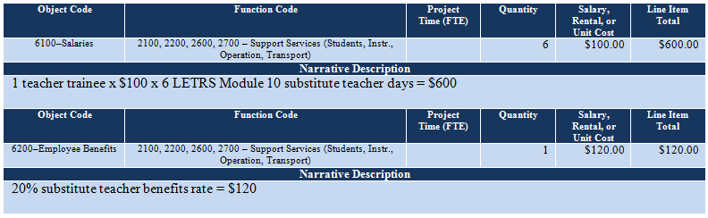

- 6300–Purchased Professional Service
- Substitutes
Substitute teacher costs at the contracted rate or flat rate. There are no employer-related benefits costs for these substitutes. The substitute teacher is a contracted service provider or is paid a flat rate for the provision of substitute teacher services.

The contracted substitute teacher is employed by another organization. The substitute teacher who is paid a flat rate, receives an annual 1099, and is responsible for paying his or her taxes.

The grant will pay for substitute costs for participating teacher trainees on the following face-to-face training days:
- January 13–15, 2016 (3 face-to-face training/coaching days)
- February 29–March 2, 2016 (3 face-to-face training/coaching days)

Additional substitute teachers may be required for travel days and are subject to approval by the IDEA capacity-building grant coordinator.

Budget Examples 2 and 3 demonstrate the standard budget format for contracted and flat-rate substitute teachers. The basic standard budget format is the same as Example 1, but there will be no associated employee benefits. Instead of being placed in 6100–Salaries, the funding is placed in 6300–Purchased Professional Services. Be sure to identify whether the substitute teacher is a contracted or flat-rate substitute.

Budget Example 2
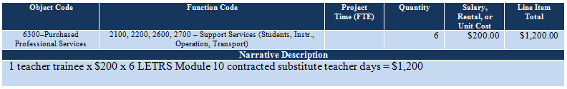

Budget Example 3
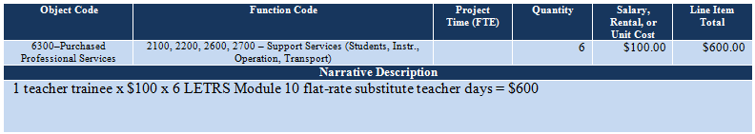

- 6300–Purchased Professional Services
- LETRS TOT Module 10 registration fee = $750/participating trainee
The registration fee covers trainer fees, webinar fees, and material costs.

Budget Example 4 shows the standard budget format for a teacher trainee and a noninstructional trainee. Notice that the teacher’s registration fee is placed in Function Code 2100, 2200, 2600, 2700 – Support Services (Students, Instr., Operations, Transport) and the noninstructional registration fee is placed in Function Code 2300, 2400, 2500, 2900 – Support Services (General School, Central Services, Other).

Budget Example 4
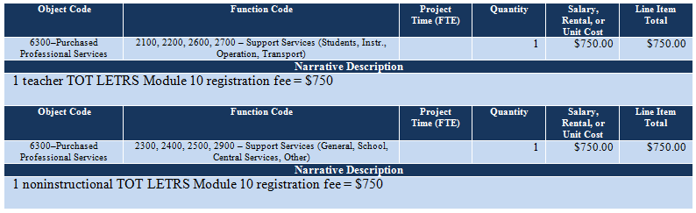

- 6500–Other Purchased Services
Travel
Funding is allowed for travel costs for a participant who must travel a minimum of 51 miles one way between the district office or school site and the face-to-fact training/coaching site.

- Mileage Allowance
- Use MapQuest to estimate the miles from the district office or school to the training site.
- Round-trip miles are calculated at $0.445 per mile in the budget.
- Funding for up to 9 miles round trip may be factored into the mileage costs to cover the miles between the hotel and the training site on each face-to-face training/coaching day.
- The grant will pay for mileage for one vehicle only with no exceptions, even if there is more than one participant. Additional vehicle mileage must be paid for by other private, local, state, or federal funding sources.

- Lodging Allowance
- Double occupancy lodging is required for two same-gender participants from the same education agency.
- Lodging is allowed for the number of nights needed to accommodate a participant’s needs. The grant will accommodate participant arrival the evening before each training/coaching session’s first day, but this early arrival is optional.
  - A participant that is unable to return to the home district by 8:00 p.m. after the last training/coaching session may request additional lodging.
  - It is the responsibility of the LEA or participant to arrange the participant’s lodging at a hotel in the vicinity of the training site. See “Downtown Area Phoenix Hotels” below, which lists hotels in the area of the training that offer the state rate. Remember to request the state rate. The grant will not fund the difference between rooms at the state rate and regularly priced rooms.

- Meal Allowance
The Phoenix lunch and dinner rates are allowed to reimburse traveling participants for the cost of meals during the face-to-face training and, in some cases, while the participant is in travel status coming to and returning from the training subject to approval by the IDEA capacity-building grant coordinator. All hotels offer a full complimentary breakfast to lodgers, so funding for breakfast is not needed.

Lodging and Meal Allowance Table
The following table provides a breakdown of state-rate lodging allowances based on the number of nights a participant needs to stay over and the allowed per-meal-amounts. Tax at a rate of 15% has been factored in. Use this table to calculate the lodging and meal needs of the participant.

LODGING ALLOWANCES
TRAINING DATES | STATE  RATE | 1 ROOM  + @ 15% TAX |  | 1 ROOM  3 NIGHTS | 2 ROOMS  3 NIGHTS |  | 3 ROOMS  3 NIGHTS
January 13–15, 2016 | $161 | $185 |  | $555 | $1,110 |  | $1,665
February 29–March 2, 2016 | $161 | $185 |  | $555 | $1,110 |  | $1,665
total: |  |  |  | $1,110 | $2,220 |  | $3,330
MEAL ALLOWANCE PER PERSON
TRAINING DATES | LUNCH |  | DINNER |  |  | total daily allowance
All dates | $13 |  | $26 |  |  | $39

Downtown Phoenix Area Hotels
The following is a list of hotels in the downtown Phoenix area. Remember to request the state rate when making the lodging accommodations.

Fairfield Inn & Suites by Marriott  2520 N Central Avenue  Phoenix AZ 85004  602-716-9900/1-800-228-2800  8 miles round trip | Hilton Garden Suites  4000 N Central Avenue, Phoenix AZ 85012  602-279-9811  9 miles round trip | Hotel San Carlos  202 N Central Avenue  Phoenix AZ 85004  1-866-253-4121  3 miles round trip
Holiday Inn Express Hotel  620 North 6th Street  Phoenix AZ 85004  602-452-2020/1-800-972-3574  5 miles round trip | Spring Hill Suites Downtown  802 E Van Buren Street  Phoenix AZ 85006  602-307-9929  4 miles round trip | Quality Inn & Suites Downtown  202 E McDowell Road  Phoenix AZ 85004  602-598-9100  5 miles round trip
Hyatt Regency Phoenix  122 N 2nd Street  Phoenix AZ 85004  602-252-1234  4 miles round trip | Wyndham-Phoenix Downtown  50 E Adams  Phoenix AZ 85004  602-333-0000/1-877-999-3223  3 miles round trip | Sheraton Phoenix Downtown  340 N 3rd Street  Phoenix AZ 85004  602-262-2500/1-866-716-8137  4 miles round trip

Budget Example 5 shows the standard budget format for travel for one participant. In this case, the participant is a teacher. The standard budget format for one noninstructional participant would be the same, but the term “instructional” replaces the term “teacher.” The funds would be placed in another function code.

You might be tempted to add a little explanation for this travel which is shown in this example. If you do this, the funding application will be rejected with a request to remove this verbiage in the online funding application’s budget and the addendum’s budget.

Budget Example 5
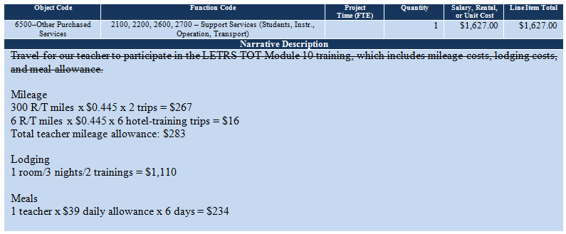

Budget Example 6 shows the standard budget format for two participants from one LEA. One participant is a teacher, and one is an administrative staff member who is identified as “noninstructional.” The two participants are the same gender, so the lodging will be shared. If the two participants were different genders, the grant would pay for separate lodging for each.

Mileage and lodging costs are shared expenses, so 50% of the mileage cost and 50% of the lodging cost will be given to each participant. Each trainee, however, will have his or her own meal allowance.

Budget Example 6
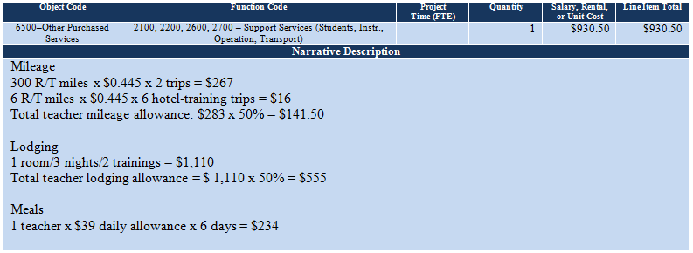

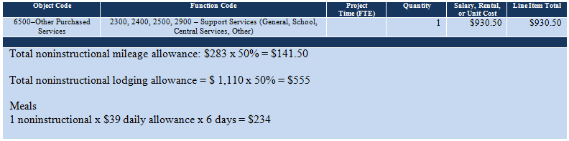

- 6910–Indirect Cost Recovery
Indirect cost recovery at the applicant’s approved indirect cost rate, if it is applicable, is allowed with this grant funding. The indirect cost rate should be preloaded into the GME system by Grants Management and will show up in the Budget section (see below).

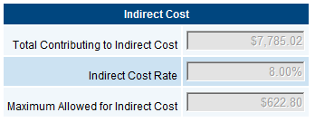

In this case, the indirect cost rate is 8%. The GME system will automatically calculate the amount of indirect cost that can be claimed in the grant (see Maximum Allowed for Indirect Cost above). The GME system, however, will not automatically add the indirect cost to the grant. You must manually type the indirect cost amount in the “Salary, Rental, or Unit Cost” column and the “Line Item Total” column (see the red type in Budget Example 7). If you fail to do this before the grant is approved, you will lose this funding. You may not increase the grant amount after the grant is approved.

No other administrative costs are allowed.

If the LEA has an approved indirect cost rate that does not show up, contact Grants Management to correct this before submitting the grant (see Contacts for Assistance, Grants Management Technical Assistance, at the end of this document).

Budget Example 7
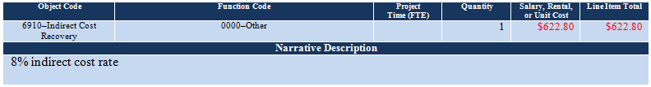

Year-End Completion Report
As with all other state and federally funded grants, an annual financial completion report is required for this funding source. The deadline for this report is September 28.

Contacts for Assistance
Professional Learning and Sustainability
Oran Tkatchov, Director, 602-364-2066, Oran.Tkatchov@azed.gov

Training and Training Outcomes
Sandra Laine, LETRS Training Coordinator, 602-542-3962, Sandra.Laine@azed.gov

Grant Issues
Celia Kujawski, IDEA Capacity-Building Grant Coordinator, 602-542-4610 (office) 602-432-3213 (cell), Celia.Kujawski@azed.gov

Purchase Orders
Abby Sanchez, Program and Project Specialist, 602-364-3026, Abby.Sanchez@azed.gov

Grants Management Technical Difficulties
Grants Management, 844-893-9789 or (local) 602-542-3901, grants@azed.gov
ADEConnect Help Desk, adesupport@azed.gov

To Do Checklist
(Before Submitting the Online Funding Application)

First Thing
☐ Read the LETRS-10 Instructions 2016.
☐ Review the LETRS-10 Addendum 2016.

LETRS-10 Addendum 2016
Open the LETRS-10 Addendum 2016 on your desktop. Have you:
☐ Typed the LEA’s name?
☐ Typed the applicant agency’s CTDS number?

Contact Information
☐ Is every cell filled in for each of the positions/functions listed in the table?

Substitute and Benefits Rates
If teacher substitutes are required:
☐ The teacher substitute daily pay rate expressed in dollars should be typed in the appropriate cell. If teacher substitutes are not required, “N/A” should be typed.
☐ The teacher substitute benefits rate expressed as a percent (%) should be typed in the appropriate cell. If teacher substitute benefits are not required, “N/A” should be typed.

LETRS Trainee(s)
☐ Are all participating trainees’ names, positions/titles, and email addresses provided in this table?
☐ If a trainee requires a teacher substitute, is the “Sub” column checkbox checked next to his or her name?
☐ Is the name of the school (not the district) identified in the first column for the trainee who works at the school level?

Budget
☐ All expenditures that support a trainee who is a teacher in this training must be placed in the appropriate object code under 2100, 2200, 2600, 2700 – Support Services (Students, Instr., Operation, Transport)
☐ All expenditures that support a noninstructional or administrative trainee must be placed in the appropriate object code under 2300, 2400, 2500, 2900 – Support Services (General, School, Central Services, Other)
☐ The number of substitute teachers in the budget matches the number of checks in the LETRS Trainee(s) “Sub” column.
☐ The daily substitute teacher pay rate and the substitute teacher benefits rate match the daily amount and percent identified in the Substitute and Benefits Rates section of the addendum.
☐ If there are funds placed under 1000 – Instruction, move them now. Funds may not be placed under 1000 – Instruction in this grant.
☐ Check the budget examples in pages 4–8 against the addendum’s budget to ensure that the addendum’s budget matches the standard budget format. Make corrections where necessary.
Double check the calculations.

Online Funding Application
☐ The budget in the online funding application is identical to the addendum’s budget. There may not be any inconsistencies between the two.
☐ If there is an indirect cost rate, the pre-calculated indirect cost amount is typed in 6910–Indirect Cost Recovery.

☐ All checkboxes in the FFATA are checked.
☐ The Primary Place of Performance (POP) Information is provided. There is a short one or two paragraph description of the project that is greater than one sentence.
☐ All assurances are checked.

☐ If all is correct, submit the grant.

Additional mileage allowance in place of a lodging allowance is permissible for the participant who will lodge at a private residence. Contact the IDEA capacity-building grant coordinator to discuss an appropriate description for this expenditure within the budget.

