Exceptional Student Services
Professional Learning and Sustainability

for Teachers of Reading and Spelling (LETRS)
Trainer of Trainings (TOT) Institute
Grant Name: 2017 IDEA – LETRS TOT Institute
Funding Source: Individuals with Disabilities Education Improvement Act (IDEA)
Participants are Pre-Selected

ONLINE FUNDING APPLICATION INSTRUCTIONS

Read this! Review the contents of this document and the document titled Addendum LETRS 2017 before starting the application process. The local education agency (LEA) is responsible for following the guidance provided and for submitting complete and accurate information according to the grant requirements set forth in these instructions and in the addendum. This includes uploading all appropriate required and optional documents to the Related Documents section in the online funding application.

Note that a funding application that is inaccurate or incomplete will be rejected for revision until compliance is met. If your funding application is rejected, please make the necessary requested revisions and resubmit it through the Grants Management Enterprise System (GME) as soon as possible.

Contact the IDEA capacity-building grant coordinator or the program and project specialist for assistance in the development of the online funding application and addendum (see Contacts for Assistance, Grant Issues at the end of this document).

Contact Grants Management for assistance with technical issues related to the GME system (see Contacts for Assistance, GME Technical Assistance at the end of this document).

Introduction
Move On When Reading challenges all educators to participate in a statewide collaborative effort to make the vision that every Arizona child will learn to read proficiently by third grade and remain a proficient reader beyond the twelfth grade.

The Arizona Department of Education, Exceptional Student Services (ADE/ESS) and K–12 Academic Standards are collaborating with Cambium Learning® (formerly Voyager Sopris Learning) to present the LETRS TOT (trainer-of-trainees) Institute and A Principal’s Primer for Raising Reading Achievement to a select group of Arizona’s and school principals and educators with experience and background in teaching and assessing reading in one or more of the following areas:
- K–3 early reading development
- K–12 reading
- K–3 early literacy
- K–12 reading assessment

Purpose

Year 1 and Year 2
LETRS TOT Institute. Funding is provided to support pre-selected district and school educators to participate in the LETRS TOT Institute. A district or school educator participating in this training will have submitted an application for admission to the Institute and been approved to participate by the LETRS training coordinator.

LETRS is an intensive professional development opportunity that increases teacher knowledge of literacy. LETRS trainees will receive comprehensive and practical knowledge of how children learn to read, write, and spell. Such knowledge can be used to improve literacy instruction and implement evidence-based literacy interventions at the district and school levels.

The basic LETRS training instructs the participants in the use of the LETRS modules. The LETRS TOT Institute shows the trainees how to train others in the use of the modules. LETRS Coaching completes the training with practical coaching strategies that the TOT will use as LETRS is shared with local educators at the district or school level.

LETRS trainees who successfully complete the LETRS TOT Institute will be equipped to train other educators in the LETRS components. They will join a cadre of certified LETRS TOTs who will use their skills at their own local education agencies and may be called upon to provide training services at a regional or state level.

Principal’s Primer. To compliment the LETRS TOT Institute, A Principal’s Primer for Raising Reading Achievement is offered to participating principals and LETRS trainees. This presentation delivers specific steps for principals to follow that will result in a successful site-based LETRS program.

Year 3
LETRS Implementation. Funding to assist in the implementation of a LETRS program may be available to local education agencies (LEAs) with certified LETRS trainers and principals who have completed the LETRS TOT Institute and the Principal’s Primer. The applicant agency must draft an implementation plan that identifies specific professional development and student achievement goals and that shows how these goals will be achieved over the course of one year using LETRS. The plan must show that training and follow-up will continue after the LETRS Implementation grant ends.

Annual Program Cycle
July 1–June 30

Grant Activation in the GME
TBD

If the grant has not received web approval by the first scheduled training session, the LEA should be prepared to temporarily reallocate funds from another local, state, or other federal funding source to pay for the immediate trainee and principal training expenses. Other funding that is spent from another source may be reimbursed with grant funds when the grant is approved. We apologize for any inconvenience this may cause.

notice! All trainees and principals who have been accepted to participate in the LETRS TOT Institute and Principal’s Primer are guaranteed a grant to pay the allowed training expenses.

Grant Submission Deadline
December 31, 2016

Submit the grant as soon as possible to avoid delays in web approval and the LEA’s ability to draw down grant funds through a request for reimbursement.

Revision Submission Deadline
May 15, 2017

Revisions to move funding from one line to another will probably not be required with this grant. However, in the event that the approved funding application must be revised, please be aware that it will be closed for any revisions after this date. It will not be reopened.

Reimbursement Request Deadline
June 15, 2017

The funding application will be closed for any reimbursement requests after this date and will not be reopened to accommodate late submissions. Outstanding reimbursements will be received after the completion report is submitted and approved.

Mark these dates on your calendar so that you do not miss any important deadlines.

Purchase Orders (POs)
LETRS Trainees and principals will be required to provide a PO number when each registers for any training through the Events Management System (EMS).

LETRS Trainee Commitments
The LETRS trainee will be required to accomplish the following:
- Attend all LETRS TOT Institute sessions over the 18 month period.
- Successfully complete all reading and homework assignments.
- Pass all tests and writing assignments required for LETRS TOT certification.
- Present a LETRS module.

The trainee may also attend the Principal’s Primer with his or her principal.

The certified LETRS TOT, in cooperation with district administration, will:
- Use the LETRS professional development materials to train teachers in his or her school or district.
- Agree to be available, if called upon, to provide regional training.
- Attend follow-up webinars and coaching sessions provided by LETRS to maintain certification.
- Read and analyze current reading research for the purpose of providing up-to-date information to trainees.

Principal’s Commitments
The principal will be required to accomplish the following:
- Attend two days of training on A Principal’s Primer for Raising Reading Achievement.
- Attend planning webinars and face-to-face sessions at ADE scheduled during FY 2017 and FY 2018.
- In collaboration with the LETRS trainee(s) and the local LETRS implementation team, plan, schedule, and support delivery and coaching of LETRS training at the district and/or school level.
- Monitor and facilitate implementation of LETRS training by completing regular walk-throughs and fidelity assessments.

LETRS TOT Institute and Principal’s Primer Calendar and Venues*
The LETRS TOT Institute and Principal’s Primer schedules follow.

*Training dates and the training location in the following calendar are subject to change.

FY 2017 Year 1 Calendar (November 2016–June 2017)
Date/Time | Modules | Training Venue
November 1–4, 2016  Tuesday–Friday  8:00 a.m.–4:00 p.m. daily | Basic LETRS Training  Modules 1–3 | AZ Department of Education  1535 W Jefferson, Room 311  Phoenix AZ 85007
December 6, 2016  Tuesday  3:30 p.m.–5:00 p.m. | LETRS Webinar  Modules 1–3 | Online Webinar
January 10–13, 2017  Tuesday–Friday  8:00 a.m.–4:00 p.m. daily | LETRS TOT Institute  Modules 1–3 | AZ Department of Education  1535 W Jefferson, Room 311  Phoenix AZ 85007
February 6–7, 2017  Monday–Tuesday  8:00 a.m.–4:00 p.m. daily | LETRS TOT Coaching  Modules 1–3 | AZ Department of Education  1535 W Jefferson, Room 311  Phoenix AZ 85007
February 27–March 2, 2017  Monday–Thursday  8:00 a.m.–4:00 p.m. daily | Basic LETRS Training  Modules 4–6 | AZ Department of Education  1535 W Jefferson, Room 311  Phoenix AZ 85007
March 29, 2017  Wednesday  3:30 p.m.–5:00 p.m. | LETRS Webinar  Modules 4–6 | Online Webinar
May 1–4, 2017  Monday–Thursday  8:00 a.m.–4:00 p.m. daily | LETRS TOT Institute  Modules 4–6 | AZ Department of Education  1535 W Jefferson, Room 311  Phoenix AZ 85007
June 7–8, 2017  Wednesday–Thursday  8:00 a.m.–4:00 p.m. daily | A Principal’s Primer for Raising Reading Achievement | AZ Department of Education  1535 W Jefferson, Room 311  Phoenix, AZ 85007
June 13–14, 2017  Tuesday–Wednesday  8:00 a.m.–4:00 p.m. daily | LETRS TOT Coaching  Modules 4–6 | AZ Department of Education  1535 W Jefferson, Room 311  Phoenix AZ 85007
FY 2018 Year 2 Calendar (July 2017–February 2018)
Date/Time | Modules | Training Venue
July 17–20, 2017  Monday–Thursday  8:00 a.m.–4:00 p.m. daily | Basic LETRS Training  Modules 7–9 | AZ Department of Education  1535 W Jefferson, Room 311  Phoenix AZ 85007
August 30, 2017  Wednesday  3:30 p.m.–5:00 p.m. | LETRS Webinar  Modules 7–9 | Online Webinar
September 12–15, 2017  Tuesday–Friday  8:00 a.m.–4:00 p.m. daily | LETRS TOT Institute  Modules 7–9 | AZ Department of Education  1535 W Jefferson, Room 311  Phoenix AZ 85007
October 26–27, 2017  Thursday–Friday  8:00 a.m.–4:00 p.m. daily | LETRS TOT Coaching  Modules 7–9 | AZ Department of Education  1535 W Jefferson, Room 311  Phoenix AZ 85007
November 29–30, 2017  Wednesday–Thursday  8:00 a.m.–4:00 p.m. daily | Basic LETRS Training  Module 10 | AZ Department of Education  1535 W Jefferson, Room 311  Phoenix AZ 85007
January 11, 2018  Thursday  3:30 p.m.–5:00 p.m. | LETRS Webinar  Module 10 | Online Webinar
January 31 – February 1, 2018  Wednesday–Thursday  8:00 a.m.–4:00 p.m. daily | LETRS TOT Institute  Module 10 | AZ Department of Education  1535 W Jefferson, Room 311  Phoenix AZ 85007
February 22–23, 2018  Thursday–Friday  8:00 a.m.–4:00 p.m. daily | LETRS TOT Coaching  Module 10 | AZ Department of Education  1535 W Jefferson, Room 311  Phoenix AZ 85007

The Excess Cost Requirement

The excess cost requirement means that the agency must spend a certain minimum amount for the education of its children with disabilities before Part B funds are used. Children served with Part B funds must have at least the same average amount spent on them from sources other than Part B as do children in the LEA as a whole.

Each applicant must assure the state education agency (SEA) that the LEA uses funds provided under Part B of the Act to supplement and, to the extent practicable, increase the level of state and local funds expended for the education of children with disabilities, and in no case, to supplant those state and local funds.

For clarification of the excess cost requirement, contact the ESS Funding Unit director (see Contact for Assistance, ESS Funding Unit).

Maintenance of Effort (MOE)

To meet the MOE requirement, the total amount or average per capita amount of state and local school funds budgeted by the LEA for expenditures in the current fiscal year for the education of children with disabilities must be at least equal to the total amount or average per capita amount of state and local school funds actually expended for the education of children with disabilities in the most recent preceding fiscal year for which the information is available. Allowances may be made for:
- Decreases in enrollment of children with disabilities;
- The termination of costly expenditures for long-term purchases, such as the acquisition of equipment and the construction of school facilities;
- The replacement of personnel with qualified, lower-salaried personnel;
- The termination of the obligation to provide a program of special education to a particular child with a disability that is in an exceptionally costly program; or
- The assumption of cost by the high-cost fund operated by the SEA.

Please note, however, that budgeting a certain amount and expending that amount by the end of the year are two different issues. If none of the allowances apply, the applicant agency must make sure that the special education expenditures meet or exceed the previous year’s special education expenditures, excluding Fund 011, impact aid for students with disabilities. The LEA must submit for Program 200 disability categories only (exclude gifted, bilingual, remedial, vocational, and career education and fund 011 amounts).

All one-year and first-year IDEA capacity-building training, tuition assistance, and implementation grants must pass the MOE test before the grant is approved and funding is released.

notice! This grant is required to pass the MOE test. If a MOE issue is identified, the superintendent and/or finance officer must resolve the issue immediately to avoid delays in the approval and disbursement of funds for all grants that are funded by current-year IDEA funds.

For additional information on MOE, contact the finance specialist assigned to your LEA (see Contacts for Assistance, ESS Funding Unit).

Uniform System of Financial Records (USFR)

The USFR provides guidance for the line item placement of funding in IDEA capacity-building training, tuition assistance, and implementation grants. The USFR stipulates that grant funding that supports the training of the following personnel must be treated as indicated:
- Funding that supports teachers, instructional aides, and all others who provide direct instruction to students in the classroom setting must be placed in the appropriate object codes under Function Code 2100, 2200, 2600, 2700–Support Services (Students, Instr., Operation, Transport).
- Funding that supports district or school administrators and other noninstructional educators must be placed in the appropriate object codes under Function Code 2300, 2400, 2500, 2900–Support Services (General, School, Central Services, Other).

notice! Never place any IDEA capacity-building training, tuition assistance, or implementation grant’s funding under Function Code 1000–Instruction unless otherwise instructed.

ESS Funding Unit Standard Budget Formats

The ESS Funding Unit has developed standard budget formats that must be used in all IDEA capacity-building training, tuition assistance, and implementation grants to describe budget line items in the online funding application and addendum narrative descriptions.

Examples of the standard budget formats for the purchase of goods and services that are allowed with this grant’s funding are shown below. You will notice that the standard budget formats are very specific and written with minimal or no embellishments. Unless otherwise indicated in the example, do not include additional information or an explanation for funding in a narrative description. This distracts the ESS budget evaluators and slows down the process.

notice! The IDEA capacity-building grants that are not written in the standard budget formats as described in this instructional document’s budget examples will be rejected until compliance is met. Avoid funding application rejections by contacting the IDEA capacity-building grant coordinator or the program and project specialist for assistance in the development of the online funding application and addendum (see Contacts for Assistance, Grant Issues at the end of this document).

Funding Restrictions

This grant will not allow or pay for the following:
- Carryover of funds from year to year.
- 6700–Property (Capital Outlay) [for school districts only] unless indicated in Allowable Expenditures below.
- 0190–Capital Outlay [for charter schools only] unless indicated in Allowable Expenditures below.

Allowable Expenditures

The following items may be purchased with this grant’s funds:
- Substitute for LETRS trainees to attend training sessions, including the Principal’s Primer, that are scheduled during school hours.
- Applicable employee benefits.
- Training registration and EMS fees.
- Travel expenses including mileage, lodging, and meals for participants who must travel a minimum of 51 miles from district office or school site to training venue.
- Applicable indirect costs.

Grant Application Process

The ESS Funding Unit recommends that you complete the addendum before opening and completing the online funding application. You will be able to copy and paste the budget information from the addendum to the narrative descriptions in the online funding application’s Budget section. Remember that the addendum’s budget and the online funding application’s budget must be identical per instructions.

Allowed Expenses and Standard Budget Formats
The following information is a detailed description of the items that may be purchased with this grant’s funds. Each item is followed by at least one standard budget format that demonstrates the way this item should be written in the budget narrative description.

Substitute Teachers and Related Service Providers With and Without Associated Employee Benefits
The grant pays for substitutes that will allow the attendance of a LETRS trainee at scheduled LETRS TOT Institute and Principal’s Primer days. Substitutes will not be needed to attend any of the LETRS webinars as these are scheduled in mid-afternoon.
- A trainee who is attending the LETRS TOT Institute scheduled during school days.
- A trainee who is attending the Principal’s Primer for Raising Reading Achievement two-day sessions scheduled on school days.
- Trainee travel days, if necessary. This option is available to the trainees who must be in travel status for five or six hours while traveling to and from Phoenix. This could include those traveling from the northeastern or northwestern corners of the state. This may also include those residing close to the southern border.
- Applicable employee benefits.

In Budget Example 1 below, substitute teachers for a hypothetical LETRS trainee are calculated using the following information:
- 1 teacher trainee.
- 20 scheduled LETRS TOT Institute days.
- 2 Principal’s Primer days.
- $100 daily substitute rate.
- 20% substitute benefits rate.

notice! The $100 daily substitute rate and 20% benefits rate are used here only to demonstrate the standard budget format for substitutes and benefits. Please use the LEA’s own substitute and benefits rates when calculating a trainee’s substitute needs.

Budget Example 1
Placement of substitute teachers in the budget when benefits are paid:
Object Code: 6100–Salaries and 6200–Employee Benefits
Function Code: 2100, 2200, 2600, 2700–Support Services (Students, Instr., Operation, Transport)

notice! If a noninstructional trainee requires substitutes to participate in the LETRS TOT Institute, the funding should be placed in Function Code 2300, 2400, 2500, 2900 – Support Services (General, School, Central Services, Other).

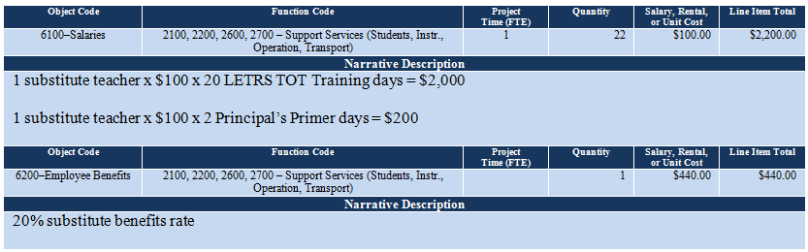

Budget Example 2
Placement of substitute teachers in the budget when benefits are not paid:
Object Code: 6100–6300–Purchased Professional Services
Function Code: 2100, 2200, 2600, 2700–Support Services (Students, Instr., Operation, Transport)

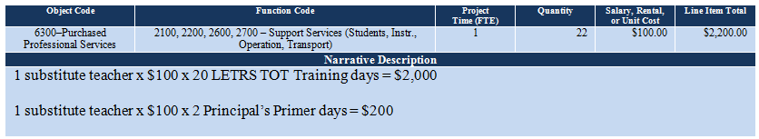

Training Registration Fees
The LETRS TOT Institute and Principal’s Primer registration fees are annual registration fees, which must be paid upon receipt of an invoice from ADE.

LETRS TOT Institute Registration Fees
1 LETRS TOT trainee = $3,693
2 LETRS TOT trainees = $7,386
3 LETRS TOT trainees = $11,079
4 LETRS TOT trainees = $14,772

Principal’s Primer Registration Fees
1 participant = $350
2 participants = $700
3 participants = $1,050
4 participants = $1,400

notice! The LETRS TOT trainees are encouraged to attend the Principal’s Primer with their principals.

EMS Fee
The ADE EMS will charge an additional $20 per person at the time of registration for the LETRS TOT Institute and the Principal’s Primer. This is a one-time charge that covers all LETRS TOT Institute days or both Principal’s Primer days that are scheduled during the fiscal year (July 1–June 30).

Budget Example 3
Placement of registration and EMS fees:
Object Code: 6100–6300–Purchased Professional Services
Teacher Function Code: 2100, 2200, 2600, 2700–Support Services (Students, Instr., Operation, Transport)
Noninstructional and Administrator Function Code: 2300, 2400, 2500, 2900 – Support Services (General, School, Central Services, Other)

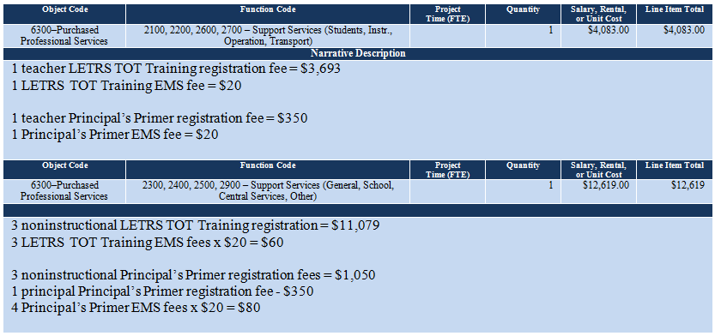

Travel Costs
Travel expenses, which include mileage, lodging, and meals, are allowed at the state rates for a LETRS trainee and principal whose home district office or school site is located a minimum of 51 miles from the training venue.

Mileage
- Use MapQuest to estimate the miles from the home district office or school site to the training venue, and double the mileage to determine round trip miles. Funding for round trip miles between the lodging site and the training venue for each training day may be factored into the mileage costs. The ESS Funding Unit prefers that you calculate your mileage costs using round trip miles.
- Miles are calculated at $0.445 per mile.
- The grant will pay for mileage for one vehicle only unless there are more than four occupants traveling to the LETRS TOT Institute and Principal’s Primer. Additional vehicle mileage after this must be paid by another private, local, state, or federal funding source.

Lodging
- Double occupancy lodging is required when it is possible. However, the grant will accommodate an odd number of grant-funded participants; or an odd number of male and female participants; or participants with medical or other personal issues where single occupancy lodging is appropriate. LEAs should use other funding sources to pay for rooms when the district policy stipulates one room for each person; when co-lodging of administrative staff and other staff is discouraged or prohibited, or for participants who prefer single lodging.
- Lodging is allowed for the number of nights needed to meet the participants’ needs. ADE/ESS expects that participants will want to arrive the evening before each session to be refreshed when the session starts, but this early arrival is optional.
- A participant who is unable to return to the home district office or school site by 8:00 p.m. after the last training day of each session may request additional lodging to ensure a safe return at a reasonable hour. When planning the inclusion of additional lodging in the budget, check the time when participants will be released and use MapQuest to calculate the amount of time the return trip will take. Add one-half to one hour to compensate for rush hour traffic.
- It is the responsibility of the LEA or the participant to reserve the lodging. Remember to request the state rate when reserving rooms. The grant will not fund the difference between a regularly priced room that exceeds the state rate. A list of hotels in the Phoenix Downtown area is provided below for your convenience.

Fairfield Inn & Suites by Marriott  2520 N Central Avenue  Phoenix, AZ 85004  602-716-9900/1-800-228-2800  2 miles round trip to/from ADE | Hilton Garden Suites  4000 N Central Avenue  Phoenix, AZ 85012  602-279-9811  3 miles round trip to/from ADE | Hotel San Carlos  202 N Central Avenue  Phoenix, AZ 85004  1-866-253-4121  6 miles round trip to/from ADE
Holiday Inn Express Hotel  620 North 6th Street  Phoenix, AZ 85004  602-452-2020/1-800-972-3574  6 miles round trip to/from ADE | Spring Hill Suites Downtown  802 E Van Buren Street  Phoenix, AZ 85006  602-307-9929  6 miles round trip to/from ADE | Quality Inn & Suites Downtown  202 E McDowell Road  Phoenix, AZ 85004  602-598-9100  2.5 miles round trip to/from ADE
Hyatt Regency Phoenix  122 N 2nd Street  Phoenix, AZ 85004  602-252-1234  6 miles round trip to/from ADE | Wyndham-Phoenix Downtown  50 E Adams  Phoenix, AZ 85004  602-333-0000/1-877-999-3223  5.5 miles round trip to/from ADE | Sheraton Phoenix Downtown  340 N 3rd Street  Phoenix, AZ 85004  602-262-2500/1-866-716-8137  5.5 miles round trip to/from ADE

Meals
Meals will not be provided during the LETRS TOT Institute; however, lunch will be provided at the Principal’s Primer.

Travelers may be reimbursed one meal for every six hours in travel status when meals are not provided. A traveler on travel status between:
- 12:00 a.m. and 10:00 a.m. is eligible for breakfast. This includes on the day following a session when the participant must stay over an additional night.
- 10:00 a.m. and 4:00 p.m. is eligible for lunch. This includes:
- When lunch is not provided at the training.
- In rare cases on the day following a session when the participant must say over an additional night and is still in normal travel status between 10:00 a.m. and 4:00 p.m.
- 4:00 p.m. and 11:59 p.m. is eligible for dinner. This includes:
- For each night’s stay-over, and
- When the participant is unable to return to the home district office or school site by 8:00 p.m. after the close of a training session but chooses not to stay over an additional night.

notice! Trainees are allowed the full per diem amount of $61 per day for the LETRS TOT Institute. Participants in the Principal’s Primer are allowed $45 per day since lunch will be provided during the two training days.

Lodging and Meal Allowance Table
The following table provides a breakdown of lodging allowances based on the dates of the trainings and the number of nights a trainee and/or principal need to stay over. An additional 15% is already added to the lodging state rates in this table to ensure that the tax is covered. The allowed per diem and per-meal-amounts are included at the bottom of the table. Use this table to calculate the lodging and meal needs of the participants.

LETRS TOT Institute
LODGING ALLOWANCE–1 ROOM
TRAINING | TRAINING DATES |  | STATE  RATE | 1 ROOM  + 15% TAX |  |  | 1 ROOM  1 NIGHT |  | 1 ROOM  2 NIGHTS | 1 ROOM  3 NIGHTS |  | 1 ROOM  4 NIGHTS |  | 1 ROOM  5 NIGHTS |  | 1 ROOM  6 NIGHTS
LETRS TOT Institute | Nov 1–4 2016 |  | $113 | $130 |  |  | $130 |  | $260 | $390 |  | $520 |  | $650 |  | $780
 | Jan 10–13 2017 |  | $161 | $185 |  |  | $185 |  | $370 | $555 |  | $741 |  | $926 |  | $1,111
 | Feb 6–7 2017 |  | $161 | $185 |  |  | $185 |  | $370 | $555 |  | $741 |  | $926 |  | $1,111
 | Feb 27–Mar 2 2017 |  | $161 | $185 |  |  | $185 |  | $370 | $555 |  | $741 |  | $926 |  | $1,111
 | May 1–4 2017 |  | $120 | $138 |  |  | $138 |  | $276 | $414 |  | $552 |  | $690 |  | $828
 | Jun 13–14 2017 |  | $89 | $102 |  |  | $102 |  | $205 | $307 |  | $409 |  | $512 |  | $614
LODGING ALLOWANCE–2 ROOMS
TRAINING | TRAINING DATES |  | STATE  RATE | 1 ROOM  + 15% TAX |  |  | 2 ROOMS  1 NIGHT |  | 2 ROOMS  2 NIGHTS | 2 ROOMS  3 NIGHTS |  | 2 ROOMS  4 NIGHTS |  | 2 ROOMS  5 NIGHTS |  | 2 ROOMS  6 NIGHTS
LETRS TOT Institute | Nov 1–4 2016 |  | $113 | $130 |  |  | $260 |  | $520 | $780 |  | $1,040 |  | $1,300 |  | $1,559
 | Jan 10–13 2017 |  | $161 | $185 |  |  | $370 |  | $740 | $1,110 |  | $1,481 |  | $1,852 |  | $2,222
 | Feb 6–7 2017 |  | $161 | $185 |  |  | $370 |  | $740 | $1,110 |  | $1,481 |  | $1,852 |  | $2,222
 | Feb 27–Mar 2 2017 |  | $161 | $185 |  |  | $370 |  | $740 | $1,110 |  | $1,481 |  | $1,852 |  | $2,222
 | May 1–4 2017 |  | $120 | $138 |  |  | $276 |  | $552 | $828 |  | $1,104 |  | $1,380 |  | $1,656
 | Jun 13–14 2017 |  | $89 | $102 |  |  | $204 |  | $408 | $612 |  | $819 |  | $1,024 |  | $1,228
LODGING ALLOWANCE–3 ROOMS
TRAINING | TRAINING DATES |  | STATE  RATE | 1 ROOM  + 15% TAX |  |  | 3 ROOMS  1 NIGHT |  | 3 ROOMS  2 NIGHTS | 3 ROOMS  3 NIGHTS |  | 3 ROOMS  4 NIGHTS |  | 3 ROOMS  5 NIGHTS |  | 3 ROOMS  6 NIGHTS
LETRS TOT Institute | Nov 1–4 2016 |  | $113 | $130 |  |  | $390 |  | $780 | $1,170 |  | $1,559 |  | $1,949 |  | $2,339
 | Jan 10–13 2017 |  | $161 | $185 |  |  | $555 |  | $1,110 | $1,665 |  | $2,222 |  | $2,777 |  | $3,333
 | Feb 6–7 2017 |  | $161 | $185 |  |  | $555 |  | $1,110 | $1,665 |  | $2,222 |  | $2,777 |  | $3,333
 | Feb 27–Mar 2 2017 |  | $161 | $185 |  |  | $555 |  | $1,110 | $1,665 |  | $2,222 |  | $2,777 |  | $3,333
 | May 1–4 2017 |  | $120 | $138 |  |  | $414 |  | $828 | $1,242 |  | $1,656 |  | $2,070 |  | $2,484
 | Jun 13–14 2017 |  | $89 | $102 |  |  | $306 |  | $612 | $918 |  | $1,228 |  | $1,535 |  | $1,842
LODGING ALLOWANCE–4 ROOMS
TRAINING | TRAINING DATES |  | STATE  RATE | 1 ROOM  + 15% TAX |  |  | 4 ROOMS  1 NIGHT |  | 4 ROOMS  2 NIGHTS | 4 ROOMS  3 NIGHTS |  | 4 ROOMS  4 NIGHTS |  | 4 ROOMS  5 NIGHTS |  | 4 ROOMS  6 NIGHTS
LETRS TOT Institute | Nov 1–4 2016 |  | $113 | $130 |  |  | $520 |  | $1,040 | $1,560 |  | $2,079 |  | $2,599 |  | $3,119
 | Jan 10–13 2017 |  | $161 | $185 |  |  | $740 |  | $1,480 | $2,220 |  | $2,962 |  | $3,703 |  | $4,444
 | Feb 6–7 2017 |  | $161 | $185 |  |  | $740 |  | $1,480 | $2,220 |  | $2,962 |  | $3,703 |  | $4,444
 | Feb 27–Mar 2 2017 |  | $161 | $185 |  |  | $740 |  | $1,480 | $2,220 |  | $2,962 |  | $3,703 |  | $4,444
 | May 1–4 2017 |  | $120 | $138 |  |  | $552 |  | $1,104 | $1,656 |  | $2,208 |  | $2,760 |  | $3,312
 | Jun 13–14 2017 |  | $89 | $102 |  |  | $408 |  | $816 | $1,224 |  | $1,638 |  | $2,047 |  | $2,456
LETRS TOT Institute
BREAKFAST |  | LUNCH |  |  |  | DINNER |  |  |  |  | FULL-DAY PER DIEM
$13 |  | $16 |  |  |  | $32 |  |  |  |  | $61
PRINCPAL’S PRIMER
LODGING ALLOWANCE–1 ROOM
TRAINING | TRAINING DATES |  | STATE  RATE |  | 1 ROOM  + 15% TAX |  |  | 1 ROOM  1 NIGHT |  | 1 ROOM  2 NIGHTS |  |  | 1 ROOM  3 NIGHTS |  | 1 ROOM  4 NIGHTS
Principal’s Primer | Jun 7–8 2017 |  | $89 |  | $102 |  |  | $102 |  | $205 |  |  | $307 |  | $409
LODGING ALLOWANCE–2 ROOMS
TRAINING | TRAINING DATES |  | STATE  RATE |  | 1 ROOM  + 15% TAX |  |  | 2 ROOMS  1 NIGHT |  | 2 ROOMS  2 NIGHTS |  |  | 2 ROOMS  3 NIGHTS |  | 2 ROOMS  4 NIGHTS
Principal’s Primer | Jun 7–8 2017 |  | $89 |  | $102 |  |  | $204 |  | $408 |  |  | $612 |  | $819
LODGING ALLOWANCE–3 ROOMS
TRAINING | TRAINING DATES |  | STATE  RATE |  | 1 ROOM  + 15% TAX |  |  | 3 ROOMS  1 NIGHT |  | 3 ROOMS  2 NIGHTS |  |  | 3 ROOMS  3 NIGHTS |  | 3 ROOMS  4 NIGHTS
Principal’s Primer | Jun 7–8 2017 |  | $89 |  | $102 |  |  | $306 |  | $612 |  |  | $918 |  | $1,228
LODGING ALLOWANCE–4 ROOMS
TRAINING | TRAINING DATES |  | STATE  RATE |  | 1 ROOM  + 15% TAX |  |  | 4 ROOMS  1 NIGHT |  | 4 ROOMS  2 NIGHTS |  |  | 4 ROOMS  3 NIGHTS |  | 4 ROOMS  4 NIGHTS
Principal’s Primer | Jun 7–8 2017 |  | $89 |  | $102 |  |  | $408 |  | $816 |  |  | $1,224 |  | $1,638
PRINCIPAL’S PRIMER MEAL ALLOWANCE
BREAKFAST |  | LUNCH |  |  |  | DINNER |  |  |  |  | PER DIEM ALLOWED
$13 |  | Not Allowed |  |  |  | $32 |  |  |  |  | $45

Budget Examples 4 and 5 show travel expenses for four TOT trainees; one teacher and three noninstructional educators. Each TOT trainee is allowed an equal portion (or as equal as possible) of the funding for mileage and lodging. In this hypothetical scenario, each trainee is allocated 25% of the LETRS training mileage and lodging funding.

notice! “R/T” means round trip. You may use either “R/T” or “round trip” to describe the miles in the Narrative Description. The ESS Funding Unit prefers that you calculate your mileage costs using round trip miles.

Budget Example 4
Placement of teacher trainee travel expenses for the LETRS TOT Institute in the budget:
Object Code: 6100–6300–Purchased Professional Services
Function Code: 2100, 2200, 2600, 2700–Support Services (Students, Instr., Operation, Transport)

notice! In Budget Example 4, the standard budget format for the teacher trainee’s expenses is more complex than the funding for the noninstructional trainees in Budget Example 5. If all of the trainees have noninstructional positions, you should use the standard budget format in Budget Example 4 to describe the travel expenses; but place the funding in Function Code 2300, 2400, 2500, 2900 – Support Services (General, School, Central Services, Other).

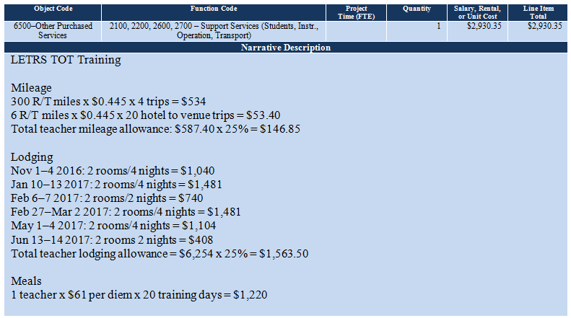

Budget Example 5
Placement of noninstructional trainee travel expenses for the LETRS TOT Institute in the budget:
Object Code: 6100–6300–Purchased Professional Services
Function Code: 2100, 2200, 2600, 2700–Support Services (Students, Instr., Operation, Transport)

notice! In this example, the standard budget format for the noninstructional trainees’ expenditures is a compressed version of the funding described in Budget Example 4 above.

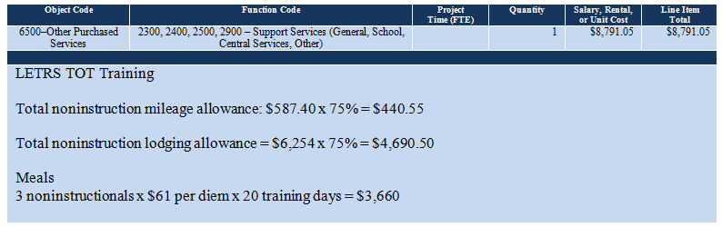

Budget Examples 6 and 7 show travel expenses for the four LETRS trainees (one teacher and three noninstructional educators) and the principal attendance at the Principal’s Primer. Each participant is allowed an equal portion (or as equal as possible) of the funding for mileage and lodging. Since there are more than four travelers, mileage for two vehicles is allowed. In this scenario, each participant is allocated 20% of the Principal’s Primer training mileage and lodging funding.

notice! Since there are more than four travelers in this scenario, the grant allows funding for two vehicles.

Budget Example 6
Placement of teacher trainee travel expenses for the Principal’s Primer in the budget:
Object Code: 6100–6300–Purchased Professional Services
Function Code: 2100, 2200, 2600, 2700–Support Services (Students, Instr., Operation, Transport)

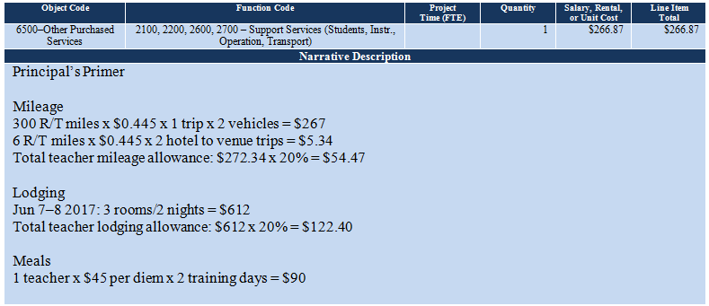

Budget Example 7
Placement of noninstructional trainee and principal travel expenses for the Principal’s Primer in the budget:
Object Code: 6100–6300–Purchased Professional Services
Function Code: 2100, 2200, 2600, 2700–Support Services (Students, Instr., Operation, Transport)

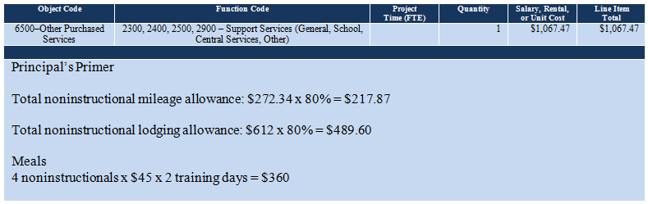

Indirect Cost Recovery
Indirect costs at the LEA’s approved indirect cost rate and county-approved indirect cost rate, if they are applicable, are allowed with this grant funding. The GME will automatically calculate the indirect cost amount based on the amount of funding in the grant less any capital outlay; but the applicant must manually type the indirect cost amount in the appropriate cell within the budget in order to add it to the total grant amount. This is demonstrated by the red type in Budget Example 8.

Budget Example 8
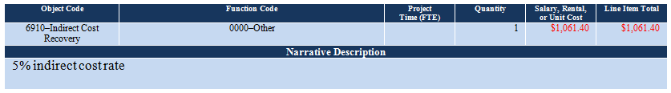

If the LEA’s approved indirect cost rate has not been loaded into this grant, or if the LEA does not have an approved indirect cost rate, it will show up as 0.00% in the budget section of the online funding application (see below). If the LEA has an approved indirect cost rate that does not show in the GME system, you should contact Grants Management to request that the indirect cost rate be loaded into the funding application before you submit it (see Contacts for Assistance, GME Technical Assistance, at the end of this document).

No other administrative costs are allowed.

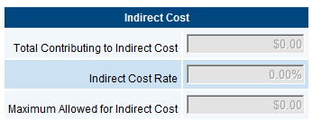

Purchase Orders
LETRS trainees and principals must register individually for the LETRS TOT Institute and the Principal’s Primer. Each registrant will be required to provide a purchase order (PO) number at the time of registration.

Contacts for Assistance
Professional Learning and Sustainability
Tracey Sridharan, Director, 602-364-2066, Tracey.Sridharan@azed.gov

Training Coordinator: Training and Training Outcomes
Kim Rice, LETRS Training Coordinator, 602-771-4299, Kim.Rice@aced.gov

Grant Issues and Questions
Celia Kujawski, IDEA Capacity Building Grant Coordinator, 602-432-3213, Celia.Kujawski@azed.gov
Abby Sanchez, Program and Project Specialist, 602-364-3026, Abby.Sanchez@azed.gov

GME Technical Assistance
Grants Management, (844) 893-9789 or local (602) 542-3901, GrantsManagementGroup@azed.gov

The application that was submitted for acceptance to the LETRS TOT Institute and Principal’s Primer for Raising Reading Achievement did not specify that the trainees should or could attend the Principal’s Primer; however, ADE/ESS believes that attendance by the trainees with their principals will benefit the local implementation of the LETRS components; and they are encouraged to attend. Their attendance will be supported by this grant.
The second year training will require a new grant application to support the trainee expenses needed to complete the LETRS TOT Institute program.
Participants with a medical or other personal issue can be accommodated. If a single occupancy room is not available because there is an even number of participants already assigned to the available rooms, or different genders are being accommodated, a waiver in PDF format and signed by the local superintendent must be uploaded to the online funding application, Related Documents section. This waiver should state whether an instructional participant or a noninstructional participant requires single lodging, that the grant does not have an available single occupancy room, and that the waiver is necessary to accommodate that participant’s personal issue. Do not identify that person by name; and do not disclose the nature of the personal issue.

