Directions to Navigate to State Determined Level of Performance Report

1. Log into ADEConnect and access CTE Data Portal. (Directions on how to get access to CTE Data Portal: [Accessing-Perkins-V-Performance-Measure-Outcomes.pdf](https://www.azed.gov/sites/default/files/2025/09/Accessing-Perkins-V-Performance-Measure-Outcomes.pdf) )
2. In the CTE Data Portal, Select “Reports” from the Top Bar

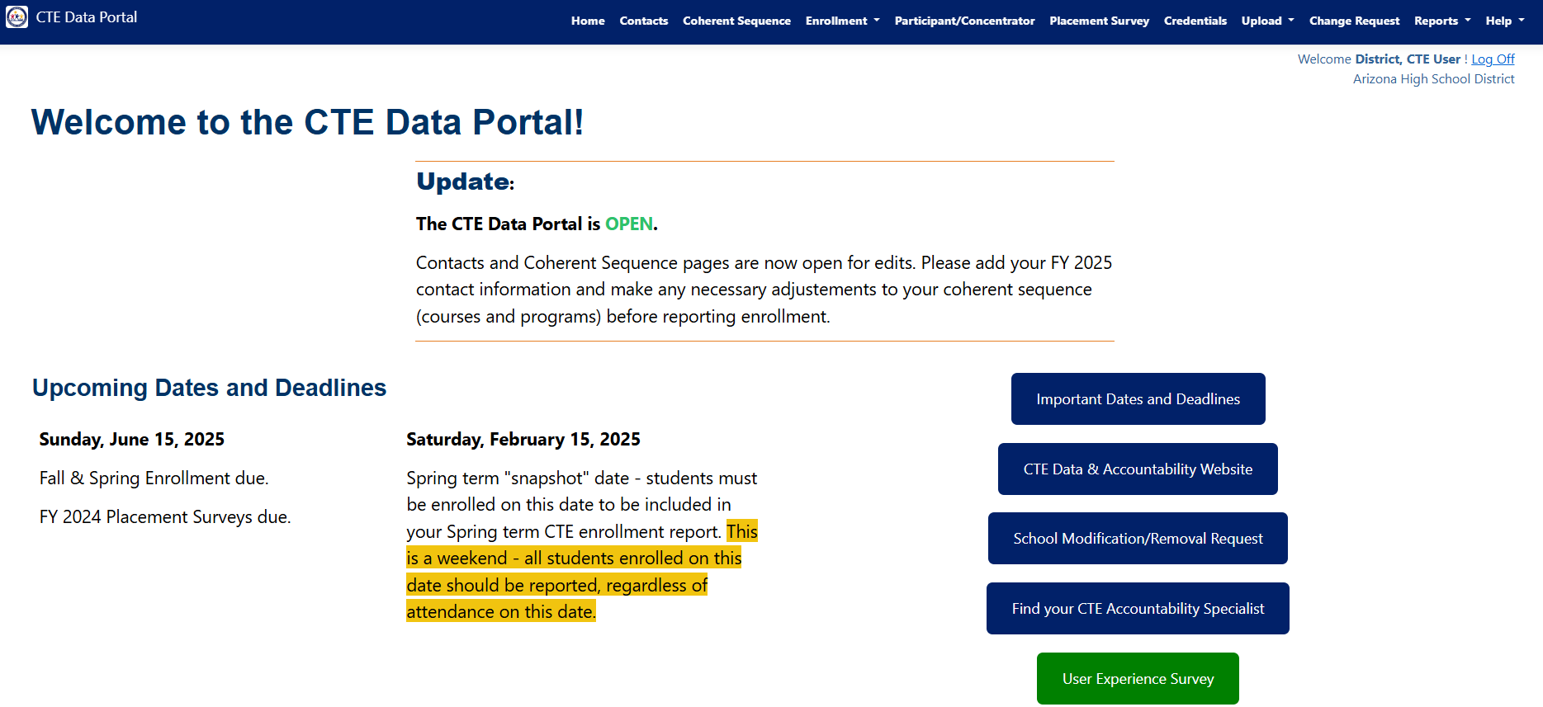

1. Ensure the Fiscal Year is Set to the Intended Year.

(For Example, utilize FY 2025 reports for FY 2026 Grant)

1. In Report Name drop down select “Performance Measures Results by District”

1. Click “Generate Report” to get the report in a new window.

1. Download Performance Measure SDLP as PDF, Excel or CSV File

1. In the sample report above. 90% of the Performance Measure was not met so a Performance Measure Improvement Plan would need to be written to address the 4S1: Nontraditional