Nita M. Lowey
21st Century Community Learning Centers

Grant Fiscal Year 2025 (FY25)

Continuing Grant Application Guidance

Table of Contents

Introduction 2
How to build your 21st CCLC Grant Budget 3
Budget Alignment 3
Recommended Budgetary Guidelines 3
Budget Application Information 5
- Staffing Requirement 5
- Supplies 5
- Salaries 5
- External Evaluators/Consultants 5
- Capital Expenses 5
- Vendors 5
- Generation of Program Income 6
- ESEA Equitable Services with Private Nonprofit School 6
- Affirmation of Consultation with Tribal Representatives 6

Nita M. Lowey 21st Century Community Learning Centers (21st CCLC) Grant
Fiscal Year 2025 (FY25)
Continuing Grant Application Guidance

Introduction
Year 1 of the 21st CCLC Grant is competitive, and Years 2-5 are Continuing based on maintaining program eligibility requirements.
In the event that anticipated federal funding is decreased or eliminated, a proportional decrease will be made to all awardees. All funding is contingent upon ADE’s receipt of federal funds
The link to log in via the ADEConnect portal is found on the ADE Grants Management web page http://www.azed.gov/grants-management/. This page also offers system guidance and contact information for Grants Management.
You will need an ADEConnect username and password to submit your Continuing Application.
The Nita M. Lowey 21st Century Community Learning Centers - Continuing Grant Application is available in the Grants Management System (GME) which is accessible in the ADEConnect portal found on the ADE Home Page. It will be posted on March 1, 2024. The Continuing Application will be due May 29, 2024.

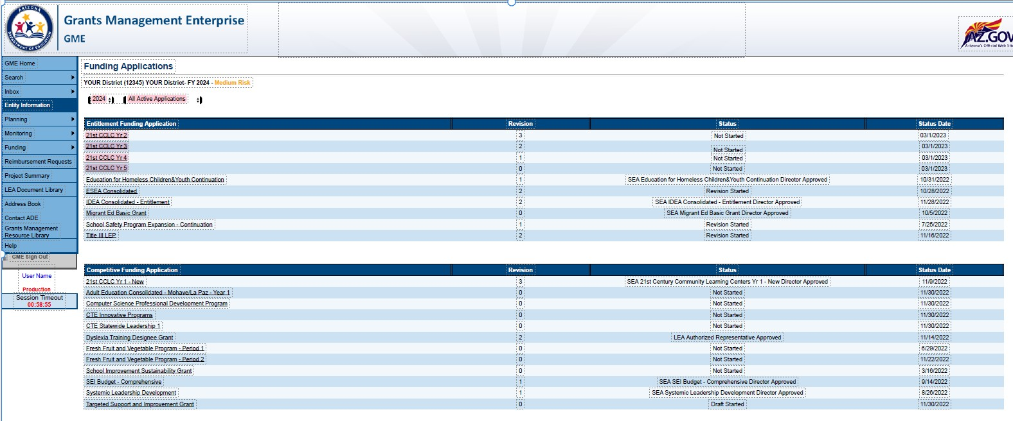
If necessary, you may make minor revisions to your 21st CCLC grant in the Continuing Grant Application. However, it is important that the integrity of the initially awarded application is not compromised. Any changes must receive pre-approval from your assigned Education Program Specialist.

Significant changes or insufficient information in the budgets of each site and narrative information explaining the budget expenditures being requested may delay approval.

Any fiscal/programmatic holds will need to be resolved before your 21st CCLC Continuing Application will be approved.

Remember that in order to submit an application, it must be approved all the way up to the “LEA Authorized Representative Approved” level. Once the application is LEA Authorized Representative Approved, ADE can then review and approve applications.

How to build your 21st CCLC Grant Budget
http://www.azed.gov/21stcclc/application-information/ See the 21st CCLC website’s “Grant Application Competition Information” webpage for the “21st CCLC Application Budget Guidance & Template” under the “Grant Resources” Tab.
Complete a budget for each site within the funding application. Before submitting the 21st CCLC application, applicants MUST contact their Finance & Accounting Office for guidance on developing the budget and for information on the most current budget coding. In addition, 21st CCLC applicants MUST consult their Human Resources Office for guidance on Salary Placement Schedules and Hiring Procedures.
*The Arizona Auditor General website is https://www.azauditor.gov/ for USFR Chart of Accounts for School Districts and USFRCS for Charter Schools and other important fiscal resources.
Be specific when completing the budget narrative descriptions.

Budget Alignment
- Budget will be checked for alignment with entire grant proposal
- Budget items should conform to the USFR or USFRCS Chart of Accounts
- The requested dollar amounts are reasonable and necessary
- Appropriate staffing requirements are reflected in the budget (One Site Coordinator must be on Site during center hours)
- Budget should include costs for Site Leadership (District Director(s), Principal(s), and Site Coordinator(s)) to attend at least one 21st CCLC sponsored/recommended Professional Development event annually

Recommended Budgetary Guidelines
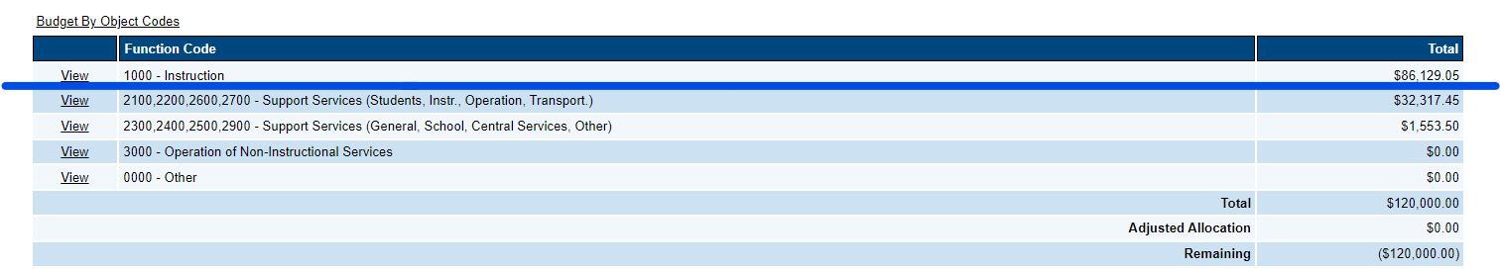
- Administrative costs may not exceed 30% of total budget and may not fall below 50% in the 1000 – Instruction Function Code during any year of the grant cycle. See the screenshot below for an example. Expenditures above the blue line must be higher than all other expenditures below the blue line

- Some Examples of Non-Instructional Costs
Function Codes in the 2100 or 2300 series do not automatically fall under the 30% administrative threshold. Contact your assigned Education Program Specialist if you need any technical assistance

Costs that DO count towards the 30% Administrative threshold | Costs that do NOT count towards the 30% Administrative threshold
Site Coordinator Salary and Benefits | Academic Year/ Summer Learning Transportation Services (some  expenditures include salaries and benefits for drivers and fuel)
District Coordinator Salary and Benefits | Crossing Guard Salary and Benefits
Internal Evaluator Salary and Benefits | Security Guard Salary and Benefits
Supplies and Capital Costs for above positions | Family Engagement Activities to meet the goals of the 21st CCLC Grant
 | Para-Professional Direct Student Services (such as working with a group of students)
Professional Development, Training, Curriculum Development, and Planning
activities for 21st CCLC Staff
*Refer to the Job Description and USFR or USFRCS chart of accounts to determine the appropriate coding in the Grants Management Enterprise (GME) system.
- Capital costs do not exceed 10% of the total budget. To avoid supplanting, capital items purchased with 21st CCLC funds may only be used outside of the regular school day, unless the capital items are purchased on a cost-shared basis proportional to the amount of use during whole day
- Transportation costs billed to the 21st CCLC grant should not exceed 4% of the annual budget when deemed necessary
- External evaluator/consultant costs do not exceed 5% of total budget. Internal evaluator costs will be included in the administrative cost percentage
- Indirect Costs charged to the grant may not exceed the negotiated restricted indirect cost rate. Indirect Costs may not be charged on capital expenditures. If Indirect Cost Rates have not been loaded into the Grants Management Enterprise System, and the applicant plans to charge the 21st CCLC grant, then applicant will write a narrative to this effect in the budget narrative description in the support services supply line (as a placeholder). The narrative should clearly indicate that this is a temporary placement of an allocation for anticipated Indirect Costs, and once the Indirect Cost Rate is approved, the applicant will submit a budget revision to include the final negotiated indirect costs in the Indirect Costs line of the budget
- Educational Field Trips are allowable under certain conditions as described in the 21st CCLC Guidance Handbook. Field trips to places where the purpose of the trip is to reward students or provide amusement, social activities, or entertainment are not allowable
- A Capital Outlay Worksheet (COW) is required when an organization budgets in the capital codes within the Funding Application. For Districts, the codes are 6731-6739. For Charters, the code is 0190. Contact the Grants Management Department for technical assistance

Budget Application Information

See examples in the “21st CCLC Application Budget Guidance & Template”

- Staffing Requirement - Must employ at least one site coordinator per site to be on site during center hours. School Administrators with contracts requiring them to be available to work 24/7 may not perform paid work in the 21st CCLC program, as that would be considered supplanting.

- Supplies – You may show items and dollar amount per type.

- Salaries - Show the formula indicating the number of staff and title of position:
  - Dollar amount per hour x number of hours per day x number of days per week x number of weeks = total
OR
  - Dollar amount per hour x number of hours per day x number of days per term = total.
  - List staff for both the ACADEMIC YEAR and SUMMER terms.

- External Evaluators/Consultants – Show the formula indicating the evaluator’s
/consultant’s name, description of service x dollar amount per hour x number of hours per day x number of days per week x number of weeks for academic year and summer school = total. An external evaluator/consultant is not required.
Example: XYZ Education Inc., provide evaluation services @ $50.00/hr. x 4 hrs. per day x 1 day per month x 10 months = $2,000

- Capital Expenses – Consult with your Business Office and/or Internal Auditors to decide if furniture and equipment should be put in Capital or Instructional Supplies. A Capital Outlay Worksheet is required when an organization budgets in the capital codes within the Funding Application. For Districts, the codes are 6731-6739. For Charters, the code is 0190. Contact the Grants Management Department for technical assistance. Also, indicate in the budget narrative description if the capital items will be used exclusively for the 21st CCLC program or if there is a cost-share with the regular school day which will allow the regular school day to use the capital items for an appropriately proportioned amount of time.
- Vendors – While you may have been solicited by a vendor or contractor, be advised that the Arizona Department of Education does not endorse vendors. We do highly encourage you to seek quality services at a reasonable cost that help you meet the objectives stated in your grant application. If you choose to contract professional services, make sure the budget narrative includes:
  - Vendor name & type of service
  - Number of students/families who will benefit from the service
  - Number of hours provided
  - Cost per hour of service
  - Duration of service

- Generation of Program Income - Generation of program income* is NOT allowed by ADE. This includes any fundraising by 21st CCLC programming or program income, including fees for student participation. ADE does NOT allow program income to be generated by charging fees for students to participate in 21st CCLC programs.
Reason: Participant fees can result in exclusion. Even if scholarships are offered, or the fees seem nominal to program staff or leaders, some students or their families may not even apply to participate if they see or become aware of a fee for the program. As there is no way to prove that this type of exclusion is not happening, and it is the intent of the law to ensure that exclusion does not occur, ADE does not allow 21st CCLC participant fees.
*Program income is income generated using 21st CCLC resources.

- ESEA Equitable Services with Private Nonprofit School: Notice of Intent to Participate (NIP) and Affirmation of Consultation (AOC) – Go to the ESEA Equitable Services website: https://www.azed.gov/titlei/privateschools for the latest guidance and requirements of equitable services for private school students, staff, and families of students enrolled in nonprofit private schools. The 21st CCLC site submitted an affirmation of consultation form when initially applying for the 21st CCLC grant. Since the school/site was awarded, the District/Charter should include the 21st CCLC Title IV-B program along with its other federal programs when completing subsequent annual private school consultation for the duration of the 21st CCLC grant award. The latest forms and guidance are located at https://www.azed.gov/titlei/privateschools. The NIP and/or AOC may be required to be uploaded into the 21st CCLC continuing application when it is completed by the District/Charter or copied from EMAC.

- Affirmation of Consultation with Tribal Representatives – Go to the Office of Indian Education website: https://www.azed.gov/oie/tribal-consultation to determine if Tribal Consultation is required by law for certain schools meeting criteria defined by the Every Student Succeeds Act (ESSA) of 2015, Public Law 114-95. School districts, also called Local Education Agencies (LEAs), who meet specified criteria are required to consult with tribes in their service area. These LEAs are labeled “affected” LEAs. If your organization is on the “Affected LEAs” list, then open the “Tribal Consultation Guide” for information about how to submit the Affirmation of Tribal Consultation form.

