Exceptional Student Services
Program Support and Monitoring

Implementation Program
Examining Data to Improve Student Achievement District and School Implementation
IDEA Capacity-Building Grant Names: 2017 EDISA-1 Implementation; 2017 IDEA EDISA-2 Implementation
Funding Source: Individuals with Disabilities Education Improvement Act (IDEA)
Pre-Approved Action Plan Required

STANDARD BUDGET FORMATS

The ESS Funding Unit has developed a standard format for all IDEA capacity-building grants that must be used to describe budget line items in the online funding application and addendum narrative descriptions. Examples of the standard budget formats for the purchase of each allowed material or service for this grant are shown below.

The LEA’s addendum for this grant was completed by the EDISA reviewers based on information provided in the district or school DAT’s action plan and checked by ESS Funding Unit staff. The applicant DAT should review its contents for accuracy and to ensure that ESS staff has captured all goods and services that are noted in the action plan and allowed by the grant’s parameters. Discrepancies and/or questions about the addendum should be discussed with the lead EDISA grants facilitator or the IDEA capacity-building grant coordinator (see Contacts for Assistance at the end of this document).

Annual Program Cycle
July 1–June 30

Grant Submission Deadline
TBD

It is possible that this grant will not be available in the GME system until after the first scheduled grant activity. If this happens, the LEA may need to use another local, state, or federal funding source to pay the initial expenses. The other funding source may be reimbursed with this grant’s funds upon grant approval.

Failure to meet this deadline without a legitimate reason will absolutely result in the termination of this grant.

Action Plan Revision Deadline
May 1, 2017

All changes to action plan activities must be submitted by this date for approval by the assigned Program Support and Monitoring (PS&M) education program specialist and the PS&M director. The LEA’s project coordinator should stay on top of the plan’s activities and anticipate changes to the plan that may be needed.

Grant Revision Submission Deadline
May 15, 2017

Pre-approved revisions to the grant’s budget that are tied to the action plan changes must be submitted through the GME system by this date. The project coordinator and the business office should stay in close communication as the end of the year winds down to ensure that funding will not be lost due to the failure to meet the deadline. Funds that are not spent by the end of the fiscal year will be lost.

Mark these dates on your calendar. Revisions after these dates will not be accepted.

Uniform System of Financial Records (USFR)

The USFR provides guidance for the line item placement of funding in IDEA capacity-building training, tuition assistance, and implementation grants. The USFR stipulates that grant funding that supports the training of:
- Teachers, instructional aides, and all other instructional staff who work with students in the classroom setting must be placed in the appropriate object codes in Function Code 2100, 2200, 2600, 2700–Support Services (Students, Instr., Operation, Transport).
- District or school administrators and other noninstructional related service providers and staff must be placed in the appropriate object codes in Function Code 2300, 2400, 2500, 2900–Support Services (General, School, Central Services, Other).

notice! Never place any IDEA capacity-building training, tuition assistance, or implementation grant’s funding under Function Code 1000–Instruction unless otherwise instructed.

The object codes and function codes in the various budget examples in this document have been highlighted to show you where to place the funding.

Funding Restrictions and Allowed Expenditures

Funding Restrictions
This grant does not allow the following:
- Carryover of funds from year to year. All funds from this grant must be spent during the program year according to the approved budget. A second grant to use unspent funds will not be allowed.
- Out-of-state travel.
- Out-of-state conference fees.
- Out-of-state contracted services and consultant fees.

Standard Budget Format Examples

The following identifies materials and services that may be purchased with this grant’s funds. Each item is followed by at least one example of the standard budget format. The standard budget format must be used to describe the item in the Narrative Description.

The examples of allowed expenditures written in the standard budget format shown here are based on hypothetical situations.

- Substitute Teachers With and Without Associated Employee Benefits

Budget Example 1 and Budget Example 2 show the standard budget format for substitute teachers based on the following hypothetical information:
- The action plan has one onsite training day during scheduled school time in October, December, February, and April.
- 20 participating teachers will need substitute teachers during each of the training days.
- The LEA’s daily substitute pay rate is $100.
- The LEA’s substitute benefits rate is 20% (shown in Budget Example 1 only).
- The number of units for each activity is identified. In this case, the units are 20 substitute teachers and one training day during each of the four months.
- The type of activity is identified. This example shows training days. Other examples of activities might be a grade-level PLC day, a planning day, or a monthly DAT meeting day.
- Identify the month during which the activity will take place. Here, training days are scheduled in October, December, February, and April according to the action plan.

Budget Example 1 (with benefits)
Placement in the budget:
Object Code: 6100–Salaries and 6200–Employee Benefits
Function Code: 2100, 2200, 2600, 2700–Support Services (Students, Instr., Operation, Transport)

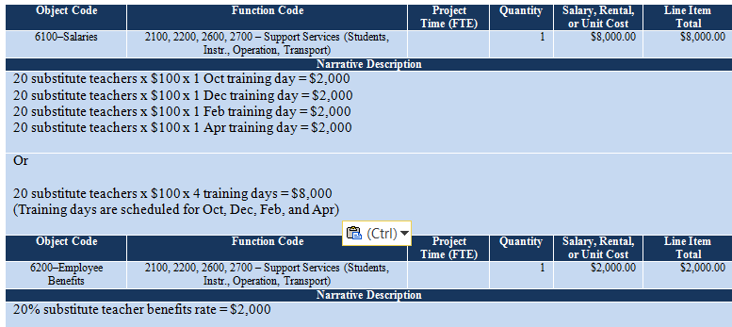

Budget Example 2 (without benefits)
Placement in the budget:
Object Code: 6300–Purchased Professional Services (no benefits)
Function Code: 2100, 2200, 2600, 2700–Support Services (Students, Instr., Operation, Transport)

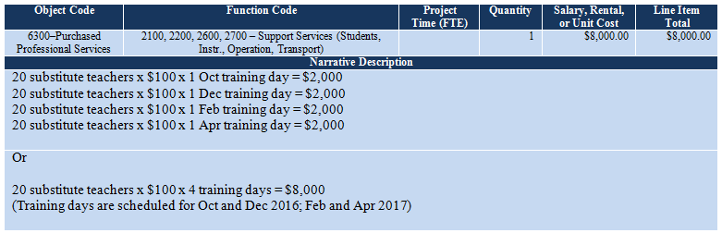

- Off-Contract Pay/Stipends With and Without Associated Employee Benefits
Funding to pay for the use personal time to participate in action plan activities may be funded at the LEA’s rate up to but not to exceed $25 per hour or not to exceed $150 per six-hour or more day.

If the LEA’s policy states that staff members must be paid an amount that exceeds $25 per hour or $150 per day for the use of their personal time, another funding source must be used to pay the balance. If the LEA pays an amount that is less than $25 per hour or $150 per day, the lesser amount must be used. If the LEA does not have a policy that specifies the amount to be paid, the allowed grant amount of to $25 per hour or $150 per day is allowed to be used.

Budget Example 3 and Budget Example 4 show the standard budget formats based the following information:
- DAT planning time is scheduled to take place for six hours on a Saturday before each planned training day.
- The DAT consists of a local special education director, a principal, an instructional coach, and two teachers (three noninstructionals and two teachers). In this scenario, all team members are eligible to be compensated for the use of their personal time.
- The compensation rate is $25 per hour.
- The LEA’s benefits rate is 25%. (You must use the LEA’s employee benefits rate.)
- The number of units is identified. In this scenario, the units are two teachers, three noninstructionals, six off-contract hours, and four months.
- The type of activity is identified. This budget example shows DAT planning time for upcoming trainings.
- The month of each activity is identified.

Budget Example 3 (compensation with benefits)
Placement of teacher compensation in the budget:
Object Code: 6100–Salaries
Function Code: 2100, 2200, 2600, 2700–Support Services (Students, Instr., Operation, Transport)

Placement of noninstructional compensation in the budget:
Object Code: 6100–Salaries
Function Code: 2300, 2400, 2500, 2900–Support Services (General, School, Central Services, Other)

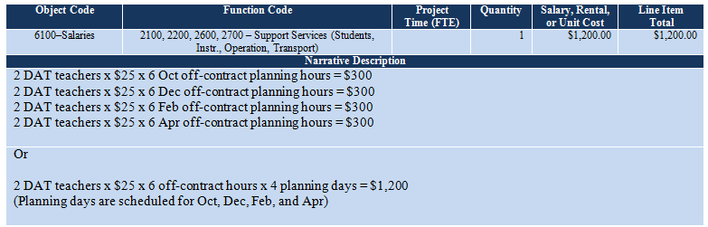

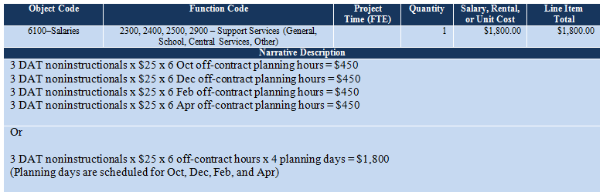

Budget Example 4
Placement of teacher compensation employee benefits in the budget:
Object Code: 6200–Employee Benefits
Function Code: 2100, 2200, 2600, 2700–Support Services (Students, Instr., Operation, Transport)

Placement of noninstructional compensation employee benefits in the budget:
Object Code: 6200–Employee Benefits
Function Code: 2300, 2400, 2500, 2900–Support Services (General, School, Central Services, Other)

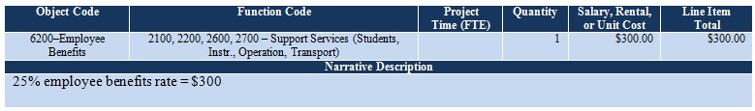
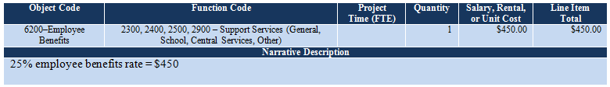

Budget Example 5 shows the standard budget format for off-contract pay that does not have associated employee benefits. The standard budget format is exactly the same as above except the funding is placed in 6300–Purchased Professional Services instead of 6100–Salaries and 6200–Employee Benefits.

Budget Example 5 (compensation without benefits)
Placement of teacher compensation without employee benefits in the budget:
Object Code: 6300–Purchased Professional Services
Function Code: 2100, 2200, 2600, 2700–Support Services (Students, Instr., Operation, Transport)

Placement of noninstructional compensation without employee benefits in the budget:
Object Code: 6300–Purchased Professional Services
Function Code: 2300, 2400, 2500, 2900–Support Services (General, School, Central Services, Other)

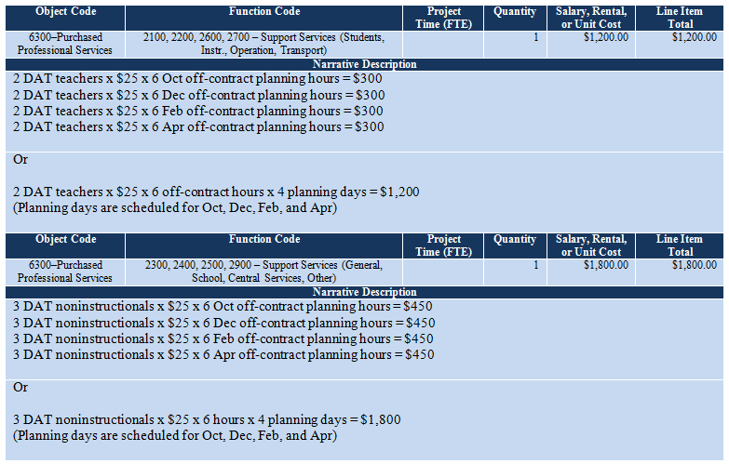

- Contracted Services Fees
The grant may pay for in-state contracted service provider fees. See Footnote #1 above for exceptions.

Budget Example 6 shows the standard budget formats centered on the following information:
- The DAT is planning four LETRS training days during October, December, February, and April.
- A certified LETRS trainer will be hired to conduct the trainings. The contracted fee is $1,000 per day.
- The name of the training and follow-up days are identified. In this case, the training is LETRS training in Modules 1-3 and Modules 4-6 with follow-up days scheduled.
- The type of activity is identified. This budget example shows one training day and one follow-up day each for LETRS Modules 1-3 and Modules 4-6.
- The month of the activity is identified. These months should correspond with the months when the activities are scheduled in the action plan.

notice! Outside professional service fees (payment to contracted trainers et. al.) must always be placed in 6300–Purchased Professional Services, 2100, 2200, 2600, 2700–Support Services (Students, Instr., Operation, Transport), even if the only participants are noninstructional staff.

Budget Example 6
Placement of contracted services in the budget:
Object Code: 6300–Purchased Professional Services
Function Code: 2100, 2200, 2600, 2700–Support Services (Students, Instr., Operation, Transport)

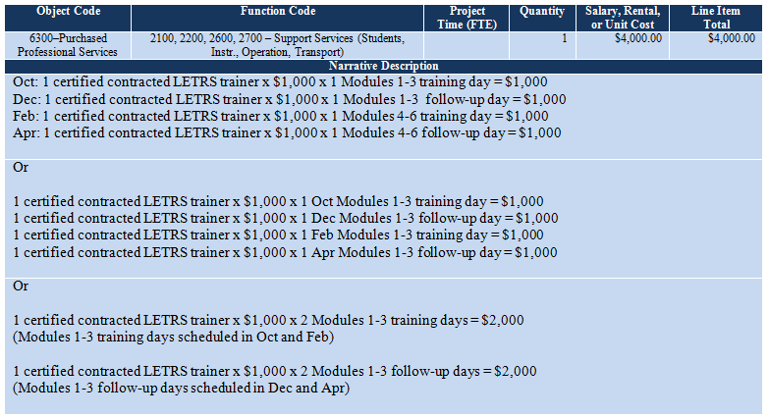

Budget Example 7 shows the standard budget formats for the following:
- The action plan has identified a well-known organization that specializes in providing professional development (PD) in reading strategies to educators. A contracted outside professional trainer from this organization is scheduled to provide one day of training and one day of follow-up classroom observations. The name of the organization is ABC Reading Strategies.
- The daily contracted services fee is $3,000.
- This scenario shows one training day and one follow-up/observation day.
- The month of each activity is identified. These months should correspond with the months when the activities are scheduled in the action plan.

Budget Example 7
Placement of outside professional training services in the budget:
- Object Code: 6300–Purchased Professional Services
- Function Code: 2100, 2200, 2600, 2700–Support Services (Students, Instr., Operation, Transport)

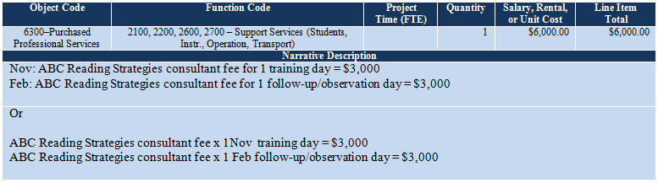
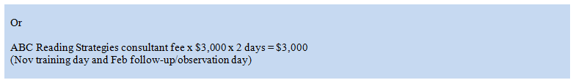

- In-State Conference, Training, or Workshop Registration Fees
Funding may be used to pay for registration fees for staff to attend in-state conferences, trainings, or workshops that are offered by the Arizona Department of Education or other organizations.

Budget Example 8 shows the standard budget format using the following information:
- The five DAT members will be attending the in-state reading training.
- The cost of an individual registration fee is $200.
- The name of the training is identified. In this scenario, the name of the training is XYZ Reading training.
- The number of units is identified. In this scenario, the units are two DAT teachers and three DAT noninstructionals.

Budget Example 8
Placement of teacher registration fees in the budget:
Object Code: 6300–Purchased Professional Services
Function Code: 2100, 2200, 2600, 2700–Support Services (Students, Instr., Operation, Transport)

Placement of noninstructional registration fees in the budget:
Object Code: 6300–Purchased Professional Services
Function Code: 2300, 2400, 2500, 2900–Support Services (General, School, Central Services, Other)

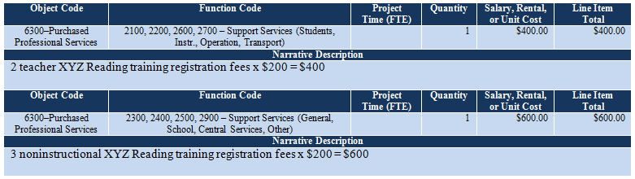

- Travel Expenses
The grant will pay for travel expenses for staff to attend in-state conferences, trainings, and workshops that support the successful achievement of the action plan’s goals. Mileage, lodging, and meals are allowed at the state rate for those whose district or school is located a minimum of 51 miles between the district or school office and the training venue. Other restrictions are also shown below.

- Mileage
- Use MapQuest to determine the miles from the district office or school site to the training venue.
- Round trip miles are calculated at the $0.445 per mile state rate.
- The grant will pay for mileage for one vehicle for every four to five travelers. Additional vehicle mileage must be paid for by another funding source.

- Lodging
- Double occupancy lodging is required when it is possible. However, the grant will accommodate an odd-number of participating travelers or an odd-number of male and female travelers. LEAs may use another funding source to pay for rooms for staff that prefer single lodging.
- It is the responsibility of the LEA or travelers to arrange the travel lodging. When the lodging arrangements are made, remember to request the state rate. The grant will not pay the difference for rooms when you do not request the state rate.
- Lodging is allowed for the number of nights needed by the travelers. Travelers who want to arrive the evening before the conference, training, or workshop is allowed with this grant’s funds, but this early arrival is optional.

Meals
Travelers may be reimbursed for one meal for every six hours in travel status; however, if the hotel offers a complimentary breakfast to hotel guests, funding to reimburse travelers for breakfast should not be included in the budget.

A meal between 12 midnight-10:00 a.m. is breakfast; a meal between 10:00 a.m.-4:00 p.m. is lunch; and a meal between 4:00 p.m.-11:59 p.m. is dinner. Use the per diem rate if all three meals will be reimbursed.

State Rate Lodging and Meal Allowance Table
This table has a breakout of lodging for up to five rooms and three nights for Phoenix, Flagstaff, and Tucson. 15% has been added to the rates to cover the taxes and fees. The lodging rates change depending on the time of year.

The meal allowance is shown at the end of each city’s section.

Phoenix
LODGING ALLOWANCE – 2 ROOMS
LOCATION | TRAINING DATES |  | STATE  RATE | 1 ROOM  + 15% TAX |  | 2 ROOMS  1 NIGHT |  | 2 ROOMS  2 NIGHTS |  | 2 ROOMS  3 NIGHTS
phoenix | Sep 1 – Sep 30 |  | $113 | $130 |  | $260 |  | $520 |  | $780
 | Oct 1 – Dec 31 |  | $113 | $130 |  | $260 |  | $520 |  | $780
 | Jan 1 – Mar 31 |  | $161 | $185 |  | $370 |  | $740 |  | $1,110
 | Apr 1 – May 31 |  | $120 | $138 |  | $276 |  | $552 |  | $828
 | Jun 1 – Aug 31 |  | $89 | $102 |  | $204 |  | $408 |  | $612
LODGING ALLOWANCE – 3 ROOMS
LOCATION | TRAINING DATES |  | STATE  RATE | 1 ROOM  + 15% TAX |  | 3 ROOMS  1 NIGHT |  | 3 ROOMS  2 NIGHTS |  | 3 ROOMS  3 NIGHTS
phoenix | Sep 1 – Sep 30 |  | $113 | $130 |  | $390 |  | $780 |  | $1,170
 | Oct 1 – Dec 31 |  | $113 | $130 |  | $390 |  | $780 |  | $1,170
 | Jan 1 – Mar 30 |  | $161 | $185 |  | $555 |  | $1,110 |  | $1,665
 | Apr 1 – May 31 |  | $120 | $138 |  | $414 |  | $828 |  | $1,242
 | Jun 1 – Aug 31 |  | $89 | $102 |  | $306 |  | $612 |  | $918
LODGING ALLOWANCE – 4 ROOMS
LOCATION | TRAINING DATES |  | STATE  RATE | 1 ROOM  + 15% TAX |  | 4 ROOMS  1 NIGHT |  | 4 ROOMS  2 NIGHTS |  | 4 ROOMS  3 NIGHTS
phoenix | Sep 1 – Sep 30 |  | $113 | $130 |  | $520 |  | $1,040 |  | $1,560
 | Oct 1 – Dec 31 |  | $113 | $130 |  | $520 |  | $1,040 |  | $1,560
 | Jan 1 – Mar 30 |  | $161 | $185 |  | $740 |  | $1,480 |  | $2,220
 | Apr 1 – May 31 |  | $120 | $138 |  | $552 |  | $1,104 |  | $1,656
 | Jun 1 – Aug 31 |  | $89 | $102 |  | $408 |  | $816 |  | $1,224
LODGING ALLOWANCE – 5 ROOMS
LOCATION | TRAINING DATES |  | STATE  RATE | 1 ROOM  + 15% TAX |  | 5 ROOMS  1 NIGHT |  | 5 ROOMS  2 NIGHTS |  | 5 ROOMS  3 NIGHTS
phoenix | Sep 1 – Sep 30 |  | $113 | $130 |  | $650 |  | $1,300 |  | $1,950
 | Oct 1 – Dec 31 |  | $113 | $130 |  | $650 |  | $1,300 |  | $1,950
 | Jan 1 – Mar 30 |  | $161 | $185 |  | $925 |  | $1,850 |  | $2,775
 | Apr 1 – May 31 |  | $120 | $138 |  | $690 |  | $1,380 |  | $2,070
 | Jun 1 – Aug 31 |  | $89 | $102 |  | $510 |  | $1,020 |  | $1,530
MEAL ALLOWANCE PER PERSON
LOCATION |  | TRAINING DATES | BREAKFAST |  | LUNCH |  | DINNER |  | TOTAL PER DIEM
phoenix |  | All dates | $10 |  | $13 |  | $26 |  | $49

Flagstaff
LODGING ALLOWANCE – 2 ROOMS
LOCATION | TRAINING DATES | STATE  RATE | 1 ROOM  + 15% TAX |  | 2 ROOMS  1 NIGHT |  | 2 ROOMS  2 NIGHTS |  | 2 ROOMS  3 NIGHTS
flagstaff | Oct 1 – Oct 31 | $124 | $143 |  | $286 |  | $572 |  | $858
 | Nov 1 – Feb 29 | $89 | $102 |  | $204 |  | $408 |  | $612
 | Mar 1 – Sep 30 | $124 | $143 |  | $286 |  | $572 |  | $858
LODGING ALLOWANCE – 3 ROOMS
LOCATION | TRAINING DATES | STATE  RATE | 1 ROOM  + 15% TAX |  | 3 ROOMS  1 NIGHT |  | 3 ROOMS  2 NIGHTS |  | 3 ROOMS  3 NIGHTS
flagstaff | Oct 1 – Oct 31 | $124 | $143 |  | $429 |  | $858 |  | $1,287
 | Nov 1 – Feb 29 | $89 | $102 |  | $306 |  | $612 |  | $918
 | Mar 1 – Sep 30 | $124 | $143 |  | $429 |  | $858 |  | $1,287
LODGING ALLOWANCE – 4 ROOMS
LOCATION | TRAINING DATES | STATE  RATE | 1 ROOM  + 15% TAX |  | 4 ROOMS  1 NIGHT |  | 4 ROOMS  2 NIGHTS |  | 4 ROOMS  3 NIGHTS
flagstaff | Oct 1 – Oct 31 | $124 | $143 |  | $572 |  | $1,144 |  | $1,716
 | Nov 1 – Feb 29 | $89 | $102 |  | $408 |  | $816 |  | $1,224
 | Mar 1 – Sep 30 | $124 | $143 |  | $572 |  | $1,144 |  | $1,716
LODGING ALLOWANCE – 5 ROOMS
LOCATION | TRAINING DATES | STATE  RATE | 1 ROOM  + 15% TAX |  | 5 ROOMS  1 NIGHT |  | 5 ROOMS  2 NIGHTS |  | 5 ROOMS  3 NIGHTS
flagstaff | Oct 1 – Oct 31 | $124 | $143 |  | $715 |  | $1,430 |  | $2,145
 | Nov 1 – Feb 29 | $89 | $102 |  | $510 |  | $1,020 |  | $1,530
 | Mar 1 – Sep 30 | $124 | $143 |  | $715 |  | $1,430 |  | $2,145
MEAL ALLOWANCE PER PERSON
LOCATION | TRAINING DATES | breakfast |  | LUNCH |  | DINNER |  | TOTAL PER DIEM
flagstaff | All dates | $11 |  | $14 |  | $29 |  | $54

Tucson
LODGING ALLOWANCE – 2 ROOMS
LOCATION | TRAINING DATES | STATE  RATE | 1 ROOM  + 15% TAX |  | 2 ROOMS  1 NIGHT |  | 2 ROOMS  2 NIGHTS |  | 2 ROOMS  3 NIGHTS
tucson | Oct 1 – Dec 31 | $89 | $102.35 |  | $204.70 |  | $409.40 |  | $614.10
 | Jan 1 – Feb 29 | $106 | 121.90 |  | $243.80 |  | $486.60 |  | $636.00
 | Mar 1 – Sep 30 | $89 | $102.35 |  | $204.70 |  | $409.40 |  | $614.10
LODGING ALLOWANCE – 3 ROOMS
LOCATION | TRAINING DATES | STATE  RATE | 1 ROOM  + 15% TAX |  | 3 ROOMS  1 NIGHT |  | 3 ROOMS  2 NIGHTS |  | 3 ROOMS  3 NIGHTS
tucson | Oct 1 – Dec 31 | $89 | $102.35 |  | $307.05 |  | $614.10 |  | $921.15
 | Jan 1 – Feb 29 | $106 | 121.90 |  | $365.70 |  | $731.40 |  | 1,097.10
 | Mar 1 – Sep 30 | $89 | $102.35 |  | $307.05 |  | $614.10 |  | $921.15
LODGING ALLOWANCE – 4 ROOMS
LOCATION | TRAINING DATES | STATE  RATE | 1 ROOM  + 15% TAX |  | 4 ROOMS  1 NIGHT |  | 4 ROOMS  2 NIGHTS |  | 4 ROOMS  3 NIGHTS
tucson | Oct 1 – Dec 31 | $89 | $102.35 |  | $409.40 |  | $818.80 |  | $1,228.20
 | Jan 1 – Feb 29 | $106 | 121.90 |  | 4487.60 |  | $975.20 |  | $1,462.80
 | Mar 1 – Sep 30 | $89 | $102.35 |  | $409.40 |  | $818.80 |  | $1,228.20
LODGING ALLOWANCE – 5 ROOMS
LOCATION | TRAINING DATES | STATE  RATE | 1 ROOM  + 15% TAX |  | 5 ROOMS  1 NIGHT |  | 5 ROOMS  2 NIGHTS |  | 5 ROOMS  3 NIGHTS
tucson | Oct 1 – Dec 31 | $89 | $102.35 |  | $511.75 |  | $1,023.50 |  | $1,535.25
 | Jan 1 – Feb 29 | $106 | 121.90 |  | $609.50 |  | $1,219.00 |  | $1,828.50
 | Mar 1 – Sep 30 | $89 | $102.35 |  | $511.75 |  | $1,023.50 |  | $1,535.25
MEAL ALLOWANCE PER PERSON
LOCATION | TRAINING DATES | breakfast |  | LUNCH |  | DINNER |  | TOTAL PER DIEM
tucson | All dates | $10 |  | $13 |  | $26 |  | $49

State of Arizona Accounting Manual
Issued 10/01/2015

You may review the entire GAO SAAM Travel Policy by clicking Here.

Budget Example 9 shows the standard budget format for travel:
- Five DAT members will be attending an in-state reading training in Flagstaff on March 11–12, 2017.
- Mileage is calculated at the $0.445 per mile state rate. The district office is 200 miles from the training venue. The grant will pay for the mileage for one vehicle only.
- The DAT will require three rooms (double occupancy lodging is required). Lodging costs will be $858 according to the Lodging and Meal Allowance Table above. The term “double occupancy,” the hotel’s city, and the month of the travel are noted in the Narrative Description for the teacher travelers.
- An equal portion of the total mileage and lodging costs is used for each participant. In this case, each member is allotted 20% of the mileage and 20% of the lodging. The total teacher percentage is 40% since there are two teachers, and the remaining total noninstructional percentage is 60%.
- The hotel offers the lodgers a complimentary breakfast. Funding is allocated for lunch and dinner at $43 per person.

notice! The standard budget format for noninstructional travel is different than the standard budget format for the teachers. Please follow the example provided.

Budget Example 9
Placement of teacher travel costs in the budget:
Object Code: 6500–Other Purchased Services
Function Code: 2100, 2200, 2600, 2700–Support Services (Students, Instr., Operation, Transport)

Placement of noninstructional travel costs in the budget:
Object Code: 6500–Other Purchased Services
Function Code: 2300, 2400, 2500, 2900–Support Services (General, School, Central Services, Other)

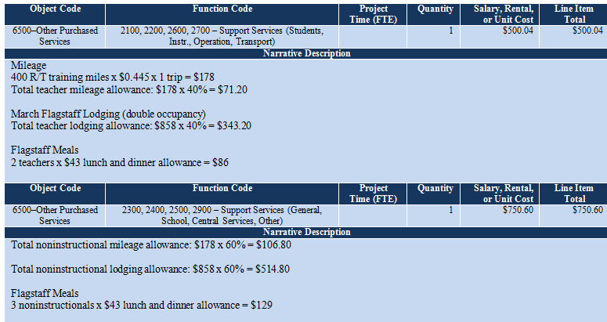

Budget Example 10
In cases where the LEA has allocated a certain amount of the grant funding that is less than the allowed amount to pay for travel, the following Budget Example 10 may be used to explain the discrepancy between the allowed amount and the amount designated by the LEA for travel.

notice! This is a different situation than our standard training grants. Action plans often set aside a specific amount to pay for travel that is less than what would normally be allowed. However, we don’t know if the set aside travel funding falls within our guidelines unless we break down the funding. You may need to ask the LEA to provide the following travel information:
- Mileage from district or school site to the training venue.
- The number of teachers who be attending the training.
- The number of noninstructionals who will be attending the training.
- The number of hotel nights needed.

If you know this information, you could calculate the travel costs as described in Budget Example 9 above but identify the funding as demonstrated in Budget Example 10 below. The notation at the top of Function Code 2100…below will tell the ESS Funding Unit that this has been reviewed and is accepted by the EDISA reviewers.

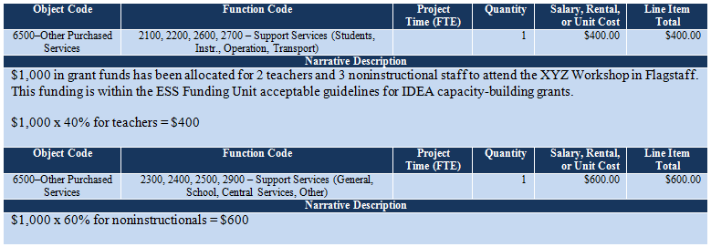

- Supplies
Supplies that are allowed with this funding are:
- Intervention kits including shipping costs, which must be used as training material.
- Books including shipping costs that are used as training materials or in PLS study groups.
- The number of intervention kits or books that are purchased may not exceed the number of teachers and noninstructional staff who will be trained in the use of these materials during the year. The LEA may not stock pile materials for future use.
- General supplies (chart paper, markers, Post-It Notes, etc.), to support training not to exceed $500.

Budget Example 11
Placement of teacher material costs and supplies to be used in training in the budget:
Object Code: 6600–Supplies
Function Code: 2100, 2200, 2600, 2700–Support Services (Students, Instr., Operation, Transport)

Placement of noninstructional material costs to be used in training in the budget:
Object Code: 6600–Supplies
Function Code: 2100, 2200, 2600, 2700–Support Services (Students, Instr., Operation, Transport)

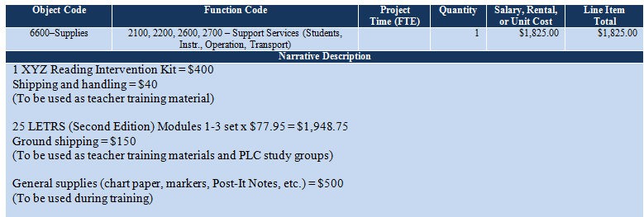
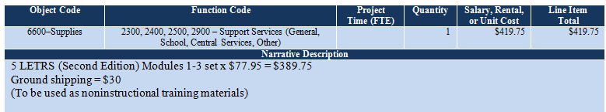

- Assessments and Progress Monitoring
This grant will pay for assessment tools for progress monitoring if the LEA does not already use one of these tools. This includes assessments such as AIMSWeb, DIBELS 6th Edition, DIBELS Next, and iSTEEP.

Budget Example 12 shows the standard budget formats for subscribing to a tool for assessing the acquisition of early literacy skills from kindergarten through sixth grade:
- The LEA is subscribing to DIBELS 6th Edition.
- There are 100 students who will be monitored for progress.
- The cost is $1 per student.
- Testing materials are free with the subscription cost (additional materials should be placed in 6600–Supplies as described in Budget Example 12 above).

Placement in the budget:
Object Code for districts: 6700–Property (Capital Outlay)
Object Code for charter schools: 0190–Capital Outlay
Function Code: 0000–Other

Budget Example 12
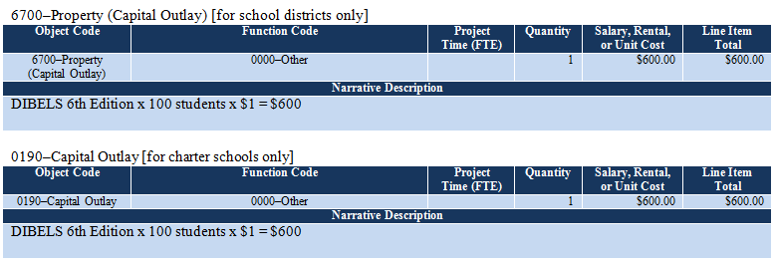

- 6910–Indirect Cost Recovery
Indirect costs at the LEA’s approved indirect cost rate and county-approved indirect cost rate, if they are applicable, are allowed with this grant funding. You must check the GME to find out the indirect cost rate for each applicant. Some applicants will not have an indirect cost rate.

notice! Indirect cost recovery may never be applied to the capital outlay lines. If the action plan calls for funding for assessments as shown in Budget Example 12 above, and the LEA has an approved indirect cost rate, add all line item totals except for the capital outlay line. Multiply that total by the approved indirect cost rate. Then add the capital outlay line item total. A grant that includes indirect costs may not exceed the total allowed amount.

Placement in the budget:
Object Code for districts: 6910–Indirect Cost Recovery
Function Code: 0000–Other

Budget Example 13
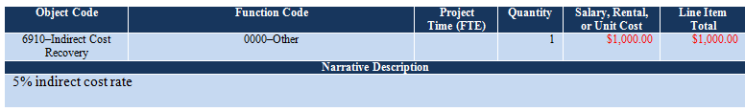

Contacts for Assistance

Program Support and Monitoring
Maura Mall, Director, 602-364-4009, Maura.Mall@azed.gov

Jeff Morton, Lead EDISA Grants Facilitator, 928-637-1864, Jeff.Morton@azed.gov

Grant Issues
Celia Kujawski, IDEA Capacity-Building Grant Coordinator, 602-542-4610 (office), 602-432-3213 (cell), Celia.Kujawski@azed.gov
Abby Sanchez, Program and Project Specialist, 602-364-3026, Abby.Sanchez@azed.gov

ESS Funding Unit
Connie Hill, Director, 602-364-4020, Connie.Hill@azed.gov
Alice Nunes, Administrative Assistant, 602-542-3851, Alice.Nunes@azed.gov

LEAs are currently assigned alphabetically to the ESS Funding Unit finance specialists as follows:
A – Coconino County Regional: Denise Pawlak, Finance Specialist, 602-542-3398 or Denise.Pawlak@azed.gov.
Collaborative Pathways – Kaizen/Liberty Arts Academy: Tanya Rodriguez, Finance Specialist, 602-542-4022, Tanya.Rodriguez@azed.gov .
Kaizen/Maya Public Charter – Pine Strawberry ESD: Ingrid Rope, Finance Specialist, 602-542-4064, Ingrid.Rope@azed.gov.
Pinon USD – Yuma UHSD: Evelyn Benavidez. Finance Specialist, 602-542-3850, Evelyn.Benavidez@azed.gov.

USFR Questions
Arizona Auditor General’s office, 602-553-0333
Ingrid Rope, Education Program Specialist, 602-542-4064, Ingrid.Rope@azed.gov

GME Technical Assistance
Grants Management, (844) 893-9789 or local (602) 542-3901, grants@azed.gov

In extremely rare situations, grant funds to pay for out-of-state professional training or consulting services may be allowed. The DAT must provide a written request for approval to hire a specific out-of-state professional or organization to provide training or consulting services. The written request must describe steps taken by the DAT to locate and secure the same or similar in-state professional services and describe why these in-state professional services are not appropriate to the success of the action plan. The written request must be signed by the PS&M director and the LEA’s assigned PS&M education program specialist and uploaded to the online funding application, Related Documents, as part of the grant’s documentation.

