

EMAC GUIDE
  - Educational Monitoring, Assistance and Compliance (EMAC)

PLEASE NOTE: This document is intended to serve as a guide for School Safety Program District Administrators. It includes information on how to access and navigate EMAC, assign roles, submit tasks, and troubleshoot steps. If you have any questions, please contact: schoolsafetysocialwellness@azed.gov.

Contents:

1. ADE Connect/EMAC Roles Overview: 3
ADE Connect Role: 3
EMAC Roles Overview: 3

2. Accessing EMAC through ADE Connect: 4

3. Steps for EMAC LEA Administrators to Assign School Safety Program to School and/or District/LEA Users. 4
Assign Users to School Safety Programs in EMAC: 4

4. Navigating and Accessing FY27 School Safety Program Application and Monitoring Submissions for School and/or District/LEA Users: 5

5. Navigating and Accessing FY27 EOP Submissions for District/LEA Users on Behalf of a School: 8

6. Quick Troubleshooting Steps: 9
Can’t Log in to ADE Connect: 9
Logged Into ADE Connect, But I do not see EMAC Application: 9
Able to access EMAC, but “My Tasks” is Empty or unable to see any School Safety EOP Tasks: 10
I am to view Tasks, But Submit Button Is Missing: 10
I am a LEA User and Cannot See School Tasks: 10
I am a LEA Admin and Cannot Assign Users: 10

ADE Connect/EMAC Roles Overview:

ADE Connect Role:
- District/Entity Administrator (ADE Connect Admin)
- Who needs this: The official district or charter administrator who manages ADE Connect accounts.
  - District/Charter Administrator
- What users can do:
- Create ADE Connect user accounts
- Assign EMAC roles in ADE Connect (School User, LEA User, LEA Admin)

Note: This is the first step before anyone can use EMAC.

EMAC Roles Overview:
There are three main roles involved with EMAC, each role has a clear purpose and specific permissions.

- EMAC School User:
- Who needs this: School staff who will submit data for their own school.
  - Principal (or Charter equivalent)
  - Awarded Position (SRO, JPO, Counselor, or Social Worker)
- What users can do:
- Log into ADE Connect → open EMAC
- Can view tasks assigned to their school.
- Submit data only for programs they are assigned to.
- If user cannot submit: User would need to contact EMAC LEA Administrator to assign them to the correct program.

- EMAC LEA User:
- Who needs this: District-level staff who submit data for the district or submit tasks on behalf of schools.
  - District/Charter Administrator
- What users can do:
- Log into ADE Connect → EMAC
- Can View tasks for the district and for all schools in the district
- Submit data only for programs they are assigned to
- If user cannot submit: User would need to contact EMAC LEA Administrator to assign them to the correct program.

- EMAC LEA Admin
- Who needs this: District staff responsible for giving EMAC access to others.
  - District/Charter Administrator
- What they can do:
- View all district and school programs
- Assign School Users and LEA Users to programs (give submission permission).

Note: Many districts have the same user who serve as both LEA User and LEA Admin.

2. Accessing EMAC through ADE Connect:
- School and District users can access EMAC through ADE Connect.
  - URL: https://www.azed.gov/adeconnect
Note: If the user does have access to ADE Connect or if “EMAC” is not listed under list of applications in ADE Connect, then contact your Entity Administrator.

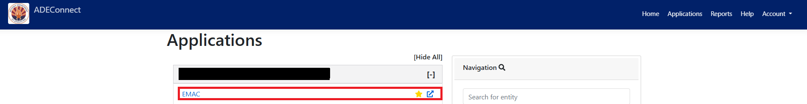

3. Steps for EMAC LEA Administrators to Assign School Safety Program to School and/or District/LEA Users.
Note: This Step is Mandatory for EMAC LEA Administrators.

Assign Users to School Safety Programs in EMAC:
- Once roles are provisioned in ADE Connect:
  - EMAC LEA Admin logs into EMAC.
  - Clicks on HomeàAssign Program Cycle.
  - Selects Organization, Program and Cycle.
    - Note: If school safety program is not populated in program dropdown for the selected school than please contact School Safety Program Area, contact details could be found under SupportàContact Us.
  - Assigns EMAC School Users or EMAC LEA Users to School Safety programs.
    - Note: This step is critical because users cannot submit data unless they are assigned to the program.

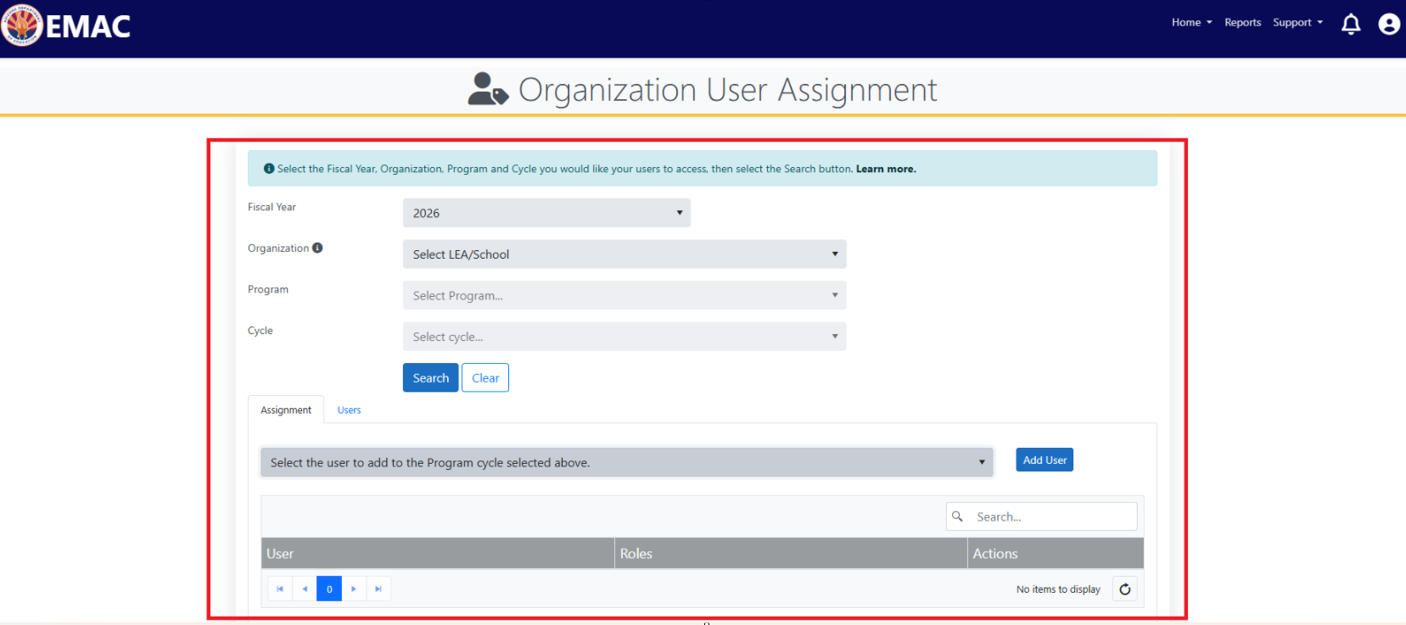

4. Navigating and Accessing FY27 School Safety Program Application and Monitoring Submissions for School and/or District/LEA Users:

Step 1: Users to verify if they can view “School Safety” Programs under “My Programs” on Dashboard.

Note: If the School Safety program is NOT listed under “My Programs” please contact your EMAC LEA Administrator.
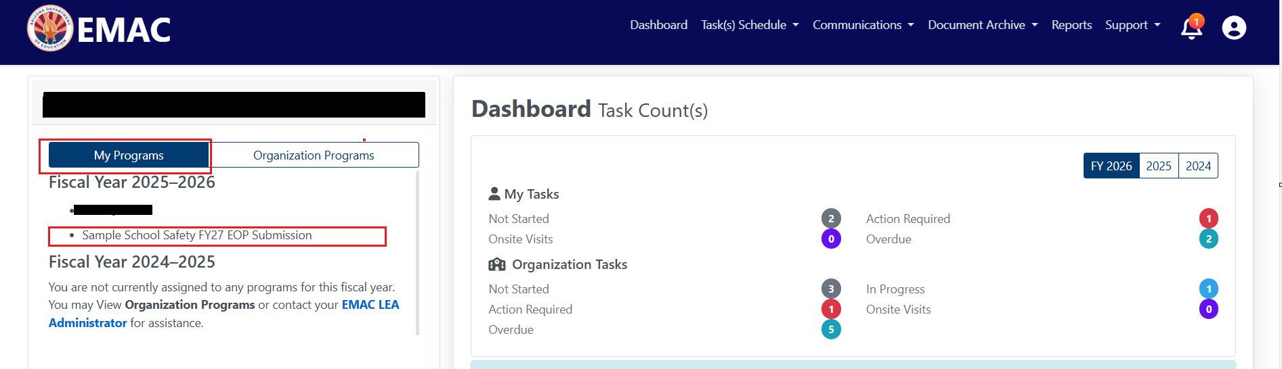

Step 2: Click on Task(s) ScheduleàMy Schedule.

Step 3: Select School Safety Program(s) and click on “Search”.

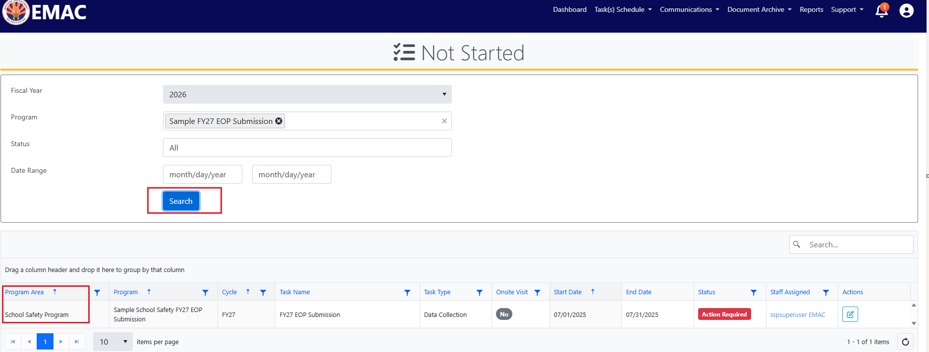

Note: If you are unable view any “School Safety Program” Area tasks, please contact your EMAC LEA Administrator.

Step 4: Select the relevant task and click on “Edit” Action.

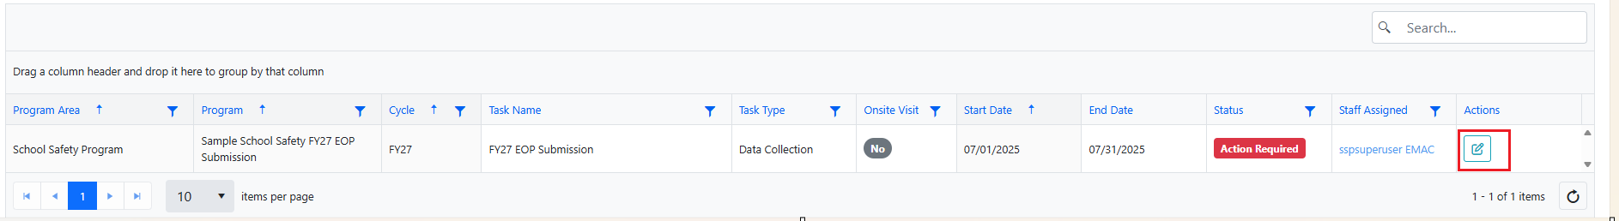

Step 5: Application will navigate user to “Task Details” Page.

Note: Every School will be assigned 2 tasks, one task is to upload School EOP Document, and another task is to complete the “EOP Screener and Checklist” Online form and upload all supporting documents.

1: Purpose: User would be able to view all the details and instructions related to the task.

2: Submission Tab: User will be able to view and submit data to ADE.
Note: If a user gets an error message in submission tab, then please contact your EMAC LEA administrator, so that they assign the program to the user.

3: Evidence Documents: All the Resource and Instruction documents which are required to create EOP Document or other required submissions would be provided by ADE under this section, User can download the file and follow the instructions listed in the document.

4: Evidence Documents Uploaded: School User would need to upload Emergency Operations Plan Document (in Task 1) and all the required supporting documents or documents related to other School Safety Programs (in Task 2). School Users can also select from available tags while uploading a file (If a relevant tag is not found please upload the file without any tag).

5: Online Forms: Once all the supporting documents are uploaded, please complete the “EOP Checklist and Screener” online form or other online forms listed for School Safety Program.

6. Once all the supporting documents are uploaded and online form is completed, please click on “Mark as Completed”.

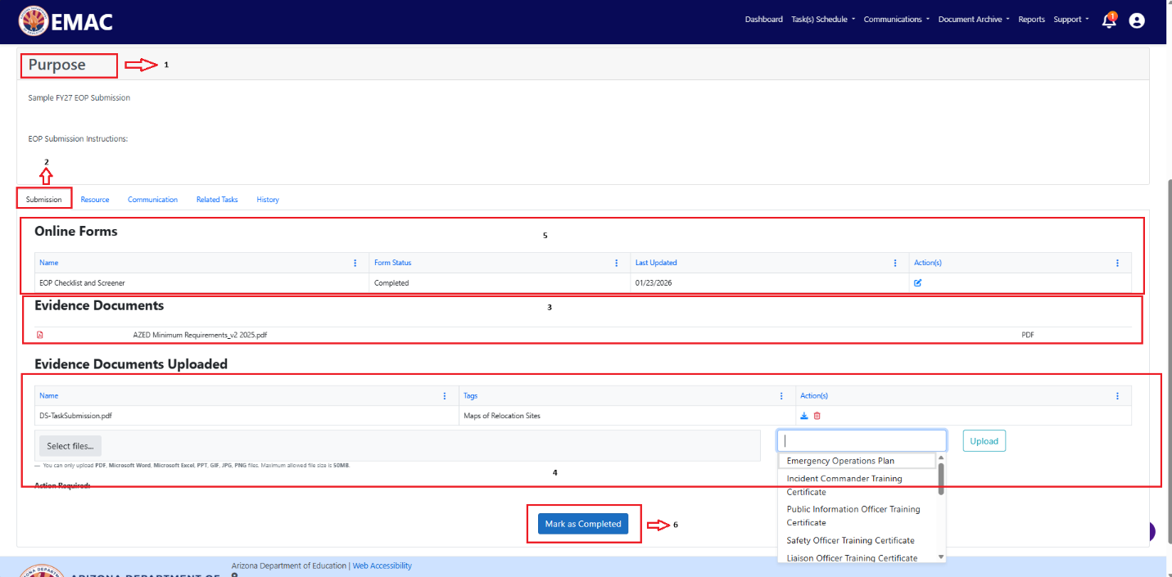

5. Navigating and Accessing FY27 EOP Submissions for District/LEA Users on Behalf of a School:

Step 1: From dashboard click on Task(s) ScheduleàSchool Schedule.

Step 2: District/LEA users will need select the relevant “School” and select “School Safety EOP” program and click on “Search”.

Note: If the school safety program is not listed in the dropdown, please contact your EMAC LEA Administrator. If the user is also the LEA administrator, then please follow above steps listed in Section 3 (Page 4).

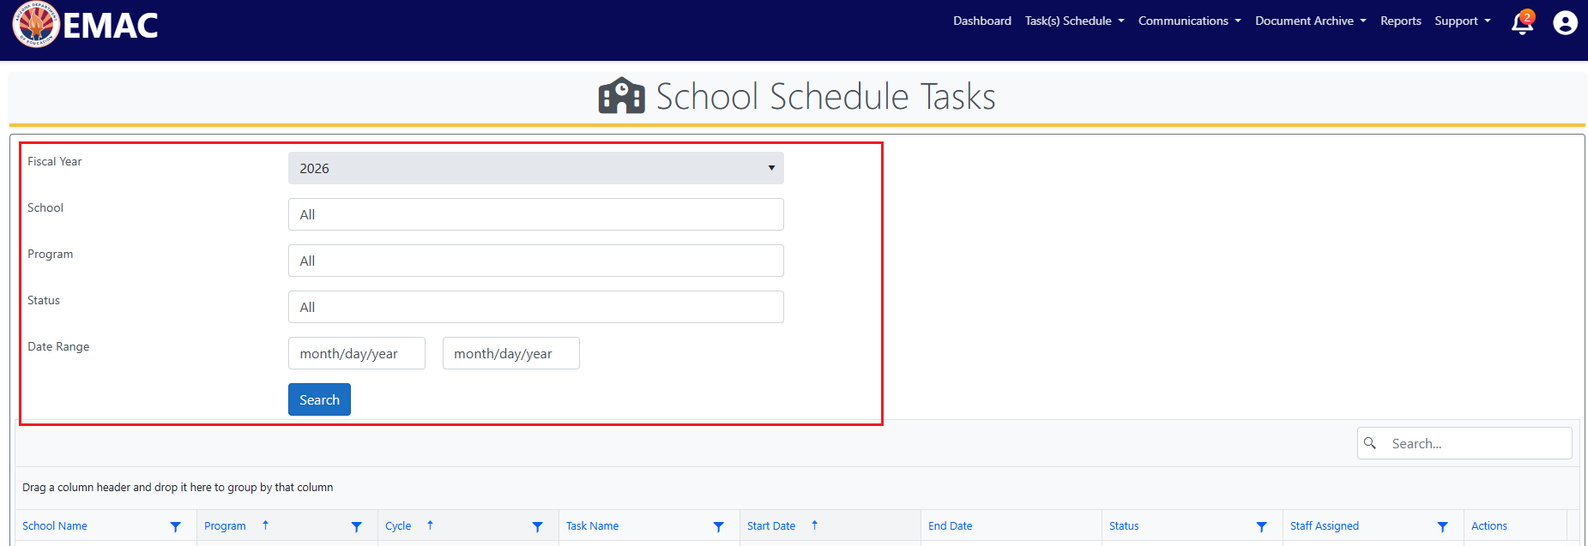

Step 3: Select the relevant task and click on “Edit” Action.

Step 4: Application will navigate user to “Task Details” Page.

Note: Every School will be assigned 2 tasks, one task is to upload School EOP Document, and another task is to complete the “EOP Screener and Checklist” Online form and upload all supporting documents.

1: Purpose: User would be able to view all the details and instructions related to the task.

2: Submission Tab: User will be able to view and submit data to ADE.
Note: If a user gets an error message in submission tab, then please contact your EMAC LEA administrator, so that they assign the program to the user.

3: Evidence Documents: All the Resource and Instruction documents which are required to create EOP Document would be provided by ADE under this section, User can download the file and follow the instructions listed in the document.

4: Evidence Documents Uploaded: User would need to upload Emergency Operations Plan Document (in Task 1) and all the required supporting documents (in Task 2) . School Users can also select from available tags while uploading a file (If a relevant tag is not found please upload the file without any tag).

5: Online Forms: Once all the documents are uploaded, please complete the “EOP Checklist and Screener” online form.

6. Once all the documents are uploaded and online form is completed, please click on “Mark as Completed”.

6. Quick Troubleshooting Steps:

Can’t Log in to ADE Connect:
- You may not have an ADE account yet.
→ Contact your District/Entity Administrator to create your ADE Connect account.

Logged Into ADE Connect, But I do not see EMAC Application:
- Your ADE Connect role may not include EMAC access.
→ Ask your Entity Administrator to assign you one of the EMAC roles:
  - EMAC School User
  - EMAC LEA User
  - EMAC LEA Admin

Able to access EMAC, but “My Tasks” is Empty or unable to see any School Safety EOP Tasks:
- You are not assigned to the program that owns the task.
→ Contact your EMAC LEA Admin to add you to the required program.

I am to view Tasks, But Submit Button Is Missing:
- You have view-only access because you are not assigned to the task’s program.
→ Ask your EMAC LEA Admin to give you assignment for that specific program.

I am a LEA User and Cannot See School Tasks:
- You may not be assigned to the school’s program.
→ Request assignment from your EMAC LEA Admin.

I am a LEA Admin and Cannot Assign Users:
- You may be missing the EMAC LEA Admin role in ADE Connect.
→ Contact your Entity Administrator to add the EMAC LEA Admin role.

