Directions to Navigate to State Determined Level of Performance Report
- Log into ADEConnect and access CTE Data Portal. (Directions on how to get access to CTE Data Portal: Accessing-Perkins-V-Performance-Measure-Outcomes.pdf )
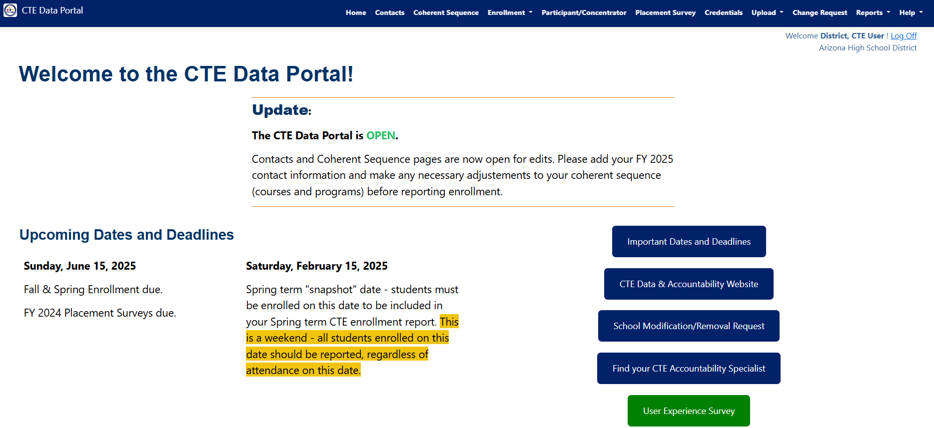
- In the CTE Data Portal, Select “Reports” from the Top Bar

- Ensure the Fiscal Year is Set to the Intended Year.
(For Example, utilize FY 2025 reports for FY 2026 Grant)
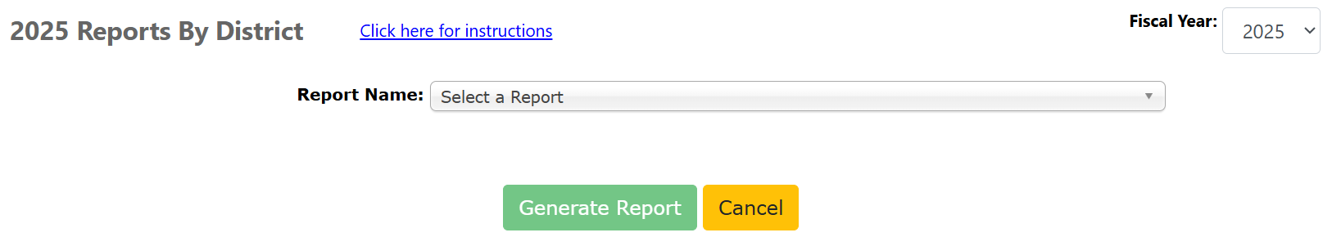
- In Report Name drop down select “Performance Measures Results by District”
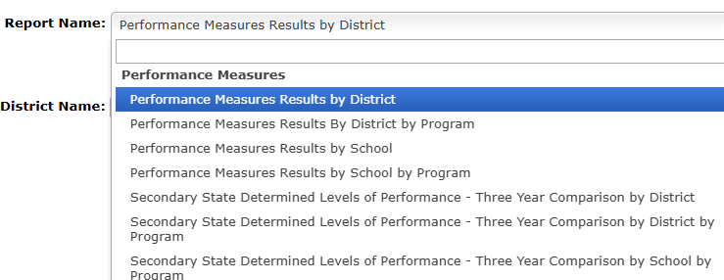
- Click “Generate Report” to get the report in a new window.

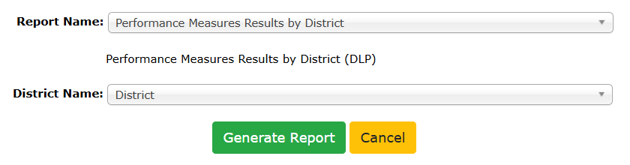
- Download Performance Measure SDLP as PDF, Excel or CSV File
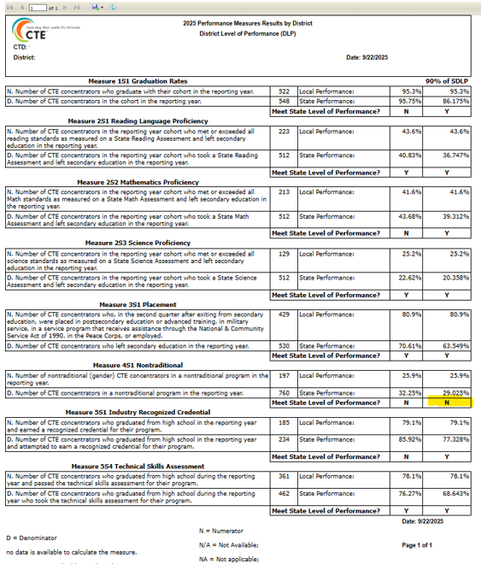
- In the sample report above. 90% of the Performance Measure was not met so a Performance Measure Improvement Plan would need to be written to address the 4S1: Nontraditional

